**EFFECT OF WATER QUALITY ON PREVALENCE AND INTENSITY OF PARASITIC INFECTIONS OF TILAPIA FISH IN SELECTED COUNTIES IN KENYA**

**FINNAN OKOTH AGENG’O (****BSC. FISHERIES AND AQUACULTURE)**

**J56/41760/2022**

**A THESIS SUBMITTED IN PARTIAL FULFILLMENT OF THE REQUIREMENTS FOR MASTERS OF SCIENCE IN VE*T*ERINARY PATHOLOGY, MICROBIOLOGY AND PARASITOLOGY (FISH SCIENCE OPTION)**

**UNIVERSITY OF NAIROBI**

**FACULTY OF V*ET*ERINARY MEDICINE**

**DEPARTMENT OF V*ET*ERINARY PATHOLOGY, MICROBIOLOGY AND PARASITOLOGY**

**JANUARY 2023**

**DECLARATION**

**Declaration by the student**

I, Finnan Okoth Ageng’o, hereby declare to the Senate of University of Nairobi that, this dissertation is my own original work and that it has neither been submitted nor currently being submitted for a degree award in any other institution.

Signature: ………………………… Date: 1st October, 2023

**Mr. Finnan Okoth Ageng’o (BSc. Fisheries and Aquaculture)**

**Declaration by the University supervisors**

This dissertation has been submitted with our approval as university supervisors:

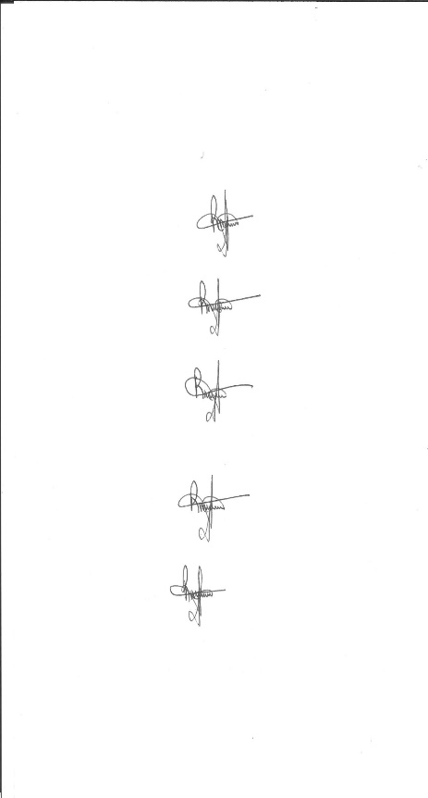

Signature: ………………………………………….. Date: 1st October, 2023

**Prof. Robert Maina Waruiru (BVM, MSc., PhD)**

Department of V*et*erinary Pathology, Microbiology and Parasitology



Signature: ………………………. ………………… Date: 1st October, 2023

**Prof. Paul Gichohi Mbuthia (BVM, MSc., PhD, FRVCS)**

Department of V*et*erinary Pathology, Microbiology and Parasitology

Signature: ………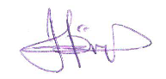………………… Date: 1st October, 2023

**Prof. Philip Njeru Nyaga (BVM, MSc., PhD)**

Department of Veterinary Pathology, Microbiology and Parasitology

# **COPYRIGHT**

©2023, Ageng’o Finnan Okoth

All rights reserved. No part of this thesis may be produced or transmitted in any form or by any means mechanical including photocopying, recording or any information storage or r*et*rieval system without prior permission of the author or University of Nairobi on his behalf.

# **DEDICATION**

This work is dedicated to the Almighty God and Elisha Ageng’o’s family for always believing in me, and their continuous inspiration and moral support during the study period.

# **ACKNOWLEDGEMENTS**

This work was carried out as part of the AHA project (Increased Sustainability in the Aquaculture Sector in SSA, through Improved Aquatic Animal Health Management, RAF-19/0051), which was funded by the Norwegian Agency for Development Cooperation (NORAD). The research was conducted by the University of Nairobi in collaboration with WorldFish and the Norwegian Veterinary Institute. I appreciate my supervisors Prof. Robert Maina Waruiru, Prof. Paul Gichohi Mbuthia and Prof. Philp Njeru Nyaga for their continuous mentorship, assistance and guidance during the study. Special thanks to Mr. Nicholas Okoth, fisheries officer Sotik sub county in Bomet county,Mr. Henry Letting, fisheries officer, Belgut sub county and Mr. Wicliffe Ariemba, Fisheries officer, Ainamoi sub county both in Kericho county for helping me in identifying suitable farms for carrying out the study. Dr. Kisuru, for allowing me to use Kericho Regional veterinary laboratory to analyze sampled fish. Mrs. Edith Keya and Mrs. Beatrice Munde for technical support at the department, parasitology section at University of Nairobi.

I am also grateful to Dr. Shimaa for organizing for us M.Sc. students thorough aquaculture training in Egypt. Where we were introduced to almost all research areas in fish farming with the aim of increasing Aquaculture production in sub-Sahara Africa. Dr. Koftsyo for his concern during the study period and mobilizing resources for smooth learning.

To my classmates; Mercy Matuma, Joseph Ndegwa, Cidee Khaseke, Merceline Ndambuki, Munene Wainaina and Victor Omondi thanks for team work and support during our learning period.

**TABLE OF CONTENTS**

TITLE……………………………………………………………………………………………………….i

DICLARATION……………………………………………………………………………………………ii

TABLE OF CONTENTS…………………………………………………………………………………iii

**COPYRIGHT** 3

**DEDICATION** 4

**ACKNOWLEDGEMENTS** 5

**LIST OF ABBREVIATIONS AND ACRONYMS** 9

**LIST OF FIGURES** 10

**LIST OF TABLES** 11

**CHAPTER ONE** 12

**1.0 INTRODUCTION** 12

**1.1Study background** 12

**1.2 The statement of problem and justification** 14

**1.3 Hypotheses** 15

**1.3 Study objectives** 16

**1.3.1 General objective** 16

**1.3.2 Specific objectives** 16

**CHAPTER TWO** 16

**2.0 LITERATURE REVIEW** 16

**2.1 Aquaculture in Kenya** 16

**2.2 Fish parasites** 17

**2.2.1 Protozoa** 18

**2.2.2 Trematodes** 20

**2.2.2.1 Monogenea** 20

**2.2.2.2 Digenea** 23

**2.2.3 Cestodes** 24

**2.2.4 Nematodes** 25

**2.2.5 Acanthocephala** 25

**2.2.6 Crustacea** 26

**2.5 Pond culture system** 26

**2.6 Biotic factors affecting fish parasitism** 27

**2.6.1 Host and site specificity** 27

**2.6.2 Host diet** 28

**2.6.3 Host age and size** 28

**2.6.4 Host sex** 29

**2.7 Abiotic factors affecting fish parasitism** 29

**2.7.1 Seasonality of parasite transmission** 29

**2.7.2 Dissolved Oxygen** 30

**2.7.3 pH** 30

**2.7.4 Ammonia** 31

**2.7.5 Electrical Conductivity** 32

**2.8 Economic importance of fish parasites** 32

**2.9 Water quality and fish parasites** 33

**3.0 Condition factor of farmed fish** 34

**CHAPTER THREE** 35

**3.0 MATERIALS AND METHODS** 35

**3.1 Study area** 35

**3.2 Ethical clearance** 38

**3.3 Questionnaire administration** 38

**3.4 Study design and sample size** 38

**3.5 Sample collection** 39

**3.6 Necropsy and Parasitological examination** 39

**3.7 Water quality parameters** 41

**3.8 Determination of fish condition factor** 41

**3.9 Data analysis** 42

**CHAPTER FOUR RESULTS** 43

**4.0 RESULTS** 43

4.1 Questionnaire survey 43

**4.1.0 Social Demographic Characteristics** 43

4.1.1 Distribution of respondents and response rate 43

**4.1.2 Gender of respondents** 43

**4.1.4 Education Level of respondents** 44

**4.2.0 Fish farming** 45

**4.2.1 Purpose for doing fish farming** 45

**4.2.1 Holding system for cultured fish** 46

**4.2.3 Fish species cultured** 46

**4. 2. 4 The sex of the cultured fish** 47

**4.3.0 Pond characteristics** 47

**4.3.1 Pond size and location** 47

**4.3.2 Pond purpose** 48

**4.3.3 Pond active status** 49

**4.4.0 Seed characteristics** 49

**4.4.1 Source of fish seeds** 49

**4.5.0 Pond water characteristics** 50

**4.5.1 Water source for fish farming** 50

**4.5.2 Water flowing through ponds** 51

**4.5.3 Water flowing through agricultural land before emptying into ponds** 51

**4.5.4 Pond drainage** 52

**4.6.0 Pond water characteristics** 53

**4.6.1 Water quality** 53

**4.7.0 Water shortage and floods** 53

**4.7.1 Water shortage** 53

**4.7.2 Challenges of floods** 53

**4.8.0 Pond management practices** 54

**4.8.1 Draining ponds harvesting** 54

**4.8.2 Drying and cleaning ponds before ponds before restocking** 54

**4.8.4 Removing Pond bottom after harvesting** 55

**4.9.0 Type of feeds and feeding rates** 56

**4.9.1 Fish feed type** 56

4.9.2 Feeding rates 57

**4.9.3 Feed shortage** 57

**4.10 Manuring ponds** 58

**4.11 Integration** 58

**5.0 Fish Sampling** 58

**5.1 Farmed fish parasites per county** 59

**5.1.2 Prevalence, mean intensity and parasite abundance per county in farmed Tilapia** 59

**5.2 Farmed fish parasites per Holding system** 61

**5.2.1 Prevalence, mean intensity and parasite abundance per culture systems in farmed Tilapia** 62

**5. 3 Wild fish parasites in Taita Taveta, Lake Jipe** 63

**5.5 Fish parasites recovered** 66

**5.5.1 Digenea trematode** 66

5.5.1.1 *Euclinostomum* spp 66

5.5.1.2 *Diplostomum* spp 66

**5.5.2 Nematodes** 67

**5.5.3 Monogea tremadote** 68

**5.5.4 Protozoan parasites** 69

**5.5.5 Acanthocephala** 70

**This could fit in another chapter** 71

**6.0 Water quality parameters in fish farms in selected Counties.** 71

**6.1 Physiochemical parameters of the study sites** 71

**6.2 Chemical parameters of the study sites** 72

**6.4 Correlation of parasites with water Quality** 72

**7.0 DISCUSSION, CONCLUSIONS AND RECOMMENDATIONS** 75

**7.1: Study questionnaire** 99

**7.2 Ethical clearance letter** 102

Remarks

1. Under the results – Remove all Figures and Tables (to be separate entity) from other titles – see other thesis
2. Address punctuations

# **LIST OF ABBREVIATIONS AND ACRONYMS**

**NH4** Ammonium

**DO**  Dissolved oxygen

**FAO** Food Agriculture Organisation

**GPS** Global Position System

**HPM** Hepatopancreatic Microsporidiosis

**KMFRI** Kenya Marine Fisheries Research Institute

**MT** Metric Tonnes

**NO3**  Nitrate

**NO2** Nitrite

**NORAD** Norwegian Agency for Development Cooperation

**NVI**  Norwegian V*et*erinary Institute

**TN** Total Nitrogen

**UoN** University of Nairobi

**WFS** White feces syndrome

**WF** World fish

**WOAH** World Organization for Animal health

# **LIST OF FIGURES**

Figure 1.A typical life cycle of fish trematodes (Beem,2019) 18

Figure 2. selected counties for study in Kenya. 37

Figure 3.Investigator examining fish parasites under microscope 40

Figure 4.Investigator measuring some water quality in situ 41

Figure 5.Earthen Pond receiving water from the river 50

Figure 6 Prevalence plots across counties 61

Figure 7 Prevalence of parasites across holding systems 63

Figure 8 Tilapia species parasitic infections in wild (Lake jipe) and farms in Taita Taveta county 65

Figure 9 *Tilapia jipe* picture 66

Figure 10 Euclinostomum spp 66

Figure 11 Diplostomum spp 66

Figure 12 Photos of Contracaecum spp 67

Figure 13 Camallanus spp 67

Figure 14 Paracamallanus spp 67

Figure 15 Dactylogyrous spp 68

Figure 16 Gyroductylus spp 68

Figure 17 Epistylis spp 69

Figure 18 Paramecium spp 69

Figure 19 Trichodina spp 69

Figure 20 Acanthocephala spp 70

# **LIST OF TABLES**

Table 1.Fish condition factor 42

Table 2.Distribution of respondents by gender in Kericho and Bomet counties 44

Table 3.Occupation of respondents per county 44

Table 4.Level of education of respondents 45

Table 5.Purpose for doing fish farming 45

Table 6.Fish holding systems in Bomet and Kericho county 46

Table 7.Fish species cultured 47

Table 8.The sex of the cultured fish 47

Table 9.Pond location 48

Table 10.Pond purpose 48

Table 11.Pond active status 49

Table 12.Source of seed 49

Table 13.Water source 51

Table 14.Water flowing through ponds 51

Table 15.Water flowing through agricultural land before emptying into ponds 52

Table 16.Pond drainage 53

Table 17.Effect of floods 54

Table 18.Draining ponds harvesting 54

Table 19.Drying and cleaning ponds before ponds before restocking 55

Table 20.Removing Pond bottom after harvesting 56

Table 21.Fish feed type 57

Table 22.Feeding rates 57

Table 23.Types of manure 58

1. Insert an abstract of the thesis before chapter 1
2. Paging up to here need to be in roman numbers NOT Times new Romans

# **CHAPTER ONE**

# **1.0 INTRODUCTION**

# **1.1Study background**

Increasing human population worldwide, need sustainable seafood for consumption. Decreased capture fisheries world-wide because of overfishing and anthropogenic activities, has led to rapid growth of aquaculture food sector worldwide (Sampantamit et al., 2021).

Currently worldwide, 52% of fish production is from aquaculture. This is anticipated to increase with increase in general human population estimated to be 9.7 billion globally, of which 2.4 billion will be in Africa and Kenya (Chan et al., 2021; Sampantamit et al., 2021; Boyd et al., 2022).

More than 800 million people are involved in fisheries and aquaculture economic activities. Out of this, over three million individuals from less and developing nations experiencing poverty have access to protein and high quality polysaturated fatty acids in their diet obtained from fish(Boyd et al., 2022). Aquaculture has played a major role in supporting food security to poor people and reducing malnutrition (Chia et al., 2020). Aquaculture production has been increasing to meet demand for fish and fisheries products by a larger and more prosperous population, but capture fisheries production has not increased in the past 20 years (Boyd et al., 2022). Globally, aquaculture produces 80 million tonnes with Africa accounting for only 2.7% of this(Boyd et.al.,2022; Sampantamit et al., 2021).In Kenya, fisheries production as at 2020 was 147,000MT with a value of $237million.Inland production contributing 120,000MT, out of this, 18,542MT was from aquaculture (Munguti et al., 2021).With the government support, scientific research and many innovations in fish farming, farmers were encouraged to venture in aquaculture. However, there are several challenges such as poor genetic material, cost of feeds, lack of markets, predation and diseases (Munguti et al., 2014; Opiyo et al., 2018; Clough et al., 2020; Wanja, et al., 2020a). Pathogens like bacteria, viruses and parasites could be pathogenic in aquaculture systems (Wanja, *et al*., 2020b). Further, production loses could be attributed to poor husbandry practices, as the farmers do not have enough knowledge and skills of fish farming.

It is documented that parasites pose a significant barrier to the expansion of intensive fish cultivation (Mavuti *et al*., 2017; Paredes-Trujillo *et al*., 2021). Many farms have experienced economic losses due to mortality, morbidity, stunted growth and condemnation during fish inspection due to parasitic infections (Wanja, et al., 2020a; Karlsbakk et al., 2021).

Some of the parasites commonly implicated in causing losses in farmed fish are monogeneans and ecto-protozoa (Mavuti *et al*., 2017) with parasite illnesses' frequency and severity directly correlated with the cleanliness of the water (Hossain 2007). Particularly for species with direct life cycles, the impacts of overpopulation and frequent water degradation offer ideal circumstances for the spread and proliferation of parasites. Degradation of water quality can be as a result of overfeeding, over fertilization using organic and inorganic fertilizers (Akoll et al., 2012; Wanja et al., 2020).Ojwala et al., (2018) found that pH, nitrates, turbidity, dissolved oxygen and temperature play important role in parasitic infections. *Chilodenella* sp., *Cryptoptobia* sp., *Argulus* sp., *Trichodina* sp., *Microsporidia* sp., *L.cyprinacea*, *C.halli* and *Ichthyobodo* sp were highly correlated with temperature, dissolved oxygen and pH. Turbidy of water was correlated with infestation of fish with *A.macracantha* and *Acanthosentis tilapiae*. Ponds with high nitrates level had higher prevalence of *Chilodenella* sp., *C.halli*, *Trichodina* sp.,*Microsporodia* sp., *L.cyprinacea* and *Argulus* sp. From the study; there is a clear correlation between water quality and fish susceptibility to parasitic infection and which according to environmental parasitological measures can influence prevalence, mean intensity, and mean quantity of parasites (Biswas & Pramanik, 2016).So far, there is no research that has been conducted to found out effect and water quality in fish parasitism in Taita-Taveta, Kericho and Bomet counties. Few researches have been done in Nakuru county. Hence there was need for further research to educate farmers how to mitigate fish parasitism on ponds.

Parasitic populations and communities are positively impacted by natural abiotic elements such as eutrophication, salinity, hydrogen ion concentration, oxygen, and temperature (Zargar et al., 2012). Stress and poorer water quality are connected, and both conditions favor the growth of protozoan parasites. In ponds with high organic loads, ectoprotozoans such as *Trichodina* spp., which affect fish skin and gills are prevalent (Mavuti et al., 2017; Adamba et al., 2020). The presence of *Amirthalingamia macracantha,* *Euclinostomum* spp., *Trichodina* spp., and *Contracaecum* spp. are positively correlated with high temperature, pH, and electrical conductivity. Further increase in dissolved oxygen (DO) level has shown positive relationship with *Cichlidogyrus sclerosus* (Adamba et al., 2020). A favorable association between an increase in nitrogen compounds (NH4, NO2, NO3 and TN) and *Clinostomum*, *Contracaecum*, *Tylodelphys*, *Argulus* and *Neascus* species has been observed by researchers in Kenya (Ojwala et al., 2018; Mukwabi et al., 2019; Adamba et al., 2020; Waruiru et al., 2020). The study was undertaken to determine any link between climate and water quality with prevalence, abundance and diversity of farmed fish parasites in Taita-Taveta, Nakuru, Kericho and Bomet counties, Kenya(Anonymous, 2018; CIDP, 2018; *COUNTY GOVERNMENT OF NAKURU NAKURU COUNTY INTEGRATED DEVELOPMENT PLAN*, 2018; *COUNTY GOVERNMENT OF TAITA TAVETA County Integrated Development Plan 2018-2022*, 2018).

# **1.2 The statement of problem and justification**

With increase in fish farming, fish parasites which were previously not considered of economic importance have drawn attention of both farmers and researchers. Parasites when they are in abundance in fish ponds cause mass mortality, morbidity, stunted growth and infected fish lose aesthetic value leading to massive economic loses (Wanja, et al., 2020a; Karlsbakk et al., 2021). This further reduces aquaculture production. Hence there is need for sustainable aquaculture to fill the consumption deficit brought by ever increasing human population worldwide, putting pressure on natural resources like lakes, rivers and oceans resulting in overfishing and less sea food for consumption (Sampantamit *et al*., 2021). Currently, 52 % of fish production is from aquaculture (Chan *et al*., 2021; Sampantamit *et al*., 2021). This percentage is still low to solve the problem of food shortage with the ever-increasing population. The low percentage can be attributed to challenges like poor genetic material, cost of feeds, lack of markets, predation and diseases. Both Kericho, Bomet, Nakuru and Taita Taveta counties have high potential of aquaculture production.

However, this has not been exploited to date due to poor extension services by fisheries officers, low fundings by both levels of government; county governments and national government, cultural believes, few research on water quality and fish parasitism. The research was done to investigate the link between water quality and parasite assemblages infecting tilapia fish in the four counties and offer technical advice to stakeholders on how to control these parasites. The study also, aimed to fill scientific gaps as there were no studies of fish parasites undertaken in Kericho, Bomet and Taita Taveta counties. Though in Nakuru country few research of fish parasites has been done (Ojwala et al., 2018).

# **1.3 Hypotheses**

* Farmers knowledge, attitude and practices practices have no effect on water quality and occurrence of parasites in farmed fish in Kericho and Bomet counties, Kenya
* There are no differences in parasite fauna prevalence, mean intensity, and abundance between selected farms in Nakuru, Taita-Taveta, Kericho and Bomet counties, Kenya
* There are no differences involving water quality indicators (physicochemical and nutrients) in fish ponds in farms in Nakuru, Taita-Taveta, Kericho and Bomet counties, Kenya
* There is no significant correlation between select water quality indicators and parasitic infections in fish farms in Nakuru, Taita-Taveta, Kericho and Bomet counties, Kenya.

# **1.3 Study objectives**

## **1.3.1 General objective**

To determine farm management practices; types, prevalence, mean intensities and mean abundances of ecto- and endo-parasites;the effect of water quality on prevalence and intensity of farmed fish parasites in Kericho, Bomet, Nakuru and Taita Taveta counties, Kenya

## **1.3.2 Specific objectives**

* Determine knowledge, attitude and practices influencing water quality and subsequent effect on parasitic load of farmed fish in Kericho and Bomet counties, Kenya
* Determine the types, prevalence, mean intensities and mean abundances of ecto- and endo-parasites infecting farmed fish in Kericho, Bomet, Nakuru and Taita Taveta counties and wild fish from Lake Jipe, Kenya
* Determine the relationship between water quality parameters and farmed fish parasites in Kericho, Nakuru, Bomet and Taita Taveta counties

# **CHAPTER TWO**

# **2.0 LITERATURE REVIEW**

# **2.1 Aquaculture in Kenya**

By 2030, 30 million tonnes of fish will be consumed worldwide according to research. The projected increase in fish consumption, makes aquaculture the fastest growing food production industry globally. As human population continue to increase steadily exerting pressure on natural resources i.e., lakes, oceans and even rivers making capture fisheries stocks to be limited resulting fish deficit globally. In Africa, specifically sub-Saharan Africa. The demand and supply of fish from aquaculture can solve the problem of fish deficit. As the region have favorable climatic conditions and abundance of locations ideal for aquaculture production. However, there is supply-demand mismatch which presents significant potential especially for the Kenyan aquaculture sector. In Kenya’s freshwater systems, Nile tilapia (*Oreochromis niloticus)* is the majorly farmed fish which provide 80% of farmed fish. The African catfish (*Clarias gariepinus*) comes second with 14%. Polyculture of these two species is often practiced. Intensive, semi-intensive and extensive systems of aquaculture production are practiced with semi- intensive contributing to the bulk of fish farming. The establishment of highly intensive systems is anticipated to contribute up to 90% of Kenya’s total fish production (FAO Fisheries and Aquaculture Department, 2013).

Kenya has a deficit of 306,592MT of fish as it produces currently only 147,000MT against the expected 453,592MT annual demand. Entrepreneurs have taken advantage of fish supply deficit by importing frozen tilapia fish majorly from China, but this still do solve consumption deficit.The deficit can be as a result of; poor seeds (fry and fingerlings), low quality, expensive feeds, predation and diseases among others (Munguti et al., 2014; Opiyo et al., 2018; Clough et al., 2020; Wanja, et al., 2020a). Even though there is little information on fish disease outbreaks nationwide, some well-known illnesses in farmed fish have been documented by Mulei *et al*. (2018; 2019) and Wanja *et al*., 2020a).

# **2.2 Fish parasites**

Parasites like any other pathogens are usually ubiquitous surviving in a dynamic equilibrium with their host(s). Any alteration of the parasite/host equilibrium by environmental factors can cause disease, mortality, stunted growth and in some extent fish and the products can be rejected in the market (Pratoomyot et al., 2015; Wanja, et al., 2020a; (Karlsbakk et al., 2021). These parasites are classified as protozoans (ciliates, flagellates, myxozoa, microsporidia, coccidia), monogeneans (i.e., *Gyrodactylus* spp., *Dactylogyrus* spp.), digenean trematodes (i.e., *Clinostomum* spp., *Diplostomum* spp., *Tylodelphys* spp., *Neascus* spp.), nematodes (*Anisakis complex*, *Contracaecum* spp., *Camillanus* spp., *Capillaria* spp., *Eustrongylides* spp.) cestodes (*Diphyllobothrium latum,* *Ligula intestinalis*), parasitic crustacea (*Ergasilus* spp., *Lernaea* spp., *Argulus africanus*) and leeches (Klinger and Floyd, 2013).

The aquatic environment is home to free-living protozoan parasites. Usually, the parasite may proliferate without an intermediate host (direct life cycle). They can multiply very fast in the infected fish and cause economic losses. Some of protozoan parasites like *Trichodina* spp.increases in number when the organic load is high in ponds or water bodies (Klinger and Floyd, 2013; Adamba et al., 2020). Various genera of digenean trematodes have been documented in Kenya, they affect the skin, gills, eyes and muscles (Maina et al., 2017; Mavuti et al., 2017; Murugami et al., 2018; Waruiru et al., 2020).

Fish trematodes, nematodes and cestodes have a life cycle involving intermediate host(s) and a final host (Meyers et al., 2008) and therefore to terminate the circle in the pond, the intermediate host like copepods and snails can be killed by liming (Noga, 2010; Wanja et al., 2020b).

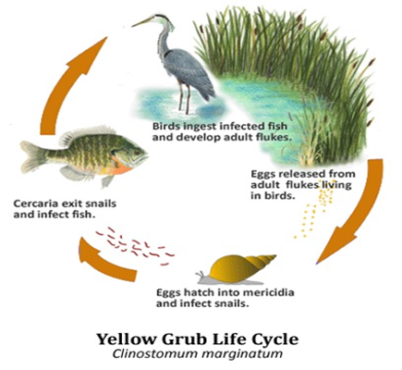

Figure 1.A typical life cycle of fish trematodes (Beem,2019)

## **2.2.1 Protozoa**

Protozoa are free-living and motile organisms that exhibit commensalistic, mutualistic, or parasitic relationships. They fall under kingdom Protista and morphologically they are simplest organisms with most of species being unicellular, eukaryotic, and microscopic in size (Aronson & Magill, 2020). They can replicate sexually, asexually, or both ways within the host’s body without intermediate host, phenomenon that largely explains their high survival. Because of their ease in build up to high numbers, they can cause heavy weight loss, debilitation and mortality in culture systems where stocking density of fish is high (Klinger & Floy, 2013).They usually serve as ecto and endoparasites in fish as well as in other vertebrates and also invertebrates. Resulting to damage and reduced growth of the host fish, the damaged part of fish can act as source of secondary infection by bacteria (Martins et al., 2015).

Fish protozoans are grouped into ciliates, flagellates, myxozoans, microsporidians, and coccidians (Klinger & Floyd, 2013) and they have been reported in different parts of the world. *Ichthyophthirius multifiliis* one of ciliated protozoan parasites affecting the gills, where fish gills will appear swollen, covered with thick mucus and the scale external body surface sloughing have been documented in Egypt. The mature parasite (trophont) is round to oval in shape, ranging from 0.5 up to 1.5 millimeters in diameter and considered as the largest external protozoan affecting fish. The macronucleus is embedded in the protoplasm and well characterized by a horseshoe C shape (Deen et al., 2016.).During that research, infected fish showed small and large yellowish encysted metacercariae in the branchial cavity or on gill filament and skin. The excysted metacercaria were a leaf-shaped, and fairly large if compared with other metacercariae. The oral sucker subterminal and the ventral one was situated near oral sucker. The pharanyex lead to bulb shape oesophages. The cysts were identified as *Clinostomum cutaneum* belonging to genus Euclinostomum (Deen et al., 2016.). Some ciliated parasites like *Trichodina* spp. which are dorsal-ventrally flattened oval parasites of marine and freshwater species of finfish can cause mass mortality of small fish or fry within the shortest period. The unique characteristic of these organisms is the presence of a prominent denticular or “tooth-like” internal cytoskeleton ring (Smith, 2019). In adult fish, cause damage by feeding on mucus and detritus covering the surface of the gills and skin of the fish causing irritation to the epithelial layer of cells which may develop into deep ulcers. Subsequently, leading to secondary infection of fish by bacteria or fungi(Smith, 2019). Another ciliate parasite, *Chilodonalla* spp. destroy fish skins and gill epithelium making fish to secret excessive mucus (Abdel-Baki et al., 2014). While *Epistylis* sp. Affect mainly the body surface and rarely gill tissues, with a wide distribution on scales and fins (Santoro et al., 2020). Histologically, hydropic degeneration with multifocal necrosis adjacent to the colony, proliferation of claviform and mucous cells, and moderate mononuclear and granulocytic inflammatory infiltrate with the presence of giant cells, featuring multifocal granulomatous dermatitis is seen (Santoro et al., 2020). These protozoan parasites have bacilli bacteria and filamentous bacteria on the tail resulting to co infection of infected fish with the parasite where they colonize deep ulcers caused by parasites on fish teguments (Santoro et al., 2020).

Myxozoan parasite like *Thelohanellus* spp.is species and site specific. They only infect common carp (*Cyprinus carpio*). *T. nikolskii* infected the fins, while *T. amurensis* and *T. hovorkai* parasitised the liver, skin and abdominal cavity, respectively(Borzák et al., 2021; Székely et al., 2021). *Thelohanellus cyprini* infects the fins and *Thelohanellus kitauei* infects the intestines and skin of common carp (Borzák et al., 2021). *Thelohanellus nikolskii* infected fish usually show darkening of the fin and appearance of dark colour nodules in carp (Borzák et al., 2021). The research done in Hungary, showed different Myxobolus spp. affect different sites in European chub *Leuciscus cephalus* (L.). *Myxobolus dujardini* was observed in the gills with the unaided eye; *Myxobolus muelleri* in network of gill lamellae on gill filaments; *M. cycloides* in the wall of the swim bladder and the plasmodia of *M. ellipsoides* infected fins between 2 fin rays (Székely et al., 2014). Parasites like *Sphaerospora festivus* have wide host range parasitizing amphibians and fish, where the mainly infect the urinary bladder and its ducts and sometimes the gills, tegument, urethra, gonads, and intestine (Bittencourt et al., 2021) .

Microsporidian parasite, *Ovipleistophora ovariae* causes Ovipleistophoriasis in golden shiner ovary (*Notemigonus crysoleucas).* A condition where the ovary size is reduced by 55 %. This can result into reduced fecundity or fish becoming sterilized (Summerfelt & Goodwin, 2010). *Enterocytozoon hepatopenaei* is one of the parasites of economic concern in shrimp production especially farmed Pacific White Leg Shrimp (*Litopenaeus vannamei*). It causes Hepatopancreatic Microsporidiosis (HPM) that associated with white feces syndrome (WFS) and slow growth many of the shrimp growing countries in Asia (Raveendra et al., 2018).

## **2.2.2 Trematodes**

Trematodes are among the three classes of the phylum plantyhelminthes. Other classes are turbellaria and cestode. Parasites of phylum plantyhelminthes generally are soft bodied, flattened dorsoventrally and hermaphroditic (Meyers et al., 2008).Of the three classes, cestodes and trematodes affects fish and other aquatic animals like frogs and snakes. Trematodes have three orders: Monogenea, Aspidogastrea and Digenea (Meyers et al., 2008).

## **2.2.2.1 Monogenea**

Monogenea are small ectoparasitic flatworms mainly found on skin, fins and gills of fish. Though a few species are adopted to an endoparasitic life like *Acolpenteron ureteroecetes* in the bladder and urinary ducts of labrids, Enterogyrus spp. in foregut and stomach of *Pomacanthus paru* (Murugami et al., 2017). These parasites are found in freshwater, brackish and marine habitats(Hansen et al., 2016; Přikrylová et al., 2012). They lack respiratory, skel*et*al and circulatory systems and have weakly developed oral suckers or none. Monogenea have well developed attachment structures like hooks and clamps(Přikrylová et al., 2012; Přikrylová & Gelnar, 2008).

The head region (anterior end) have apical sensory structures, a mouth with or without accessory suckers and special glands or clamps for attachment while posteriorly (tail region) they attach by special positioned attachment organs (haptor or opisthaptor) to their host's skin or gills and are hermaphrodites(Barzegar et al., 2017; Roohi, 2020). The two main monogeans parasites are *Dactylogyrus* sp and *Gyrodyctylus* sp. They typically have a simple (direct) life cycle with no intermediate host and they spend their entire life cycle as an ectoparasite on an individual fish (Ojwala et al., 2018).Their intensity is usually high when there is reduced water level and high stocking density of farmed fish in culture systems like ponds and cages which makes these parasites to be so much close to the host(Ojwala et al., 2018). Severely infested fish have thickened cuticle, frayed fins, skin ulcers and damaged gills because of the feeding activities of the parasites and damage caused by their attached hooks(Hansen et al., 2022a). The result is usually high mortality of the farmed fish. *Dactylogyrus* sp and *Gyrudyctylus* sp differs in reproduction strategies, morphologically and site for attachment to the host.

Most *Gyrodactylus* sp. are viviparous, with embryos in utero already containing a further developing embryo. The cytological details by which this occurs are unclear, but there is evidence that at least the first-born daughter develop without cross- or self-fertilization. On a later stage in the life-cycle, the worms develop male sexual organs, allowing for cross-fertilization. Gyrodactylids have no specific transmission stage; the viviparous worms give birth to fully grown adults, which during the birth process attach to the same host as the parent and only subsequently may transfer to a new host (Olstad K. (2013)). *Gyroductylus* parasites have elongated body which attaches to the host by means of a small organ called opisthaptor with sixteen marginal hooks and one pair of anchors connected by one dorsal bar and one ventral bar; because of their simple life, there is auto-infection of the host which leads to quick build up in numbers in the infected fish(Barzegar et al., 2017). They infect fish from different ecological habitats from fresh water, brackish and marine water fishes, though this depends on different species of *Gyrodactylu*s parasites(Barzegar et al., 2017). They are more of skin parasites but they also infect gills and fins(Barzegar et al., 2017). Due to their hyper viviparous reproduction and monoxenous life cycle, when there is high stocking density; high mortality usually occurs. The parasites feed on the mucus and epithelial cells and can move freely on the host by alternatively attaching to the host’s epidermis with their posterior opisthaptor and anterior attachment glands(Barzegar et al., 2017). The infected host are unable to regulate its ion balance due to the puncture wounds inflicted by the attachment and the feeding of the parasites making them more susceptible to other pathogens (Barzegar et al., 2017). These parasites have been documents in different parts of world like Africa, Asia, Europe and even America where different species of the parasites infected different species of fishes (Barzegar et al., 2017; Hansen et al., 2022b; Neary et al., 2012; Přikrylová & Gelnar, 2008).In Africa, the following countries have records of Gyrudactylus infection; *G.**cichlidarum* in *Sarotherodon galilaeus galilaeus*(L) in Ghana, G.ergensi in *Sarotherodon galilaeus* (L), *G.haplochromi* in *Haplochromis angustifrons Boulenger* in Uganda, *G.hildae* in *Oreochromis niloticus niloticus* in Ethiopia, *G.nyanzae* in *Oreochromis varabilis* in Uganda, *G.sturmbaure* in Simochromis diagramma in Zambia, *G.thlapi* in *Pseudocrenilabrus philander philander* in Bostwana, *G.thysi* in Simochromis diagramma in Zambia, *G.ulinganisus* in *Oreochromis mossambicus* in South Africa and *G.zimbae* in *Simochromis diagramma* in Zambia (Přikrylová et al., 2012). In Kenya the first Gyrudactylus species identification was done in Lake Turkana. Three species of tilapia were examined during the study; *Oreochromis niloticus*, *Tilapia zillii* and *Sarotherodon galilaenus*. The following genus of the parasites were recorded; *G. cichlidarum* in *Oreochromis niloticus* and *G.argensi* in *Sarotherodon galilaenus*. A new genus of Gyrodactylus called Gyrodactylus malalai was identified for the first time and it was found in Oreochromis niloticus and Oreochromis zillii (Přikrylová et al., 2012). Morphologically, the shape of hamuli of *G. malalai* *sp. nov*. is similar to those of *G. ergensi* and *G. nyanzae*, of a slender appearance with a long root, but the hamuli of *G. malalai sp. nov*. are larger with total length mean of 109 μm than in *G. ergensi* and *G. nyanzae* (88.4 μm and 91 μm, respectively). In terms of shape of marginal*, G. ergensi* has a rounded curved sickle proper, while *G. malalai sp. nov*. sickle proper curves in a wide angle and has the sickle proper longer. Although the size of the marginal hook sickle, *G. malalai sp. nov.* and *G. nyanzae* are similar, but they differ in the shape of their marginal hook (Přikrylová et al., 2012). Among the genus recorded word wide, *Gyrodactylus salaris* is the most pathogenic. It has caused serious economic impacts in salmonids farms in Norway. Currently, it has been listed by OIE as a notifiable disease(Hansen et al., 2022b).

*Dactylogyrus* species are a group of monogenean gill parasites. These parasites are highly host specific to freshwater fish of family Cyprinidae (Sharma et al., 2011).They cause serious infections in the gill filaments that impair respiration, their pathogenicity results in high mortalities and significant economic losses in aquaculture (Chaudhary et al., 2017). They exhibit direct life cycle, having no intermediate host. The mature hermaphrodite are oviparous and produce eggs into the water which hatch prior to attaching to the gills of a fish host and developing into oncomiracidium(Otachi, 2009). Some of the unique features of *Dactylogyrus* parasites is the presence of four eye-sport, marginal hooks mostly seven, one to two connective bars and two needle like structures and spindle shaped dactylogyrid-type seminal vesicles (Mhaisen & Abdul-Ameer, 2009)*.*

## **2.2.2.2 Digenea**

Digenea are endoparasites of vertebrates which mainly infect fresh water fish, reptiles and amphibians. They have life cycle involving at least one intermediate host (Fred D, 2018). Morphologically, the parasites have two suckers, one anteriorly and the other antero-ventral(Fred D, 2018). The definitive host of the parasites are fish eating birds and sometimes other mammals that eat fish can be by accident. The larval development of parasites occurs in molluscs and metacercarial stages are found in fish with the exception of genus Aporocotyle (Maleki & Ghaderi, 2018). The *Clinostomidae* family, *Clinostomum sp* of recent have drawn attention of researchers because of its zoonotic potential. Many countries have recorded patients being infected (Mitiku & Konecny, 2015) and raising issue of public health and food safety among fish mongers. The zoonotic metacercariae causes Laryngo-pharyngitis disease in humans who eat improperly cooked fish, and may lead to death due to asphyxia (Salem et al., 2021). In fish *Clinostomum sp* parasitize the muscles, abdominal cavity, fins, and gill cavity. Cercariae encysted in the fish muscle can grow into metacercaria leading to formation of yellow grub (Fayaz Ali, 2020). Metacercarial infection in fish is the main source of disease with subsequent economic loss. Metacercariae may affect growth and survival, or disfigure fish so that they loss their mark*et* value as a food or ornamental product (Mitiku & Konecny, 2015).

The genus *Diplostomum*, in the family of *Diplostomatidae* have three sub genera that is; *Diplostomum* sp., *Tylodelphys sp*. and *Dolichorchis sp* which infect the eyes, skin and gills of fish causing eye fluke blindness(Fred D, 2018). These parasites are ubiquitous in freshwater systems and infection of fingerlings by metacercarial stage usually result to high mortalities (Fred D, 2018). In adult fish, the metacercariae of *D. spathaceum* that live in the eye lenses, retina and aqueous humour and even brain, spinal cord, nasal spaces of many freshwater fish without undergoing Encystation result to diplostomiasis, dipostomatosis and parasitic cataract of eye fluke disease. This can high mortality of fish farms (Rintamäki-Kinnunen et al., 2004). The surviving blind fish are prone to predation since they tend to feed for long hours, they cannot spot predators quickly and are not able to hide from predators. The growth rate is also slow making production cycle in fish farming to prolong hence making fish farming unprofitable (Migiro Kembenya et al., 2012; Rintamäki-Kinnunen et al., 2004).

## **2.2.3 Cestodes**

Cestodes are endoparasites whose bodies (strobila) are divided into a number of segments called proglottids and have a single set of reproductive organs, with exception being the order Caryophyllaeidea that is not segmented (Mathenge & Charles G, 2010). They infect all species of fish, either during their larval stage or when they have matured into adult worms. They have at least one intermediate host in their life cycle(Murugami et al., 2017). Cestodes mainly infects gastro intestinal tract of fish and sometimes their plerocercoids can be seen encysted in viscera and musculature of infected fish (Mathenge & Charles G, 2010). Adults cestodes are elongated, white in colour and uses scolex found in the anterior region for attachment to the host fish. Examples of fish cestodes are; *Caryophayllaeus spp*., *Trypanorhynchidea spp*., *Bothriocephalus spp., Diphyllobothrium spp.,* *Ligula spp.,* *Tetraphyllidea spp.,* *Protocephalidea spp*. and *Amphilinidae spp*. Severely infected fish exhibits the following symptoms and signs; swollen abdomen, compression and distortion of the viscera and gonads takes long to mature, sometimes fecundity of fish can reduce significantly because of the large sizes of the worms and absorption of host nutrients when in body cavities (Mohammed et al., 2018). The study done by Haji in 2017; Prevalence and Diversity of Internal Cestode Parasites Infected Nile Tilapia (*Oreochromis niloticus*) and African Catfish (*Clarias gariepinus*) in Farmers Fresh Water Ponds in Kenya. Shows that *C. gariepinus* had a higher infection rate 55(55.0%) out of the 100 fish sampled compared to *O. niloticus* 185 (44.1%) of the 420 fish sampled. And in terms of prevalence; *Diphyllobothrium latum* (34.59%), *Proteocephalus spp* (49.62%), *Caryophyllidea spp* (13.53%) and mixed infection (2.26%)(Mjakakhamis & Sagweorina, 2017). Of these parasites *Diphyllobothrium latum* is of public health concern as people who consume raw fish or slightly cooked fish can be infected too(Scholz & Kuchta, 2016)

## **2.2.4 Nematodes**

The phylum Nemathelmintes, class nematoda have both free-living organisms and are parasites of plants and animals. It is the most common animal phyla with over 80,000 species of which 15,000 species are parasites that infect organisms found in freshwater, marine and terrestrial environments (Mitiku & Konecny, 2017). They are commonly referred as round worms because morphologically; they are bilaterally symmetrical, coelomate elongate worms with unsegmented cylindrical body tapering at both ends with a solid resistant cuticle. Nematodes have complete digestive system consisting of three sections: anterior (esophagus), middle (intestine), and posterior (rectum) ending with the anus/cloacae. The body cavity (pseudocoel) is filled with perivisceral fluid imparting turgor to the body ( Otachi, 2009). Sexes are separate, females are bigger in size compared to males. They are oviparous which indirect life cycle. Where the fish can be final host or intermediate host. They infect mainly gastro intestinal tract of fish( Otachi, 2009).

Nematodes of the family *Anisakidae* especially the species of the genera *Anisakis*, *Pseudoterranova* and *Contracaecum*, are parasites of a wide range of aquatic organism. The *Anisakis sp* have caused medical and economic concern worldwide as they are responsible for a fish borne zoonosis known as anisakiasis and allergic reactions to fish mongers who take slightly cooked or raw fish. The larval worms when are encysted in muscles of fish, the fish becomes dark in colour making them unappealing to the eyes of buyers hence causing economic losses to the fishing industry due to reduced marketability of fishery product as well as job lost as experienced in Germany(Bao et al., 2019). World Health Organization have reported 56 million cases of Anisakiasis across the globe, where patients experience severe pathologies. With the following symptoms; severe abdominal pain, nausea, and vomiting (Aibinu et al., 2019).

## **2.2.5 Acanthocephala**

Acanthocephalans are endoparasites helminths mainly found in both marine and freshwater fishes and vertebrates worldwide. With a life cycle involving arthropods as intermediate hosts and vertebrates as definitive or paratenic hosts (Sanil et al., 2011) .They are commonly known as spiny or thorny headed worms. They have elongated cylindrical bodies, with an armed anterior retractable proboscis carrying hooks. They have no gut; they absorb nutritive materials with the whole surface of the body. The sexes are separate, with males being smaller than the females and they are oviparous (Duarte et al., 2020; Sanil et al., 2011). They infect host through the alimentary tract by ingestion of the infective larva with food resulting to pathological effects (Sanil et al., 2011). Attachment by armed proboscis on the intestinal tissues causes permanent mechanical damage to the tissues leading pathological effects (Sanil et al., 2011). Fish infected with acanthocephalans exhibits the following signs and symptoms; fibrotic nodules on the surface of intestines, degeneration of the intestinal villi, formation of granular tissues and capsule formation associated with host immune responses which seriously affect the digestive absorptive efficiency of the animal (Ojwala et al., 2018; Sanil et al., 2011).

## **2.2.6 Crustacea**

Crustaceans belong to the phylum Arthropoda which compromises about 52,000 described species. They leave mainly in aquatic habitats either marine or freshwater environments. Their bodies are covered with hard segmented shells called exoskeletons and have two pairs of antennae, breath using gill or the body surface. The anterior parts are paired, segmented, usually biramous appendages. Most of crustaceans are motile, moving about independently and a few taxonomic units are parasitic and live attached to their hosts such as sea lice, tongue worms and anchor worms (Mitiku & Konecny, 2017). They have direct life cycle and are ectoparasites of fish that have caused serious economic problems to farmed fish (Klinger & Floyd, 2013).

One of the crustaceans of economic effect is *Argulus*, which causes Argulosis. They are commonly referred as fish lice and are members of a large group of branchiuran parasites that infest and cause disease in fish. These parasites are potent carriers of viruses and bacteria in the ornamental fish industry (Kumar et al., 2012). The parasites are related to crabs, lobsters and shrimp (Steckler & Yanong, 2011). Argulus attach to the skin, gill chamber, and mouth of host fish. These frequently results to localized inflammation that occurs at the contact site due to mechanical damage from hooks and spines on the stylet and appendages, and irritation from digestive enzymes (Steckler & Yanong, 2011). Signs and symptoms of infested fish by *Argulus* are; pinpoint hemorrhages, anemia, fin and scale loss, increased mucus production, lethargy, erratic swimming, reduced feeding, hanging at the surface and poor body (Steckler & Yanong, 2011).

# **2.5 Pond culture system**

Fish can be raised in different culture systems like ponds, tanks, race ways, pens and cages. All these culture systems have unique characteristics that lead fish parasitism (Murugami K W Maina et al., 2017). For instance, under pond culture system; there are liner ponds and earthen ponds. Fertilization of liner ponds and over feeding usually lead to build up of nitrogenous compounds like nitrates and nitrites as the nutrients cannot seep out of the culture system. Increase in nitrogenous compound have been associated with increase of *Clinostomum*, *Contracaecum*, *Tylodelphys*, *Argulus* and *Neascus* parasite species according to research done by (Adamba et al., 2020) and (Ojwala et al., 2018). Earthen ponds are usually more predisposed to high levels of parasitic infestations than liner and concrete ponds due to interplay of vegetation growth, presence of snails and in some cases, piscivorous birds can be present. Creating a complex environment where snails, leeches and copepods can lay their eggs in the vegetation and pond mud acting as a reservoir for cysts of dinoflagellates such as *Amyloodinium* or invertebrates acting as intermediate hosts and piscivorous birds as the final host (Murugami K W Maina et al., 2017). Culture systems like tanks, cages and race ways where there is intensive fish farming, stocking density is usually high thereby making fish to be in close contact with each other creating a good environment for the transmission of ectoparasites with a direct life cycle such as monogenean trematodes (MA, 2021). High stocking density can result to stress and poor water quality conditions leading to surge of protozoan parasites. Low dissolved oxygen (DO) is associated with increase in number of *Cichlidogyrus sclerosus* (Adamba et al., 2020).

# **2.6** **Biotic factors affecting fish parasitism**

Fish parasites are mainly grouped in to two major categories; generalist and specialist based on host range. Generalist infect a wide range of hosts, while specialists are restricted to a narrow range of hosts mainly one family of host in most cases (Asiru et al., 2012). The biotic factors that affect their host range varies from; host and site specificity, host di*et*, migration behavior, host sex, host age and size, and host size and parasite size(Asiru et al., 2012; F. Iyaji & Eyo, 2009).

## **2.6.1 Host and site specificity**

Most of the host specific parasites are monogenean species, and this can be attributed to their simple life cycle. Although ectoparasites like copepods that are directly transmitted are not highly host specific(F. Iyaji & Eyo, 2009). *Gyrodactylus turnbulli* is host specific to guppy fish (*Poecilia reticulata*) (Richards et al., 2010). Myxozoan parasite like *Thelohanellus* spp.is species and site specific. They only infect common carp (*Cyprinus carpio*). *T. nikolskii* infect the fins, while *T. amurensis* and *T. hovorkai* parasitise the liver, skin and abdominal cavity, respectively (Borzák et al., 2021; Székely et al., 2021)*Thelohanellus cyprini* infects the fins and *Thelohanellus kitauei* infects the intestines and skin of common carp (Borzák et al., 2021).*Dactylogyrus heteromorphus* parasitize exclusively the gills of *Luciobarbus callensis*. The fish is native to North African like Algeria, Morocco and Tunisia(Allalgua et al., 2021). Some of Acanthocephalans like *Neoechinorhynchus rutili* are site specific. They are mainly restricted to the gut of fish species, which is mainly attributed to the abundant food supply in the organ (Asiru et al., 2012).

## **2.6.2 Host diet**

The feeding pattern of fish plays important role in their infestation by parasites. The abundance, intensity and prevalence of parasites are associated with ontogenetic diet shift, length of the gut and feeding behavior(F. Iyaji & Eyo, 2009; Richards et al., 2010). Most of comparison research on fish diet shows that fish that feed on carnivorous diets like invertebrates and other fish species like Clariid have the highest infestation followed by invertebrate feeders like *Citharinus citharus* and most of algal feeders and herbivores as well as some zooplankton specialist have very low helminth infestation (F. Iyaji & Eyo, 2009).Fishes like tilapias that exhibits ontogenetic diet shift have high infestation during juvenile stage as they are omnivorous while low in adult as they are herbivores. The predatory fish species (carnivorous) habour a greater diversity and abundance of larval helminths than herbivorous and planktivorous species. As they ingest more infective larvae in their diet rendering them more susceptible to higher parasite colonization (Richards et al., 2010).

## **2.6.3 Host age and size**

Normally, standard length of fish is directly related to age and fish body size. Age has often been found to be positively associated with the prevalence and intensity of parasitic infection (F. Iyaji & Eyo, 2009).Older fish have gone through a longer period to accumulate parasites than younger ones. The older or big fish species give more internal and external space for parasite establishment and consequently incline to have heavier worm burdens because they eat more parasitized prey and offer large surface area for skin-attaching parasites (F. Iyaji & Eyo, 2009). For instance, the larger guppy fish (*Poecilla reticulata*) habour more *Gyrodatylus turbulli* parasites and parasitic load increases exponentially with increased body size (Richards et al., 2010).This is contrary to the findings of Allalgua et al., (2021) which found *Dactylogyrus heteromorphus* parasitic index in different classes of host size shows the individuals had the highest infestations and parasitic loads. And this is attributed to the fact that young fish are more susceptible to parasites infestations and have fragile immune system compared to the mature ones.

## **2.6.4 Host sex**

Sex-skewed parasitism in fish is as a result of differences in immunocompetence, hormone in the systems, fish biology and adaptation behaviours. Shoaling fish like guppy fish (*Poecilla reticulata*), there is high prevalence of *Gyrodactylus turbulli* parasites in females compared to males. Female guppies form larger, and tighter shoals than males and shoal for longer time hence increasing chances of being infected by the parasite(Richards et al., 2010). A study done by Allalgua et al., (2021) shows female *Luciobarbus callensis* had the highest rate of infestation by *Dactylogyrus heteromorphus.* This is similar to the research findings done by Alvin et al., (2019).Where all the six genera of ectoparasites recorded had high prevalence in female *Oreochromis niloticus* with thefollowing percentages: *Trichodina* 85.2%; *Dactylogyrus* 49.6%; *Gyrodactylus* 35.2%; *Coleps* 17.70%; *Euplotes* 14.25%; *Ergasilus* 0.60%; Digenean 0.4% as compared to male *Oreochromis niloticus* where *Trichodina* was 52.4%; *Dactylogyrus* 33.35%; *Gyrodactylus* 25.35%; *Coleps* 11.25%; *Euplotes* 9.00%; *Ergasilus* 0.4%.In the same study, Alvin et al.,( 2019), contrary findings were found in endoparasite where male tilapias had higher prevalence of *Camallanus spp* and acanthocephalan compared to females. These differences in parasitic prevalence percentages between male and female tilapias in response to ectoparasites and endoparasites is based on spawning behaviors and fish biology. Females invest more in gamete production, with the assumption that energy for reproduction is costly and it reduces the energy for immunocompetence. Males invest more in mate attraction through the display of sexual ornamentation, which is characterized with production of steroid hormones mainly testosterone that affect directly the production of immune cells. Immunosuppression by steroid hormones result in higher endoparasite parasites level in breeding individual (Alvin et al., 2019).

# **2.7 Abiotic factors affecting fish parasitism**

## **2.7.1 Seasonality of parasite transmission**

Rainfall and temperature vary throughout the year. They are important factors in fish infestation as they control seasonal prevalence of parasites. In temperate areas, monogenean parasites lifespan depends on high temperature, as high temperature increases the rate of egg hatching, survival, infection capacity and population compositions (Bertaglia et al., 2023).Bertaglia et al., (2023) found that seasonality influences variation of monogenean parasites. Higher prevalence and abundance were recorded in autumn and spring, and lower values in winter and summer in a climate where September experiences spring and march summer are the rainiest months and autumn winter months like April September are driest months. The similar were found in Uganda by Akoll et al., (2012) in Nile tilapias raised in tanks, *C.sclerous* and *C.tilapiae* had the highest infestation rate in dry months of June and august.

## **2.7.2 Dissolved Oxygen**

Dissolved oxygen is the quantity of gaseous oxygen dissolved in water. Used by aquatic organisms like fish, reptiles and amphibians for breathing. For instance, fish absorb oxygen directly from the water into their bloodstream using gills to meet their metabolic demands (Francis-Floyd, 1992).Dissolved oxygen in water can be directly from the effect of wind and wave, photosynthesis, and direct diffusion from the atmosphere (Francis-Floyd, 1992). Though the principal source is photosynthesis by phytoplanktons and aquatic plants (Bhatnagar & Devi, 2013; Francis-Floyd, 1992).The recommended oxygen concentration for most of fish for optimal performance is 5mg/L, some fish species are very sensitive to drop oxygen level between 2mg/L and 4mg/L. The fall of oxygen concentration is usually characterized by poor feeding of fish, starvation, reduced growth and fish mortality rate (Bhatnagar & Devi, 2013; Yusuf et al., 2016). Some of the factors that lead to oxygen depletion in water are; pond turn over, cloudy weather, increase in temperature, increase in salinity, low atmospheric pressure, high humidity, high concentration of submerged plants, plankton blooms and decaying organic matters(Bhatnagar & Devi, 2013; Francis-Floyd, 1992). Signs that are associated with low oxygen in water are; Fish swim at or near the surface gulping air and suddenly stop feeding. Water colour changes very fast to brown, gray and sometimes black because of algal bloom in the pond and water produces putrid odour(Francis-Floyd, 1992; Yusuf et al., 2016).Hypoxia fish death; death as a result low levels of dissolved oxygen usually less than 2-3 milligrams of oxygen per litre of water can be ascertain in pond when; All fish die at night or pre-down hours at approximately the same time, moribund floating on water surface gasping for oxygen, most of fish affected are large, species like catfish may die with their back arched, gills flared and mouth open. Most likely, prior to death, the weather tends to be hot and occasioned by thunderstorm (Francis-Floyd, 1992; Yusuf et al., 2016).

## **2.7.3 pH**

pH of the water is the measure of the concentration of hydrogen (H+) or hydroxyl (OH-) ions in the water. When concentration of hydrogen (H+) or hydroxyl (OH-) ions are the same, water is neutral and that is at pH of 7.0. A drop of pH below 7, water becomes acidic and arise in pH above 7 water becomes alkaline (Boyd, 2015).The average blood pH of fish is 7.4. Though the ideal pH for fish farming ranges between 6.5 and 9.0 for biological productivity (Bhatnagar & Devi, 2013). Between pH of 4 to 6.5 and 9 to 11 fishes become stressed, rendering their immune system be susceptible to opportunistic diseases. Young fish and immature stages of fish like larvae, fries and fingerlings are extremely sensitive to pH levels below 5 and this can result into their mass mortality in the farm(*AN 10B01R20-01E Http://Www.Yokogawa.Com PH in Fish Farming*, 2014; Bhatnagar & Devi, 2013). High pH above 9 denatures cell membranes of fish. It also accelerates conversion ammonium in water to most to toxic ammonia (NH3) which can kill fish(Aba Mustapha,2019). A pH of below 4, increases the number and turnover of ion-transporting cells (ionocytes), elevating mucus production and recruits leukocytes. Continuous acidification of water can result to breakdown of gill structure and suffocation caused by mucus accumulation leading to death of fish (Kwong et al., 2014).

## **2.7.4 Ammonia**

Ammonia is a form of nitrogen compound usually excreted as a byproduct from protein metabolism by fish, some inorganic fertilizers like ammonium sulphate, ammonium nitrate, ammonium phosphate and bacterial decomposition of organic matter from wasted fish feeds, faeces, dead planktons and sewage (Chang et al., 2021; Aba Mustapha,2019; Kwong et al., 2014). In water, ammonia can exist in either gaseous ammonia (NH3) which is very toxic or in ammonium ion (NH4+) which is slightly toxic, gaseous ammonia and ammonium ion form total ammonia (AN 10B01R20-01E Http://Www.Yokogawa.Com PH in Fish Farming, 2014; Aba Mustapha,2019). Most of ammonia produced in water are consumed by algae and bacteria as source of nitrogen therefore creating a balance between total ammonia concentration to be zero or slightly above zero(Aba Mustapha, 2019). Excessive feeding of fish leads to most feeds being uneaten. The uneaten feeds decompose producing supply that exceeds the treatment and assimilation capacity of algae and bacteria (Bhatnagar & Devi, 2013; Aba Mustapha,2019). High temperature and pH increase the transformation of the ammonium ion (NH4+) into ammonia gas (NH3) which leads to increase in the concentration of toxic ammonia in the water (Bhatnagar & Devi, 2013). Ammonia levels higher than 2mg/l cause stress to fish. If the levels increase to more than 7mg/l Fish losses increase. Unionized ammonia is stressful to fish at concentrations greater than 0.1 mg/litre and lethal at concentrations above 0.5 mg/litre of water (Bhatnagar & Devi, 2013).

## **2.7.5 Electrical Conductivity**

Electrical conductivity is the measure of how ease electrical charge or heat can pass through water and usually affected by the concentration of free ions and to water temperature (Stefanakis, 2020). Free ions are critical in the lives of fish and their presence or absence in water determines the productivity, health and fish growth as ionic regulation and acid–base balance is fundamental to the physiology of fish (Kwong et al., 2014; Stefanakis, 2020). Majority fish do well within the range of 100-2,000 µS/cm the upper range varies with fish species, catfish, for instance, can withstand salinities up to 1/2-strength seawater(Mutea et al., 2021).In Kenya study by Ndiwa et al., (2012) found electrical conductivity range of 312µS/cm - 730µS/cm in Naromoru, the same study done in Meru county by (Laibu et al., 2018) showed electrical conductivity of fish farms were between the range of 35.3µS/cm – 203.2µS/cm in fish . In both studies, all results were within the acceptable limit of 1000µS/cm as recommended by World Health Organization (WHO) in 2006.

# **2.8 Economic importance of fish parasites**

Most parasites do not typically cause their hosts to suffer severe injuries or die, which has a discernible impact on population number (Flores and Flores, 2003). However, some parasites in fish farming are able to proliferate quickly and infect a significant number of farmed fish, which causes the emergence of diseases and high mortality rates (Flores and Flores, 2003; Mathews *et al*., 2013) In addition to the direct losses brought on by death, parasite infections also result in a number of other issues, such as sluggish growth, decreased reproductive rates, altered fish behavior, resistance to numerous stressors, and increased susceptibility to predation. Moreover, the presence of parasites certainly reduces the commercial value and marketability of fish (Lom and Dyková, 1992; Wanja, et al., 2020a; Karlsbakk et al., 2021).

Apart from the economic implications, some parasites of fish especially helminths are of public health importance. The most prominent helminths that individuals contract from fish are anisakid nematodes (*Anisakis simplex*), cestodes of the genus *Diphyllobothrium*, and digenetic trematodes of the families *Heterophyidae*, *Opisthorchiidae*, and *Nanophyetidae* (Adams *et al*., 1997). These parasites are infective to humans especially when fish are consumed raw (Chai et al., 2005). In addition to this, fish parasite populations are a good indicator of environmental quality status. As markers of dysfunction at the ecosystem level, they can therefore be seen as an addition to chemical analyses or conventional biological surveys (bacteria counts or invertebrate assessments) (Galli et al., 2001). Numerous studies have shown how closely parasitism and ecological factors in a particular ecosystem are related. They discussed how parasites can be utilized to learn more about the integrity and function of ecosystems (Nachev & Sures, 2009).

# **2.9 Water quality and fish parasites**

The interplay between the host, pathogens, and aquatic environment leads to the development of illnesses in fish. The secret to excellent fish production is good water quality. All physical, chemical, and biological elements that affect the utilization of water for fish culture are considered to be part of water quality. A water quality variable is any aspect of water that has an impact on fish management, reproduction, growth, or survival (Noga, 2010). Water quality parameters like low dissolved oxygen, high ammonia, pH and temperature can make pathogens like viruses, bacteria and parasites that are usually ubiquitous in aquatic ecosystems to be virulent (Iyaji & Eyo, 2009). High parasitic infections in fish can cause loss of vision, reduced growth, emaciation, loss of aesthetic value leading to rejection in the market and even death (Iyaji & Eyo, 2009; Klinger & Floyd, 2013).Fish immunity is affected by the condition of the aquatic habitat, which affects fish health and makes them more susceptible to disease (Biswas & Pramanik, 2016). There is a clear correlation between water quality and parasitic infection in aquatic habitats, as indicated by various environmental parasitological indices like prevalence, mean intensity, and mean quantity of parasites (Biswas & Pramanik, 2016).

The prevalence of monogeneans has been shown to correlate with seasonal changes in water temperature (Biswas & Pramanik, 2016). Temperature shortens the generation time and lengthens the parasites' growth period. The optimum pH for primary fish productivity is between 7.0- 8.5. Studies have shown that pH ranges between 6.1-7.2 correlate with parasitic infection (Biswas & Pramanik, 2016). Lower levels of salinity (550-611 mg/l) in the aquatic habitat have been associated with parasitic infections (Biswas & Pramanik, 2016).

Increase in water temperature, pH and electrical conductivity had a positive correlation with parasites such as *A. macracantha*, *Euclinostomum* spp. and *Trichodina* spp.(Klinger and Floyd, 2013; Adamba et al., 2020). *Trichodina* spp.also had a positive relationship with increase in organic load in water while parasites like *Clinostomum* spp. showed positive correlation with nitrogenous compounds (Klinger and Floyd, 2013; Adamba et al., 2020). The prevalence of parasites was positively connected with ammonia free nitrogen, nitrates, and phosphates, according to a study conducted in Kirinyaga County, Kenya. Dissolved oxygen was found to have a significant relationship with the number of the digenean trematode *Clinostomum cutaneum* (Waruiru et al., 2020)*.*

# **3.0 Condition factor of farmed fish**

The condition factor (K) of a fish reflects physical and biological circumstances and fluctuations by interaction among feeding conditions, parasitic infections and physiological factors (Le Cren 1951). This is by showing the degree of fitness, adaptability and well-being of the fish in their habitat through calculation of weight length relationship(Githukia et al., 2015; Kumar Sarkar et al., 2013; Raghavan et al., 2013) . Weight length relationship differentiate taxonomic units and relationship in the growth and on set of maturity. Lower condition factor values indicate that fish are growing relatively in length more than in weight and have a more elongate shape, whereas higher condition factor values indicate that fish attain more weight as they grow in length and therefore are plumper and more marketable (Githukia et al., 2015). The value of k calculated can be used to estimate change in nutritional condition of the examined fish and fitness, development of gonads and their adaptability in the habitat or pond conditions. Condition factor is influenced by age of fish, sex, season, stage of maturation, fullness of gut, type of food consumed, amount of fat reserve, degree of muscular development and aquatic environmental i.e., water quality parameters(Khallaf et al., 2003; Nehemia & Maganira, 2012)**.**

# **CHAPTER THREE**

# **3.0 MATERIALS AND METHODS**

# **3.1 Study area**

This study was undertaken in selected active fish farms in Kericho and Bomet counties between the month March and April 2023, Nakuru county in the month of July 2023 and in Taita Taveta county both fishing in Lake Jipe and harvesting of fish for study was done in the month of June 2023.

Kericho county is approximately 256 kilometers from Nairobi and it is located in the southern portion of the Great Rift Valley. The county has an elevation of roughly 2002 meters above sea level and is located between longitudes 35o 02' and 35o 40' East, as well as between the equator and latitude 0 23' South. The county enjoys a nice climate with moderate temperatures of 170C and low evaporation rates, as well as relieving rainfall. The temperature ranges from 100C to 290C. The county has an area of 2,111 km2, six sub-counties and a population of 901,777. In Kericho County, small-scale aquaculture is practiced for sustenance (Anonymous, 2018a).

Bomet County lies between latitudes 0o 29' and 1o 03' south and longitudes 35o 05' and 35o 35' east. Its neighbouring counties are: Nyamira to the west, Kericho to the north, Narok to the south, and Nakuru to the north-east. Its area is 2,037.4 Km2.The county has major rivers that drain into Lake Victoria, like the Mara and Itare. Aquaculture development, fisheries resource preservation and usage, and regulation are the primarily fishing operations in Bomet county. Fishing operations are supported by the Mara, Itare, Kipsonoi, Kiptiget, Nyongores and Amalo rivers. The most popular fish is tilapia (*Oreochromis niloticus*) with annual production of 53,140 kg.The following fish species are also found within the county; *Clarias gariepinus* , *Barbus labeo* and trout (Anonymous, 2018b).In the Chesoen ward's Sisich Farm Cooperative Society, the county has erected a fish feed mill. The county also constructed one hundred fish ponds throughout the county and added one hundred thousand fingerling fish to ten dams. Ten thousand trout fingerling were stocked in the river Kipsonoi (Anonymous, 2018b).

Nakuru County lies between longitude 35º28’and 35º36’E and Latitude 0º13’and 1º10’S, with approximately land coverage area of 7,495.1 Km² in the Great Rift Valley region in Kenya.160 km northwest of Nairobi along the Kenya-Uganda Highway (Ojwala et al., 2018). The County experiences short rains in the month of October and December while long rains fall between March and May(Ojwala et al., 2018). The county is divided climatically into three ecological zone (II, III and IV zones). The first zone, II; have altitude that ranges between 1980 and 2700 m above sea level with minimum rainfall of about 1000 mm per annum. Zone two (III) and Zone three (IV) cover areas with the same altitude between 900-1800 m above sea level but with rainfall ranges of 950-1500 mm for zone two and 500-1000 mm per annum for zone three (*COUNTY GOVERNMENT OF NAKURU NAKURU COUNTY INTEGRATED DEVELOPMENT PLAN*, 2018).

Taita-Taveta County is one of the six coastal counties in Kenya. It is bordered to the north by Makueni, Kitui and Tana River counties. And to the south by Tanzania, to west by Kajiado county and to the east by Kilifi and Kwale counties (*COUNTY GOVERNMENT OF TAITA TAVETA County Integrated Development Plan 2018-2022*, 2018) . The county covers an area of 17,083.9 km2, out of this area ;62% which represents 11,100 km2 is under management of Kenya wildlife service as it either falls in Tsavo East or Tsavo West National Parks. The remaining area;5,876 km2 is made up of small-scale farms, ranches, sisal estates, water bodies like Lakes Chala and Jipe and Mzima springs, and the hilltop forests(Abera et al., 2022). The climate of the county is a tropical wet and dry or savanna with annual temperature of 25.44ºC which is 2.94% higher than average temperature of Kenya. And receives 144.51 millimeters of precipitation in 158.92 rainy days annually (Abera et al., 2022). Lake Jipe which is found in Tave*t*a county in Kenyans side and Kilimanjaro region on Tanzanians lies within latitude of 3.58330 and longitude of 37.750 with elevation of 705 meters above sea level. The lake is shallow with average depth of 3 metres, covering area of 28 square kilometres. It is known for its endemic *Tilapia jipe* which is under threat of extinction because of invasion of *Oreochromis niloticus* and over fishing (*COUNTY GOVERNMENT OF TAITA TAVETA County Integrated Development Plan 2018-2022*, 2018).

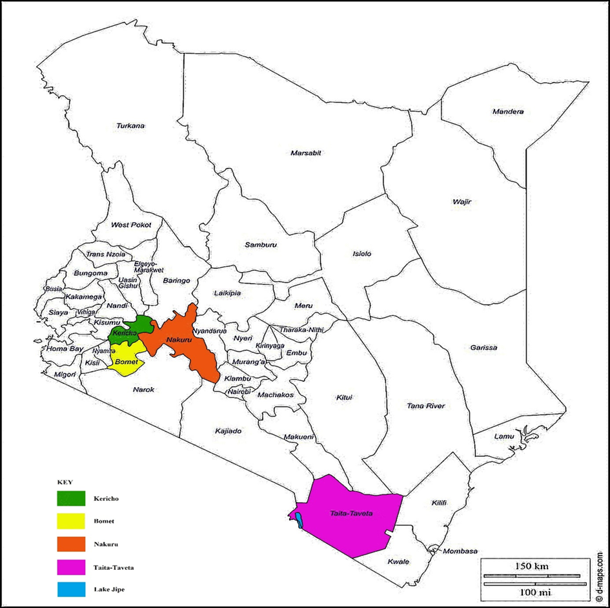

Figure 2. selected counties for study in Kenya.

# **3.2 Ethical clearance**

Ethical clearance was sorted from the Biosafety, Animal Use and Ethics Committee of the Faculty of Veterinary Medicine, University of Nairobi (UoN), National Commission for Science, Technology and Innovations and respective directors of fisheries and selected farmers from the two counties( REF: FVM BAUEC/2023/421).

# **3.3 Questionnaire administration**

A semi structured questionnaire with both closed and open-ended was prepared, pretested and administered to 88 fish farmers for the survey; Spread throughout the Kericho and Bomet counties in areas where numbers of fish farmers were high. The GPS coordinates of the selected farmers were recorded for follow up. Farmers were asked challenges they experience in fish farming, aquaculture practices they carry out and strategies they have put into place to maximum fish production. The questionnaires were complimented with direct observations. Which were used to identify risk factors linked to fish parasite and illness presence in study farms.

# **3.4 Study design and sample size**

A cross sectional study design involving visits of operational farms and recording of their GPS coordinates in the selected counties and also along the shores of Lake Jipe at Kenya Wildlife station, River Lumi inlet and Mukwanjuni beach was undertaken. In Taita taveta county; 10 *Oreochromis niloticus* was sampled in liner pond in Voi sub-county, 30 tilapia species were sampled in Mwatate sub-county in two earthen ponds. One pond having *Oreochromis niloticus* 10 fish were sampled and the second pond, ten (10) *Oreochromis jipe* and 10 hybrids of *Oreochromis jipe* and *Oreochromis niloticus* were sampled. In Wundanyi sub-county, 10 *Oreochromis jipe* was sampled in liner pond and finally the last sub- county in Taita Taveta was Taita sub-county where two earthen ponds were sampled. The first pond had a mixture of *Oreochromis jipe* and *Oreochromis niloticus* where 10 *Oreochromis jipe* and 6 *Oreochromis niloticus* were sampled and the second pond 10 *Oreochromis jipe* were sampled.

In Bomet county, study was done in Sotik sub-county. Where six ponds were selected. One concrete pond, two liner ponds and three earthen ponds. From each pond, 10 *Oreochromis niloticus* were sampled. Two sub-counties were selected in Kericho; Ainamoi and Belgut Sub-counties. In Ainamoi sub-county, out of five ponds selected, three were liner ponds and two earthen ponds. While in Belgut sub-county, three earthen ponds and one liner pond were selected. In every pond, 10 *Oreochromis niloticus* were sampled.

In Nakuru county, the study was done in six farms spread throughout Njoro and Rongai sub counties. Ten *Oreochromis niloticus* were sampled from tanks in a private hatchery and another 10 *Oreochromis niloticus* sampled from liner pond in Egerton university farm both in Njoro sub- county. The remaining four farms were in Rongai sub-county. Ten Nile tilapia were sampled in concreate pond in first Rongai farm. Fourteen, 16 and 10 *Oreochromis niloticus* were sampled in liner ponds second, third and fourth farms respectively.

On the shores of Lake Jipe in Taita Taveta county; 4 *Oreochromis jipe* were sampled at River Lumi inlet. Ten *Oreochromis niloticus* and 1 *Oreochromis jipe* at Kenya Wildlife Service station. At Mukwanjuni beach, 20 *Oreochromis jipe* were sampled.

The sample size was determined by utilizing the formula provided by Naing *et al* (2006).

n = z2 P (1-P)/L2, where n defined as sample size, Z is confidence interval = 1.96 for 95% confidence, P is prevalence of disease=86.5% (Florio *et al*., 2009), L is expected error = 0.05. Sample size =1.962×0.86 (1-0.14)/0.052 = 185. A total of 331 Tilapia fish were examined during the study.

# **3.5 Sample collection**

Purposive sampling techniques was used to choose the fish farms based on their distinctive qualities from the others. Fish from the ponds was harvested using seine nets and put in oxygenated bags with source pond water. Samples were taken Regional Veterinary Investigation Laboratories for examination of ectoparasites, tissue trematodes and gut endoparasites. Some samples transported to set up laboratories in Taveta, Wundanyi, Sotik and in Kericho and Nakuru counties. The remaining gut samples were removed and preserved in containers having 70% alcohol, stored in cool box and transported to University of Nairobi parasitology laboratory for detailed analysis of gastrointestinal parasites.

# **3.6 Necropsy and Parasitological examination**

Fish were humanely killed by giving a sharp blow on the cranium and pithed to separate the central nervous system from the spinal cord. They were weighed using a weighing machine to the nearest grams, standard length and full length were measured using a ruler to the nearest centimetres. After that, gross examination for presence of ectoparasites and pathological lesions like wounds/ulcers was done. Macroscopic and microscopic examination on the external surface of the gills and body surface was done for ectoparasites. Fresh mounts of the skin scrapings and gill filaments were collected on slides with saline and examined under the microscope (Woo 2006; Noga 2010). After that, each fish was laid on its side on the dissecting table. Eyes were removed and contents expressed on a slide and examined for eye flukes. A transverse incision was made anterior to the vent from which a longitudinal incision along the ventral midline was made up to the operculum. Another incision from the transverse one in an arc was made on the abdominal wall of the fish up to the upper corner of the operculum. The muscular flap was then removed by connecting the two incisions at the operculum. The peritoneal cavity and the organs were examined grossly for parasites and then separated. Intestinal contents were put on a slide with 0.64% saline and examined for endoparasites as described by Noga (2010) and Roberts (2012). The muscles of ﬁsh was also examined for existence of tissue parasites. Blood smear was done for haemoparasites (Noga, 2010). Gastrointestinal parasites were preserved in 70% alcohol for later identification at University of Nairobi, department of pathology, microbiology and parasitology using morphological characteristics as given by (Woo 2006; Noga, 2010; Roberts, 2012) . At the laboratory, stomach and intestines were put in a petri dish with saline, the contents expressed and examined under the dissecting microscope for parasites.

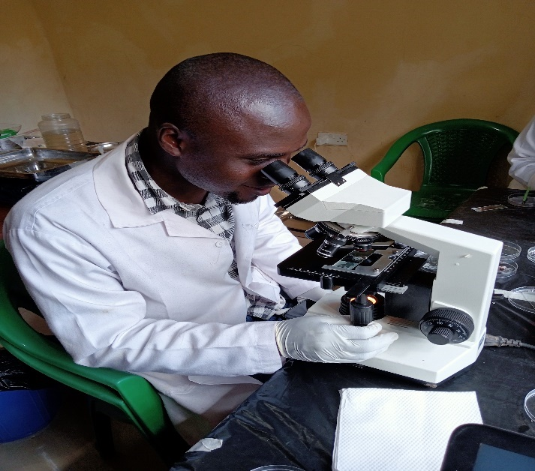

Figure 3.Investigator examining fish parasites under microscope

# **3.7 Water quality parameters**

Pond water quality was assessed in study farms in the morning hours before 10: am. A mobile waterproof HANNA Multiprobe meter (Hanna Instruments Inc., USA) was used to monitor water quality parameters such as pH, temperature, dissolved oxygen, conductivity (s/cm), and turbidity (Nephelometric Turbidity Units (NTU)) in each of the selected fish farms. Two (2) litres of pond water were collected for spectrophotometry chemical analysis for; phosphates, nitrites, nitrates and ammonia free nitrogen at Government Chemist, Nairobi.

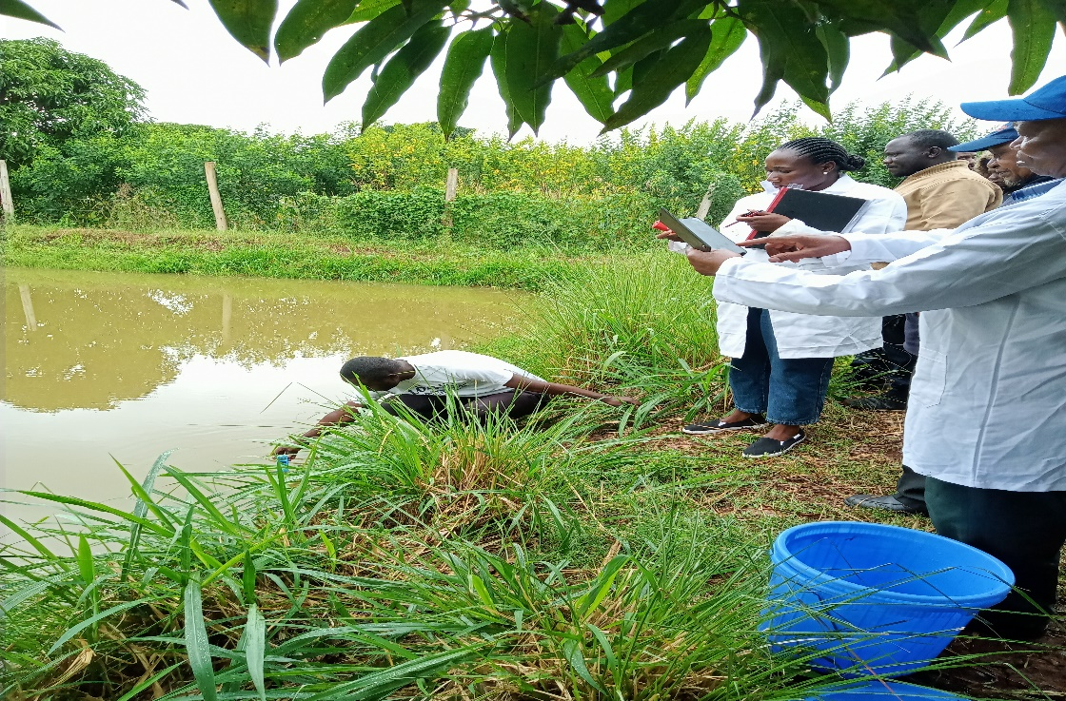

Figure 4.Investigator measuring some water quality in situ

# **3.8 Determination of fish condition factor**

The fish Fulton’s condition factor(k) was calculated by measuring the total length using a 30 cm ruler to the nearest centimetres, followed by weighing each fish by digital weighing machine to determine weight before dissecting. The length was measured from the tip of the mouth to the end of the tail fin in centimeters (cm) and the weight was measured in grams (g). The fish condition factor was calculated using Froese (2006) as shown in equation.

𝐾 =100𝑊/ 𝐿³

Where K is the condition factor, W is the weight of the fish in grammes (g), L is the total length of fish in centimetres (cm). After calculation, the resulting values of condition factor for each fish was compared with the standard values of Barnham and Baxter (1998) given in Table 1.

|  |  |
| --- | --- |
| K- Value | Condition of fish |
| 1.60 | Excellent |
| 1.40 | Good |
| 1.20 | Fair |
| 1.00 | Poor |
| 0.8 | Extremely poor |

Table 1.Fish condition factor

# **3.9 Data analysis**

Microsoft Excel was used to validate, enter, and save the collected data. The frequency, average amount, and average severity of infection as reported by Margolis *et al.* (1982) and Bush *et al.* was used to evaluate parasitic infections (1997). Statistical analysis was done using a Statistical software Program (Genstat Version 15) and significant treatment means was separated using Tukey’s test. The level of significance was set at P < 0.05. The correlation coefficient between various physico-chemical parameters and parasitic infections was determined using Pearson's correlation.

Parasitological variables of type, prevalence and mean intensities were collected for the fish parasites. Quantifying of parasites was done using prevalence and intensity as shown

in the following equations (Bush *et al*., 1997)

𝑃𝑟𝑒𝑣𝑎𝑙𝑒𝑛𝑐𝑒 (𝑃) =𝑁𝑢𝑚𝑏𝑒𝑟 𝑜𝑓 𝑓𝑖𝑠ℎ 𝑖𝑛𝑓𝑒𝑐𝑡𝑒𝑑 𝑤𝑖𝑡ℎ 𝑝𝑎𝑟𝑎𝑠𝑖𝑡𝑒𝑠 × 100

𝑇𝑜𝑡𝑎𝑙 𝑛𝑢𝑚𝑏𝑒𝑟 𝑜𝑓 𝑓𝑖𝑠ℎ 𝑐𝑜𝑙𝑙𝑒𝑐𝑡𝑒𝑑

𝑀𝑒𝑎𝑛 𝑖𝑛𝑡𝑒𝑛𝑠𝑖𝑡𝑦 =𝑇𝑜𝑡𝑎𝑙 𝑐𝑜𝑢𝑛𝑡 𝑜𝑓 𝑎 𝑠𝑝𝑒𝑐𝑖𝑓𝑖𝑐 𝑝𝑎𝑟𝑎𝑠𝑖𝑡e

𝑁𝑢𝑚𝑏𝑒𝑟 𝑜𝑓 𝑓𝑖𝑠ℎ 𝑖𝑛𝑓𝑒𝑐𝑡𝑒𝑑 𝑤𝑖𝑡ℎ 𝑡ℎ𝑎𝑡 𝑝𝑎𝑟𝑎𝑠𝑖𝑡e

# **CHAPTER FOUR RESULTS**

# **4.0 RESULTS**

## 4.1 Questionnaire survey

## **4.1.0 Social Demographic Characteristics**

### 4.1.1 Distribution of respondents and response rate

A total of 88 questionnaires were distributed unevenly throughout Kericho and Bomet counties in areas with high numbers of fish farmers. Investigator interviewed 33/88 fish farmers in Bomet and 55/88 fish farmers in Kericho with the help of respective fisheries officers during the study.

### **4.1.2 Gender of respondents**

Generally, the gender was skewed towards male in the overall study and in both counties.71/88 (81%) respondents in the study were male and only 17/88 (19%) of the respondents were female. In Kericho, 46/55 (84%) of the farmers interviewed were male and only 9/55 (16%) were female. The sex biased was also witnessed in Bomet where 25/33 (76%) respondents were male and only 8/33(24%) were female. Table 2 show the gender distribution. Most of the respondents were over 56 years .81% were directly involved in farm management while 19% were hired people to run fish farms. Over 60% have been in fish farming for more than 7 years though the area under aquaculture has been reducing day by day.

|  |  |  |  |  |  |  |  |  |  |
| --- | --- | --- | --- | --- | --- | --- | --- | --- | --- |
|  | | | | | | | | | |
| **Gender** | | **Overall study** | | | **Bomet** | | | **Kericho** | |
|  | **Numbers** | | **Percentages** | **Numbers** | | **Percentages** | **Numbers** | | **Percentages** |
| Male | 71 | | 81 | 25 | | 76 | 46 | | 84 |
| Female | 17 | | 19 | 8 | | 24 | 9 | | 16 |
| Total | 88 | | 100 | 33 | | 100 | 55 | | 100 |

Table 2.Distribution of respondents by gender in Kericho and Bomet counties

**4.1.3 Employment status of fish farmers**

More than three quarters of fish farmers interviewed in Bomet and Kericho; the main occupation is farming as per 75/88 (85%) of respondents. Employed people were 10/88 (11%) and business people were only 3/11(3.4%). Per county; in Kericho, 48/55 (87%) of respondents were farmers. 6/55 (11%) and 1/55 (1.8%) of the respondents were employed and business people respectively. In Bomet; 27/33 (82%), 4/33(12%) and 2/33 (6.1%) main occupation were farming, salaried and business people respectively.

|  |  |  |  |  |  |  |
| --- | --- | --- | --- | --- | --- | --- |
| **Occupation** | **Overall study** | | **Bomet** | | **Kericho** | |
|  | Numbers | Percentages | Numbers | Percentages | Numbers | Percentages |
| Farming | 75 | 85 | 27 | 82 | 48 | 87 |
| Salaried | 10 | 11 | 4 | 12 | 6 | 11 |
| Business | 3 | 3.4 | 2 | 6.1 | 1 | 1.8 |
| Total | 88 | 100 | 33 | 100 | 55 | 100 |

Table 3.Occupation of respondents per county

### **4.1.4 Education Level of respondents**

Only 11/88 (13%) of the respondents had no formal education. With Kericho having 8/55 (15%) and Bomet 3/33 (9.1%). Generally ;35/88 (40%) of respondents had attained secondary level of education. With Kericho having 24/55 (44%) and Bomet with 11/33 (33%). Farmers with college diploma were 16/88 (18%), with Bomet having the highest 11/33 (33%) of the respondents while Kericho had 5/55 (9.1%).8/88 (9.1%) of the respondents had undergraduate degree in different fields, Bomet had 4/33 (12) and Kericho also had 4/55 (7.3%). Only 3/88 (3.4%) of respondents had post graduate degree all of them came from Kericho county. 15/88 (17%) of people with formal education left at primary level. 4/33(12%) were from Bomet and the remaining 11/55 (20%) were from Kericho.

|  |  |  |  |  |  |  |
| --- | --- | --- | --- | --- | --- | --- |
| **Education level** | **Overall study** |  | **Bomet** |  | **Kericho** |  |
|  | **Numbers** | **Percentage** | **Numbers** | **Percentage** | **Numbers** | **Percentage** |
| No formal education | 11 | 13 | 3 | 33 | 8 | 55 |
| Primary | 15 | 17 | 4 | 12 | 11 | 20 |
| Secondary | 35 | 40 | 11 | 33 | 24 | 44 |
| Diploma | 16 | 18 | 11 | 33 | 5 | 9.1 |
| Under graduate degree | 8 | 9.1 | 4 | 12 | 4 | 7.3 |
| Post graduate degree | 3 | 3.4 | 0 | 0 | 3 | 5.5 |
| **Total** | 88 | 100 | 33 | 100 | 55 | 100 |

Table 4.Level of education of respondents

## **4.2.0 Fish farming**

### **4.2.1 Purpose for doing fish farming**

More than half of the respondents; 58/88 (66%) started fish for subsistence reasons. With Kericho having 35/55 (64%) and Bomet with 23/33 (70%). 27% of the respondents (24/88) ventured into fish farming for business purposes. With Kericho having 16/55 (29%) and Bomet with 8/33(24%). 3/88 (3.4%) of the total respondents, 1/33(3%) and 2/55 (3.6) started fish farming as a hobby and for education.

|  |  |  |  |  |  |  |
| --- | --- | --- | --- | --- | --- | --- |
| **Farming purpose** | **Overall study** | | **Bomet** | | **Kericho** | |
|  | Numbers | Percentages | Numbers | Percentages | Numbers | Percentages |
| Business | 24 | 27 | 8 | 24 | 16 | 29 |
| Education | 3 | 3.4 | 1 | 3 | 2 | 3.6 |
| Hobby | 3 | 3.4 | 1 | 3 | 2 | 3.6 |
| Subsistence | 58 | 66 | 23 | 70 | 35 | 64 |
| **Total** | 88 | 100 | 33 | 100 | 55 | 100 |

Table 5.Purpose for doing fish farming

### **4.2.1 Holding system for cultured fish**

64% of respondents (56/88) reared fish on earthen pond. 20 /33 (61%) were in Bomet county and 36/55 (65%) in Kericho. 26% (23/88) of respondent were doing fish farming in liner pond; 9/33 (27%) in Bomet and 14/55 (25%) in Kericho. Seven respondents were doing fish farming in concrete pond; where 3/33(9.1) were from Bomet and 4 /55(7.3%) were from Kericho. Only 1/88 (1.1%) was practicing aquaponic and was from Bomet county 1/33 (3%). Fish farming in liner pond under green house had 1/88(1.1%) of the respondent from Kericho 1/55 (1.8%).

|  |  |  |  |  |  |  |
| --- | --- | --- | --- | --- | --- | --- |
| **Holding system** | **Overall study** | | **Bomet** | | **Kericho** | |
|  | **Numbers** | **Percentages** | **Numbers** | **Percentages** | **Numbers** | **Percentages** |
| Concrete | 7 | 8 | 3 | 9.1 | 4 | 7.3 |
| Earthen | 56 | 64 | 20 | 61 | 36 | 65 |
| Liner pond | 23 | 26 | 9 | 27 | 14 | 25 |
| Liner(greenhouse) | 1 | 1.1 | 0 | 0 | 1 | 1.8 |
| Aquaponics | 1 | 1.1 | 1 | 3 | 0 | 0 |
| **Total** | 88 | 100 | 33 | 100 | 55 | 100 |

Table 6.Fish holding systems in Bomet and Kericho county

### **4.2.3 Fish species cultured**

95% of the farmers (84/88) interviewed were farming Nile tilapia. 32/33 (97%) in Bomet while 52/55 (95%) in Kericho. 3.4% (3/88) of the respondents were practicing polyculture of tilapia and catfish, all of the 3/55 (5.5%) farmers were from Kericho. Only 1.1% (1/88) were farming catfish and the respondent 1/33 (3%) was from Bomet county.

|  |  |  |  |  |  |  |
| --- | --- | --- | --- | --- | --- | --- |
| **Fish species** | **Overall Study** |  | **Bomet** |  | **Kericho** |  |
|  | **Numbers** | **Percentages** | **Numbers** | **Percentages** | **Numbers** | **Percentages** |
| Catfish | 1 | 1.1 | 1 | 30 | 0 | 0 |
| Tilapia | 84 | 95 | 32 | 97 | 52 | 95 |
| Tilapia/catfish | 3 | 3.4 | 0 | 0 | 3 | 5.5 |
| Total | 88 | 100 | 33 | 100 | 55 | 100 |

Table 7.Fish species cultured

### **4. 2. 4 The sex of the cultured fish**

53% of the respondents (47/88) were farming sexually reversed male tilapias. 30/33(91%) of the sex reversed tilapia were from Bomet and 17/55 (31%) in Kericho. This was followed by mixed sex tilapia 39/88 (44%). The latter, mostly were from Kericho which had 36/55 (65%) and Bomet 3/33 (9.1%). 2/88 (2.3%) of farmers faced with prolific breeding of tilapias were doing polyculture with catfish and all of them were from Kericho.

|  |  |  |  |  |  |  |
| --- | --- | --- | --- | --- | --- | --- |
| **Fish sex** | **Overall study** | | **Bomet** | | **Kericho** | |
|  | Numbers | Percentages | Numbers | Percentages | Numbers | Percentages |
| Tilapia mixed sex | 39 | 44 | 3 | 9.1 | 36 | 65 |
| Tilapia Monosex | 47 | 53 | 30 | 91 | 17 | 31 |
| Tilapia mixed sex and catfish | 2 | 2.3 | 0 | 0 | 2 | 3.6 |
| Total | 88 | 100 | 33 | 100 | 55 | 100 |

Table 8.The sex of the cultured fish

## **4.3.0 Pond characteristics**

### **4.3.1 Pond size and location**

The average pond size in the study area was 220m2 . Kericho had an average pond area of 234m2 and Bomet 196m2 . In terms of location, 47% (41/88) of farmers located their ponds in the valley. 11/33 (33%) in Bomet and 30/55(55%) in Kericho.8/88 (9.1%) of farmers located their ponds to adjacent agricultural land. 1/33 (3%) in Bomet and 7/55(13%) in Kericho. One respondent (1/88;1.1%) from Kericho (1/55;1.8%) dug pond along the road. 2/33 (6.1%) of farmers in Bomet dug ponds in grazing farms. 2/88 (2.3%) of the respondent dug pond in a swampy area and was from Kericho 2/55(3.6%). 31/88 (35%) of the respondents had ponds in residential areas. Bomet having 17/33(52%) and Kericho 14/55 (25%) of the respondents. 1/88(1.1%) of the respondent had a pond in a rice field and was from Bomet 1/33(3%).1/88 (1.1%) of the respondent constructed a pond inside greenhouse and was from Bomet 1/33(3%).1/88(1.1%) of the respondent from Kericho1/55(1.1%) had a pond within school compound.

|  |  |  |  |  |  |  |
| --- | --- | --- | --- | --- | --- | --- |
| Pond Location | Overall Study | | Bomet | | Kericho | |
|  | Numbers | Percentages | Numbers | Percentages | Numbers | Percentages |
| Agricultural land | 8 | 9.1 | 1 | 3 | 7 | 13 |
| Along the road | 1 | 1.1 | 0 | 0 | 1 | 1.8 |
| Grazing farms | 2 | 2.3 | 2 | 6.1 | 0 | 0 |
| Swamps | 1 | 1.1 | 0 | 0 | 1 | 1.8 |
| Residential areas | 31 | 35 | 17 | 52 | 14 | 25 |
| Rice field | 1 | 1.1 | 1 | 3 | 0 | 0 |
| School compound | 1 | 1.1 | 0 | 0 | 1 | 1.8 |
| Green house | 1 | 1.1 | 1 | 3 | 0 | 0 |
| Valley | 41 | 47 | 11 | 33 | 30 | 55 |
| Wetland | 1 | 1.1 | 0 | 0 | 1 | 1.8 |
| Total | 88 | 100 | 33 | 100 | 55 | 100 |

Table 9.Pond location

### **4.3.2 Pond purpose**

99% (87/88) of farmers were using ponds for rearing fish for consumption, hobby or business. Only 1 person (1.1%) had hatchery and was from Kericho 1/55 (1.8%).

|  |  |  |  |  |  |  |
| --- | --- | --- | --- | --- | --- | --- |
| **Pond Purpose** | **Overall study** | | **Bomet** | | **Kericho** | |
|  | Numbers | Percentages | Numbers | Percentages | Numbers | Percentages |
| Production | 1 | 1.1 | 0 | 0 | 1 | 1.8 |
| Rearing | 87 | 99 | 33 | 100 | 54 | 98 |
| Total | 88 | 100 | 33 | 100 | 55 | 100 |

Table 10.Pond purpose

### **4.3.3 Pond active status**

92% (81/88) farmers were using ponds throughout the year. 31/33(94%) from Bomet and 50/55(91%) from Kericho. Whereas 7/88(8%) of farmers were fully depending on rain water during rainy season. 2/33 (6.1%) from Bomet and 5/55 (9.1%) were from Kericho.

|  |  |  |  |  |  |  |
| --- | --- | --- | --- | --- | --- | --- |
| **Pond active statis** | **Overall study** | | **Bomet** | | **Kericho** | |
|  | Numbers | Percentages | Numbers | Percentages | Numbers | Percentages |
| Rainy season | 7 | 8 | 2 | 6.1 | 5 | 9.1 |
| Throughout year | 81 | 92 | 31 | 94 | 50 | 91 |
| Total | 88 | 100 | 33 | 100 | 55 | 100 |

Table 11.Pond active status

## **4.4.0 Seed characteristics**

### **4.4.1 Source of fish seeds**

82/88 (93%) of the respondents were sourcing seeds from hatcheries. 32/33 (97%) in Bomet and 50/55(91%) in Kericho. Only 6/88 (7%) of the farmers interviewed were sourcing seeds locally from other farmers. With Kericho leading with 5/55(9.1%) and Bomet having 1/33 (3%).

|  |  |  |  |  |  |  |
| --- | --- | --- | --- | --- | --- | --- |
| **Seed source** | **Overall study** | | **Bomet** | | **Kericho** | |
|  | Numbers | Percentages | Numbers | Percentages | Numbers | Percentages |
| Hatchery | 82 | 93 | 32 | 97 | 50 | 91 |
| Local farmers | 6 | 7 | 1 | 3 | 5 | 9.1 |
| Total | 88 | 100 | 33 | 100 | 55 | 100 |

Table 12.Source of seed

## **4.5.0 Pond water characteristics**

### **4.5.1 Water source for fish farming**

Most of fish farmers 46/88(52%) were drawing water for ponds from rivers. 13/33 (39%) in Bomet and 33/55 (60%) in Kericho. 12/88 (14%) depended on underground water; 1/33(3%) in Bomet and 11/55 (20%) in Kericho.10/88 (11%) used rain water to fill their ponds; 5/33(15%) in Bomet and 5/55(9.1%) in Kericho. Borehole water was used by 4/88 (4.5%) of farmers; 1/33(3%) from Bomet and 3/55 (5.5%) from Kericho. Water pan, dam, house hold water and swamp each supplied water to 1/88 (1.1%) of the farmers all were from Bomet (1/33;3%). 2/88(2.3%) of the farmers used spring water. 1/33 (3%) from Bomet and 1/55 (1.8%) from Kericho. 5/88(5.7%) of farmers drew water from taps.3/33 (9.1%) in Bomet and 2/55(3.6%) in Kericho. 5.7%(5/88) of the interviewed farmers used well water for fish farming and all 5/33(15)were from Bomet county.

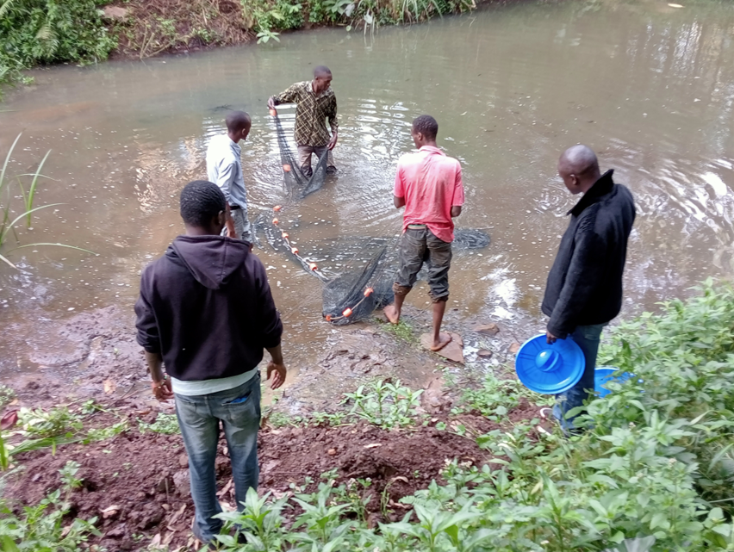

Figure 5.Earthen Pond receiving water from the river

|  |  |  |  |  |  |  |
| --- | --- | --- | --- | --- | --- | --- |
| **Water source** | **Overall study** |  | **Bomet** |  | **Kericho** |  |
|  | Numbers | Percentages | Numbers | Percentages | Numbers | Percentages |
| Borehole | 4 | 4.5 | 1 | 3 | 3 | 5.5 |
| Dam | 1 | 1.1 | 1 | 3 | 0 | 0 |
| Household water | 1 | 1.1 | 1 | 3 | 0 | 0 |
| Rain water | 10 | 11 | 5 | 15 | 5 | 9.1 |
| River | 46 | 52 | 13 | 39 | 33 | 60 |
| Spring | 2 | 2.3 | 1 | 3 | 1 | 1.8 |
| Swamp | 1 | 1.1 | 1 | 3 | 0 | 0 |
| Tap water | 5 | 5.7 | 3 | 9.1 | 2 | 3.6 |
| Underground water | 12 | 14 | 1 | 3 | 11 | 20 |
| Water pan | 1 | 1.1 | 1 | 3 | 0 | 0 |
| Well | 5 | 5.7 | 5 | 15 | 0 | 0 |
| **Total** | 88 | 100 | 33 | 100 | 55 | 100 |

Table 13.Water source

### **4.5.2 Water flowing through ponds**

Out of 88 farmers interviewed, 17 (19%) had water flowing through ponds. Bomet had 8/33 (24%) farmers and Kericho had 9/55(16%). However, the flow of water was intermittent whereas some ponds having flowing water throughout the year while some in specific months.15/17 ponds had water flowing throughout the year. 7 in Bomet and 8 in Kericho. In the month of January to February, only one pond had water flowing through, this was in Bomet while between March and May also another one pond in Kericho had water flowing through.

|  |  |  |  |  |  |  |
| --- | --- | --- | --- | --- | --- | --- |
| **Water flowing through ponds** | **Overall study** | | **Bomet** | | **Kericho** | |
| **Months** | Numbers | Percentages | Numbers | Percentages | Numbers | Percentages |
| All months | 15 | 88 | 7 | 87.5 | 8 | 89 |
| January-February | 1 | 5.9 | 1 | 12.5 | 0 | 0 |
| March-May | 1 | 5.9 | 0 | 0 | 1 | 11 |
| **Total** | **17** | **100** | **8** | **100** | **9** | **100** |

Table 14.Water flowing through ponds

### **4.5.3** **Water flowing through agricultural land before emptying into ponds**

90% (79/88) farmers did not have water flowing through agricultural land before emptying into their ponds. 29/33(88%) of the farmers were in Bomet while 50/55 (91%) were in Kericho. 7/88 (8%) farmers were feeding their ponds with water flowing from other ponds. 2/33(6.1%) were from Bomet while 5/55 (9.1%) were from Kericho. Only 1/88 farmer got their water flowing through from swamps and vegetations and all from Bomet before emptying into their ponds.

|  |  |  |  |  |  |  |
| --- | --- | --- | --- | --- | --- | --- |
| **Water flowing** | **Overall study** | | **Bomet** | | **Kericho** | |
|  | Numbers | Percentages | Numbers | Percentages | Numbers | Percentages |
| Vegetation | 1 | 1.1 | 1 | 3 | 0 | 0 |
| Ponds | 7 | 8 | 2 | 6.1 | 5 | 9.1 |
| Swamps | 1 | 1.1 | 1 | 3 | 0 | 0 |
| Water does not flow into ponds | 79 | 90 | 29 | 88 | 50 | 91 |
| Total | 88 | 100 | 33 | 100 | 55 | 100 |

Table 15.Water flowing through agricultural land before emptying into ponds

### **4.5.4 Pond drainage**

Only 1/88(1.1%) farmer was not draining the pond. Water was leaving the pond through horizontal water seepage, this was in Kericho (1/55;1.8%). Majority of farmers 56/88 (64%) were draining their ponds into nearby agricultural lands. Bomet having 25/88 (76%) while Kericho having 31/88 (56%) of farmers. This was followed by farmers (24/88;27%) who were draining their ponds in rivers. Kericho leading in numbers by 17/55 (31%) and Bomet 24/33 (27%). Farmers draining their ponds in grassland and other ponds were two each. Both from Kericho county. 2/88(2.3%) farmers were to be draining into swamps with Kericho and Bomet producing one each.1/88(1.1%) was found to be draining the ponds along the road, and was from Kericho.

|  |  |  |  |  |  |  |
| --- | --- | --- | --- | --- | --- | --- |
| Pond drainage | Overall study | | Bomet | | Kericho | |
|  | Frequency | Percentages | Numbers | Percentages | Numbers | Percentages |
| Agricultural land | 56 | 64 | 25 | 76 | 31 | 56 |
| Grassland | 2 | 2.3 | 0 | 0 | 2 | 3.6 |
| Other ponds | 2 | 2.3 | 0 | 0 | 2 | 3.6 |
| River | 24 | 27 | 7 | 21 | 17 | 31 |
| Roads | 1 | 1.1 | 0 | 0 | 1 | 1.8 |
| Swamps | 2 | 2.3 | 1 | 3 | 1 | 1.8 |
| Water seepage | 1 | 1.1 | 0 | 0 | 1 | 1.8 |
| Total | 88 | 100 | 33 | 100 | 55 | 100 |

Table 16.Pond drainage

## **4.6.0 Pond water characteristics**

### **4.6.1 Water quality**

During the study 67% (22/33) of farmers in Bomet and 53% (29/55) in Kericho believed that water quality is influenced by water source. And they all thought river water was the most suitable for fish farming because of phytoplanktons and high volume of water. Majority of farmers were not monitoring water quality. For instance, in Kericho all farmers 55/55 (100%) do not monitor water quality and in Bomet 70% (23/33). The remaining 10/33(30%) farmers in Bomet were monitoring ponds to check the level of pond fertilization with only one of them checking even water temperature.

## **4.7.0 Water shortage and floods**

### **4.7.1 Water shortage**

Water shortage was not a major problem facing fish farmers in Kericho. 75/88 (85%) had sufficient water for fish farming, 30/33 (90%) in were found Bomet and 45/55 (82%) in Kericho. However, the remaining 15% (13/88) of farmers admitted to be facing water shortage especially during the month of November to march,3/33(9.1%) in Bomet and 10/55 (18%) in Kericho.

### **4.7.2 Challenges of floods**

14% (12/88) of farmers we experiencing floods during fish farming. Which led to farmers having challenges like 4/88 (4.5%) escape of fish from the ponds.1/33(3%) In Bomet and 3/55(5.5%) in Kericho. Floods also introduced predators like monitor lizards in ponds of 5/88 (5.7%) farmers. 1/33 (3%) in Bomet and 4/55(7.3%) in Kericho. Outbreak of diseases were also witnessed by 3/88 (3.4%) of the farmers, 1/33(3%) in Bomet and 2/55 (3.6%) in Kericho.

|  |  |  |  |  |  |  |
| --- | --- | --- | --- | --- | --- | --- |
| **Effect of floods** | **Overall study** | | **Bomet** | | **Kericho** | |
|  | Numbers | Percentages | Numbers | Percentages | Numbers | Percentages |
| No floods | 76 | 86 | 30 | 91 | 46 | 84 |
| Fish escape | 4 | 4.5 | 1 | 3 | 3 | 5.5 |
| Introduced predators | 5 | 5.7 | 1 | 3 | 4 | 7.3 |
| Outbreak of diseases | 3 | 3.4 | 1 | 3 | 2 | 3.6 |
| Total | 88 | 100 | 33 | 10 | 55 | 100 |

Table 17.Effect of floods

## **4.8.0 Pond management practices**

### **4.8.1** **Draining ponds harvesting**

Most of farmers were able to drain their pond with ease during harvesting in both Bomet and Kericho counties, 26/33 In Bomet (79%) and 54/55 (98%) in Kericho. However, 7/33(21%) of farmers in Bomet and 1/55 (1.8%) farmer in Kericho had difficulties in draining their ponds.

|  |  |  |  |  |
| --- | --- | --- | --- | --- |
| Draining pond | Bomet | | Kericho | |
|  | Numbers | Percentages | Numbers | Percentages |
| Able | 26 | 79 | 54 | 98 |
| Not able | 7 | 21 | 1 | 1.8 |
| **Total** | 33 | 100 | 55 |  |

Table 18.Draining ponds harvesting

### **4.8.2** **Drying and cleaning ponds before ponds before restocking**

33/88(38%) of the farmers were cleaning and drying their ponds frequently before restocking. With Kericho having 21/55 (38%) of farmers and Bomet having 12/33 (36%) of their farmers. A good number of farmers 24/88 (27%) were cleaning and drying their ponds but not frequent before restocking. These was witnessed in Kericho were 15/55 (27%) of their farmers were drying and cleaning the ponds before stocking but not frequent. In Bomet 9/33 (27%) of farmers were also doing the same. A farmer (1/88) has never dried or cleaned ponds before restocking. Another farmer only dried and cleaned pond during first stocking. A good number of farmers 29/88 (33%) rarely dry and clean their ponds before restocking. 10/33(30%) were in Bomet and 19/55 (35%) were in Kericho.

|  |  |  |  |  |  |  |
| --- | --- | --- | --- | --- | --- | --- |
| **Drying and cleaning ponds before restocking** | **Overall study** |  | **Bomet** |  | **Kericho** |  |
|  | Numbers | Percentages | Numbers | Percentages | Numbers | Percentages |
| First stocking | 1 | 1.1 | 1 | 3 | 0 | 0 |
| Never | 1 | 1.1 | 1 | 3 | 0 | 0 |
| Rarely/Never | 29 | 33 | 10 | 30 | 19 | 35 |
| Yes, sometimes | 24 | 27 | 9 | 27 | 15 | 27 |
| Yes, often | 33 | 38 | 12 | 36 | 21 | 38 |
| **Total** | **88** | **100** | **33** | **100** | **55** | **100** |

Table 19.Drying and cleaning ponds before ponds before restocking

### **4.8.4** **Removing Pond bottom after harvesting**

A good percentage (34%;30/88) of farmers do not remove the pond bottom after harvesting.12/33 (36%) were in Bomet and 18/55 (33%) were in Kericho. One farmer from Bomet had intent of removing pond bottom after harvesting. 32% (28/88) of farmers were removing pond bottom routinely after harvesting the fish. 9/33(27%) were from Bomet and 19/55(35%) were from Kericho.29/88(33%) of the farmers were removing pond bottom but not routinely. 11/33(33%) were from Bomet and 18/55 (33%) were from Kericho.

|  |  |  |  |  |  |  |
| --- | --- | --- | --- | --- | --- | --- |
| **Removing pond bottom** | **Overall study** | | **Bomet** | | **Kericho** | |
|  | Numbers | Percentages | Numbers | Percentages | Numbers | Percentages |
| Never | 30 | 34 | 12 | 36 | 18 | 33 |
| Not yet | 1 | 1.1 | 1 | 3 | 0 | 0 |
| Yes, each time | 28 | 32 | 9 | 27 | 19 | 35 |
| Yes, sometimes | 29 | 33 | 11 | 33 | 18 | 33 |
| Total | 88 | 100 | 33 | 100 | 55 | 100 |

Table 20.Removing Pond bottom after harvesting

## **4.9.0 Type of feeds and feeding rates**

### **4.9.1 Fish feed type**

Half 45/88 (51%) of the farmers were feeding their fish using commercial feeds. 20/33 (61%) of them were from Bomet and 25/55 (45%) were in Kericho.3.4% (3/88) of farmers were using omena dust and kales for feeding fish. 2/33 (6.1%) in Bomet and 1/55(1.8%) in Kericho. Poultry feeds were used 2.3% (2/88) of farmers and all were from Kericho 2/55 (3.6%). 17% (15/88) of farmers depended rice/wheat bran and husk. 8/33 (24%) were from Bomet and 7/55 (13%) from Kericho. 3.4% (3/88) used vegetables and ugali to feed fish. 2/88 farmers were using weeds and duckweed to feed fish. Fresh shrimp locally named as Ochong’aa were 11/88 (13%) of farmers to feed fish.3/55 (9.1%) in Bomet and 8/55 (15%) in Kericho. 8% (7/88) of farmers were not feeding their fish at all, and were from Kericho county.

|  |  |  |  |  |  |  |
| --- | --- | --- | --- | --- | --- | --- |
| **Feed type** | **Overall study** | | **Bomet** | | **Kericho** | |
|  | Numbers | Percentages | Numbers | Percentages | Numbers | Percentages |
| Commercial feeds | 45 | 51 | 20 | 61 | 25 | 45 |
| Omena dust and kales | 3 | 3.4 | 2 | 6.1 | 1 | 1.8 |
| No feeding | 7 | 8 | 0 | 0 | 7 | 13 |
| Poultry feeds | 2 | 2.3 | 0 | 0 | 2 | 3.6 |
| Vegetables and ugali | 3 | 3.4 | 0 | 0 | 3 | 5.5 |
| Rice/wheat bran and husk | 15 | 17 | 8 | 24 | 7 | 13 |
| Weeds, duckweed | 2 | 2.3 | 0 | 0 | 2 | 3.6 |
| Ochong’aa | 11 | 13 | 3 | 9.1 | 8 | 15 |
| **Total** | **88** | **100** | **33** | **100** | **55** | **100** |

Table 21.Fish feed type

### 4.9.2 Feeding rates

Most 46/88 (52%) of the farmers were feeding their fish twice a day.21/33 (64%) of them were in Bomet and 25/55 (45%) were in Kericho. This was followed by 32% (28/88) of farmers who were feeding fish onces.11/33(33%) were from Bomet and 17/88 (31%) from Kericho. Only one farmer was feeding fish four times a week. 8% (7/88), all from Kericho were not feeding fish. 6.8% (6/88) of farmers were feeding their fish less frequently.

|  |  |  |  |  |  |  |
| --- | --- | --- | --- | --- | --- | --- |
| **Feeding rates** | **Overall study** | | **Bomet** | | **Kericho** | |
|  | Numbers | Percentages | Numbers | Percentages | Numbers | Percentages |
| Four times | 1 | 1.1 | 1 | 3 | 0 | 0 |
| Less frequently | 6 | 6.8 | 0 | 0 | 6 | 11 |
| Never | 7 | 8 | 0 | 0 | 7 | 13 |
| Once | 28 | 32 | 11 | 33 | 17 | 31 |
| Twice | 46 | 52 | 21 | 64 | 25 | 45 |
| **Total** | **88** | **100** | **33** | **100** | **55** | **100** |

Table 22.Feeding rates

**4.9.3 Feed shortage**

Only 20/88 farmers had enough fish feed. The remaining 58/88 farmers had challenges of getting quality, quantity and affordable feeds. 88% (51/58) of farmers with feeds challenges were having the problem throughout production cycle. Majority of them came from Kericho 44/46 (92%), Bomet had 7/10 (70%). Small percentage (12%;7/51) of farmers with feed problem only during the period of December to March. 3/10 (30%) in Bomet and 4/48 (8%) in Kericho.

### **4.10 Manuring ponds**

73/88 farmers were using manure to increase pond production. However, they were using different types of manures in different forms. 81% (59/73) were using cattle manure. 25/30(83%) were from Bomet and 34/43 (79%) were from Kericho. Only one farmer from Bomet was using DAP and another one farmer was from Kericho was using pig. 16% (12/73) were using poultry manure. 4/30 (13%) in Bomet and 8/43 (19%) in Kericho.67/73(91%) were using manure in dry form.27/30 were from Bomet and 40/43 were from Kericho. There remaining 6 farmers were using wet manures. 3/30 in Bomet and 3/43 in Kericho.

|  |  |  |  |  |  |  |
| --- | --- | --- | --- | --- | --- | --- |
| **Manure** | **Overall study** | | **Bomet** | | **Kericho** | |
|  | Numbers | Percentages | Numbers | Percentages | Numbers | Percentages |
| Cattle | 59 | 81 | 25 | 83 | 34 | 79 |
| DAP | 1 | 1.4 | 1 | 3.3 | 0 | 0 |
| Pig | 1 | 1.4 | 0 | 0 | 1 | 2.3 |
| Poultry | 12 | 16 | 4 | 14 | 8 | 19 |
| **Total** | **73** | **100** | **30** | **100** | **43** | **100** |

Table 23.Types of manure

## **4.11 Integration**

16% (14) of farmers integrated fish farming with cattle and poultry. 8/14 were farming fish with poultry, all were from Bomet county. The remaining farmers farmed fish with cattle.4/6 from Kericho and 2/6 from Bomet.

This need to be another chapter

# **5.0 Fish Sampling**

331 tilapias were sampled from farms spread throughout four counties and from lake Jibe. Those from aquaculture were; 60 tilapias in Bomet, 90 in Kericho, 70 in Nakuru and 76 in Taita Taveta county. Additional 35 tilapias were sampled from the lake Jipe in Taita Taveta county. The 296 were farmed in different holding systems. Of these, 20 (6.78%) were from concrete ponds,140 (47.46%) from liner ponds, 125 (42.37%) from earthen ponds and 10 (3.38%) from tanks.

## **5.1 Farmed fish parasites per county**

Out of 296 farmed examined during the study, 41.22% (122/296) were infected with either one or more parasites. The prevalence of parasitic infections was different in different counties.

In Taita Taveta county, 35 out of 76 fish were positive making an overall prevalence of 46.05%; mean intensity of 3.86 and parasite abundance of 1.8. Five genera of parasites were found and a total of 135 parasites were observed.

In Bomet county, 20 out of 60 fish were positive showing a prevalence rate of 33.33%; mean intensity of 3.3 and parasite abundance of 1.1. Eight (8) genera of parasites and a total 66 parasites recovered.

In Kericho county, 44 of 90 fish were positive showing a prevalence rate of 48.89%; mean intensity of 10.93 and parasite abundance of 5.34. A total of 481 fish parasites in 9 genera were recovered. In Nakuru county, 23 out of 70 fish were positive. A prevalence rate of 32.86%; mean intensity of 7.13 and parasite abundance of 2.34.

### **5.1.2 Prevalence, mean intensity and parasite abundance per county in farmed Tilapia**

During the study, the following parasites were found. Protozoan parasites; *Trichodina* spp, *Riboscyphidia* spp, *Epistylis* spp and *Paramecium* spp.; Nematodes; Camallanus spp, Paracamallanus spp and Contracaecum spp.; Digenea trematode; *Diplostomum* spp and *Euclinostomum* spp.; Monogea trematode; *Gyrodactylus* spp and *Dactylogyrus* spp.; Crustaceans there were copepods; and *Acanthocephalus* spp were also found. There mean intensities, prevalence and abundance varied per county.

In Bomet county; *Dactylogyru*s spp had prevalence of 15.15 % (10/66), mean intensity of 1.67 (10/6) and abundance of 0.17 (10/60). *Camallanus* spp prevalence was 3.03% (2/66), arithmetic mean intensity of 2(2/1) and abundance of 0.03 (2/60). Prevalence of *Epistylis* spp was 21.21% (14/66), arithmetic mean intensity of 4.67(14/3) and abundance 0.23 (14/60). Copepods; prevalence was 3.03% (2/66), arithmetic mean intensity of 2(2/1) and abundance of 0.03 (2/60). *Riboscyphidia* spp the prevalence was 30.30% (20/66), arithmetic mean intensity of 4(20/5) and abundance of 0.33 (20/60). *Paramecium* spp had a prevalence of 1.67 (1/66), arithmetic mean of 1(1/1) and abundance of 0.02 (1/60). *Tichodina* spp prevalence was 9.1% (6/66), arithmetic mean intensity of 1.2 (6/5) and *Paracamallanus* spp prevalence was 16.77% (11/66), arithmetic mean of 5.5 (11/2) and abundance of 0.18 (11/60).

Nine (9) parasite genera were found in Kericho county. *Contracaecum* spp had a prevalence of 0.62% (3/481), arithmetic mean intensity of 1.5 (3/2) and with abundance of 0.01 (3/90). *Diplostomum* spp had a prevalence 2.91% (14/481), arithm*et*ic mean intensity of 4.67(14/3) with abundance of 0.16 (14/90). *Dactylogyrous* spp was prevalence was 20.17% (97/481), arithmetic mean intensity of 3.73 (97/26) with abundance 1.08 (97/90). *Riboscyphidia* spp prevalence was 33.68% (162/481), arithmetic mean intensity of 32.4(162/5) with abundance of 1.8 (162/90). *Epistylis* spp prevalence was 26.40% (127/481), arithmetic mean intensity 15.88 (127/8) with abundance 1.41 (127/90). *Camallanus* spp prevalence was 1.04% (5/481), arithm*e*tic mean intensity of 2.5 (5/2) and abundance 0.06 (5/90). The prevalence of *Paracamallanus* spp was 12.89% (62/481) with arithmetic mean intensity 12.4 (62/5) and abundance 0.69 (62/90). *Trichodina* spp prevalence was 1.87% (9/481) with a mean intensity of 3 (9/3) and abundance 0.1(9/90). Lastly, *Paramecium* spp prevalence was 0.42% (2/481) with arithmetic mean intensity of 1 (2/2) and abundance of 0.02 (2/90).

Seven (7) genera of parasites were found in Nakuru county. *Tichodina* spp had the highest prevalence 49.39% (81/164) with arithmetic mean intensity of 10.13 (81/8) and abundance 1.16 (81/70). Prevalence of *Euclinostomum* spp was 34.15% (56/164), arithm*et*ic mean intensity of 11.2 (56/5) and abundance0.8 (56/70). *Camallanus* spp prevalence was 1.22% (2/164), arithmetic mean intensity of 2 (2/1) with abundance of 0.03 (2/70). *Diplostomum* spp the prevalence was 7.93% (13/164), arithmetic mean intensity 2.6 (13/5) and abundance of 1.89 (13/70). *Dactylogyrous* spp prevalence was 4.88% (8/164), arithmetic mean intensity 2.7 (8/3) and abundance 0.114 (8/70). *Acanthocephalu*s spp prevalence was 1.22% (2/164), arithmetic mean intensity 1 (2/2) and abundance 0.03 (2/70). And the parasite genera in Nakuru was *Contracaecum* spp with a prevalence 1.22% (2/164), arithmetic mean intensity 1 (2/2) and abundance 0.03 (2/70).

In Taita Taveta county, five genera of parasites were found. *Acanthocephalus* spp had the highest prevalence of 60% (81/135), with arithmetic mean intensity of 4.05 (81/20) and abundance of 1.08 (81/75). *Dactylogyrous* spp had a prevalence 14.81%, arithmetic mean intensity of 2 (20/10) and abundance 0.27 (20/75). *Diplostomum* spp the prevalence was 23.70% (32/135), arithmetic mean intensity 2.67 (32/12) and abundance 0.43 (32/75). *Euclinostomum* spp, prevalence was 0.74% (1/135), arithmetic mean intensity 1 (1/1) with abundance 0.013 (1/135). The last genus was *Gyroductylus* spp; prevalence was 0.74% (1/135), arithmetic mean intensity 1 (1/1) with abundance 0.013 (1/135).

Figure 6 Prevalence plots across counties

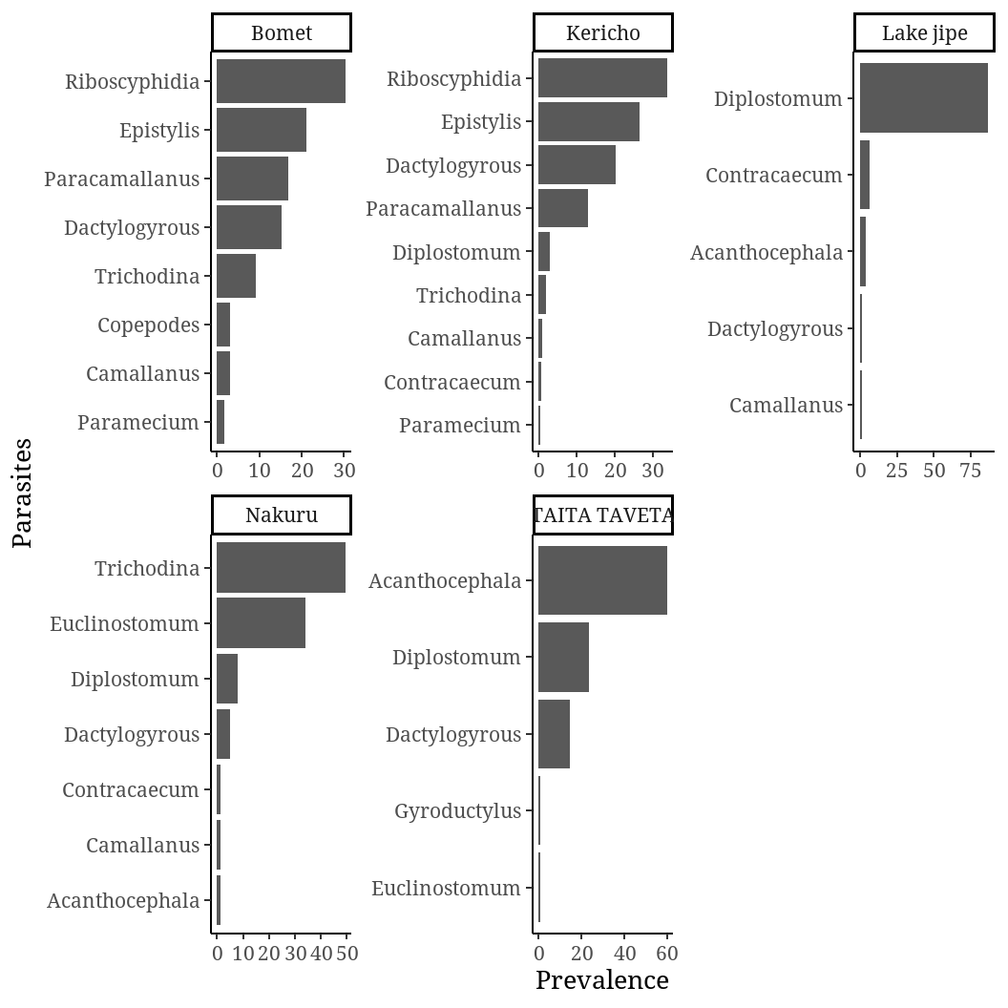

## **5.2 Farmed fish parasites per Holding system**

3/20 fish examined in concrete ponds were infected with one or more parasites. The parasite prevalence in concrete pond was 15%, arithmetic mean in 3 and the abundance was 0.45. 3/10 fish sampled from Tanks were positive and the prevalence was 30%. Arithmetic mean intensity was 1.67 and abundance 0.5. Overall parasite prevalence of fish parasites in liner ponds was 37.86% (53 /140 fish were infected with parasites) with arithmetic mean intensity of 9.68 with abundance of 3.76. Earthen pond had a prevalence 28%, with 35/125 being infected with one or more parasites. Arithmetic mean intensity was 8.89 with abundance of 2.49.

### **5.2.1 Prevalence, mean intensity and parasite abundance per culture systems in farmed Tilapia**

Two parasite genera were found in concrete ponds and 9 parasites were found out of 20 examined fish. *Dactylogyrus* spphad the highest prevalence of 77.78% (7/9), arithmetic mean intensity 3.5 (7/2) and with abundance 0.35 (7/20). *Camallanus* spp had a prevalence 22.22 (2/9) with in a mean intensity 2 (2/1) and abundance 0.1(2/20).

10 (ten) fish were examined in Tanks. *Camallanus* spp prevalence was 40% (2/5), arithmetic mean intensity 2 (2/1) with abundance 0.2 (2/10). *Diplostomum* spp prevalence was 60% (3/5), arithmetic mean intensity 1.5 (3/2) and abundance of 0.3 (3/10).

Twelve (12) parasite genera were found in liner ponds and a total 527 fish parasites were recovered. *Epistylis* spp had a prevalence of 26.56% (140/527), arithmetic mean intensity 14(140/10) and abundance 1 (140/140). Copepods prevalence was 0.38% (2/527), arithmetic mean intensity 2 (2/1) and abundance 0.0143 (2/140). *Riboscyphidia* spp prevalence was 14.04 (74/527), with arithmetic mean intensity 12.33(74/6) and abundance 0.5729 (74/527). The prevalence of *Paramecium* spp was 0.95% (5/527) with arithmetic mean intensity of 1.67 (5/3) and abundance of 0.036 (5/140). *Trichodina* spp had prevalence of 16.13% (85/527), arithmetic mean intensity of 7.73 (85/11) and abundance 0.607 (85/140). *Dactylogyrous* spp prevalence was 3.23% (17/527), with arithmetic mean intensity 1.89 (17/9) and abundance 0.121 (17/140). *Paracamallanus* spp prevalence was 10.63% (56/527), arithm*et*ic mean intensity 28 (56/2) and abundance 0.4 (56/140). *Camallanus* spp had a prevalent of 0.19% (1/527), arithm*et*ic mean intensity 1 (1/1) and abundance 0.00714 (1/140). *Diplostomum* spp prevalence was 6.45% (34/140), arithmetic mean intensity 3.78 (34/9) and abundance 0.243 (34/140). *Contracaecum* spp prevalence in liner pond as 0.38 (2/527), arithmetic mean intensity of 1 (2/2) and abundance 0.0143 (2/140). *Acanthocephalu*s spp had a prevalence 10.25% (54/527), arithm*et*ic mean intensity of 3.857 (54/14) and abundance 0.386 (54/140). *Euclinostomum* spp prevalence was 10.82% (57/527), arithmetic mean intensity of 9.5 (57/6) and abundance of 0.407 (57/140).

Ten (10) genera of parasites were found in earthen pond from 125 tilapias sampled. Three hundred and eleven (311) fish parasites were recovered during the study. *Dactylogyrous* spp had a prevalence of 36.98% (115/311), with arithmetic mean intensity of 3.97(115/29) and abundance 0.92(115/125). *Paracamallanus* spp prevalence was 5.47% (17/311), arithmetic mean intensity3.4(17/5) and abundance 0.136(17/125). *Trichodina* spp prevalence was 3.54% (11/311), arithm*et*ic mean intensity 2.2(11/5) and abundance 0.088(11/125). *Riboscyphydia* spp prevalence was 34.73% (108/311), arithmetic mean intensity 27 (108/4) with abundance of 0.864 (108/125). *Contracaecum* spp prevalence was 0.96% (3/311), arithmetic mean intensity of 1.5 (3/2) and abundance 0.024 (3/125). *Diplostomum* spp prevalence was 7.07% (22/311), with arithm*et*ic mean intensity of 2.44(22/9) and abundance 0.176 (22/125). *Epistylis* spp prevalence was 0.32% (1/311), with arithmetic mean intensity of 1(1/1) and abundance 0.008 (1/125). *Camallanus* spp prevalence was 1.29% (4/311), with arithmetic mean intensity of 4 (4/1) and abundance 0.032 (4/125). *Acanthocephalus* spp prevalence was 9.32% (29/311), arithmetic mean intensity 3.625 (29/8) with abundance *Gyroductylus* spp had a prevalence of 0.32% (1/125), with arithmetic mean intensity of 1(1/1) and abundance of 0.008(1/125).

Figure 7 Prevalence of parasites across holding systems

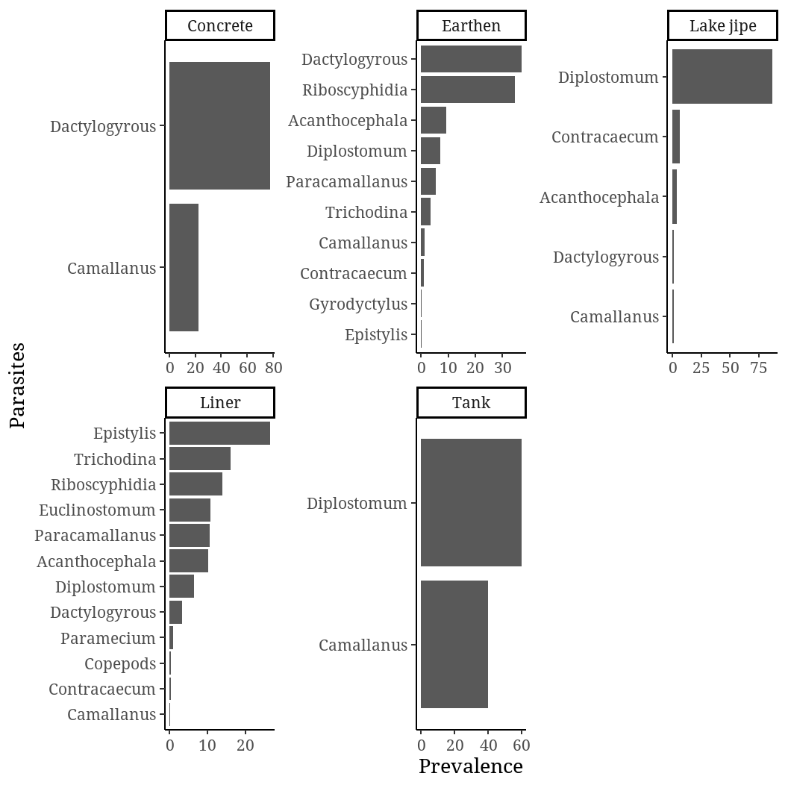

## **5. 3 Wild fish parasites in Taita Taveta, Lake Jipe**

Thirty-five (35) Tilapia species were taken from Lake Jipe. Five (5) parasite genera were found and a total seventy-seven (77) parasites were recovered. In the lake, *Diplostomum* spp had the highest prevalence of 87% (67/77), with arithmetic mean intensity 3.05 and abundance of 1.91. *Contracaecum* spp prevalence was 6.5% (5/77), arithmetic mean intensity of 1.67 (5/3) and abundance of 0.143(5/35). *Dactylogyrus* spp prevalence was 1.3% (1/77), with arithmetic mean of 1(1/1) and with abundance of 0.03 (1/35). *Camallanus* spp prevalence was 1.3% (1/77), with arithmetic mean of 1(1/1) and with abundance of 0.03 (1/35). *Acanthocephala* spp prevalence was 3.9% (3/77), arithmetic mean intensity of 1 (3/3) with abundance 0.09 (3/35)

**5.4** **Tilapia species parasitic infections in wild (Lake jipe) and farms in Taita Taveta county**

Seventy-six (76) Tilapia species were collected in farms in Taita Taveta. Fifty (50) were *Oreochromis jipe*, fifteen (15) were Nile tilapia (*Oreochromis niloticus*) and eleven (11) were hybrid of *Tilapia jipe* and *Oreochromis niloticus*. In farmed fish, five (5) parasite genera were found infecting *Oreochromis jipe* and one hundred and eleven (111) parasites recovered. Nineteen fish were infected with either one or more parasites. The overall prevalence was 30.78% (19/49), arithmetic mean intensity of 5.8 (111/19) and abundance 2.27 (111/49). Per genera, *Acanthocephalus* spp had the highest prevalence 54.05% (60/111), with arithm*et*ic mean intensity of 3.53 (60/17) and abundance 1.22 (60/49). *Diplostomum* spp prevalence was 27.03% (30/111) with arithmetic mean intensity 2.73 (30/11) and abundance 0.61 (30/49). *Dactylogyrous* spp prevalence was 17.12% (19/111), with arithmetic mean intensity of 2.11 (19/9) and abundance 0.39 (19/49). *Euclinostomum* spp prevalence was 0.9% (1/111) with arithmetic mean intensity of 1(1/1) and abundance 0.02 (1/49). *Gyroductylus* spp prevalence was 0.9% (1/111) with arithmetic mean intensity of 1(1/1) and abundance 0.02 (1/49). Only one genus, *Diplostomum* spp, was found infecting *Oreochromis nilotiticus* in farmed fish. And only one fish was infected out of fifteen (15) examined. The total parasites recovered were two (2). The prevalence was 6.67% (1/15) with arithmetic mean intensity of 2 (2/1) and abundance 0.13 (2/15). Eleven (11) hybrid of *Tilapia jipe* and *Oreochromis niloticus* examined, two were infected with one or more parasites and a total of twelve (12) parasites were recovered from two parasite genera. The overall prevalence was 36.36% (4/11), arithmetic mean intensity of 3(12/4) and abundance 1.091(12/11). *Acanthocephalus* spp had the highest prevalence 91.67% (11/12), with arithmetic intensity of 3.67 (11/3) and abundance 1(11/11). *Dactylogyrous* spp prevalence was 8.33% (1/12), with arithmetic mean intensity of 1(1/1) and abundance 0.091 (1/11).

In lake jipe, ten (10) Nile tilapia were caught. Eight (8) were infected with one or more parasites. The prevalence was 80% (8/10) with arithmetic mean intensity of 2.625(21/8) and abundace2.1 (21/10). Twenty-one (21) fish parasites were recovered from three parasites genera. *Diplostomum* spp was the highest prevalence of 71.43% (15/21), arithmetic mean intensity of 2.14(15/7) and abundance 1.5(15/10). *Contracaecum* spp prevalence was 23.81% (5/21) with arithmetic mean intensity 1.67 (5/3) and abundance 0.5 (5/10). *Dactylogyrous* spp prevalence was 4.76% (1/21), arithmetic mean intensity 1 (1/1) and abundance was 0.1 (1/10). 25 *Tilapia jipe* were caught in lake jipe (Fig ----??). Sixteen (16) were infected with one or more parasites and a total of 54 parasites were recovered from three different parasite genera. The overall prevalence was 64% (16/25), arithmetic mean intensity 3.375 (54/16) and abundance was 2.16 (54/25). *Diplostomum* spp prevalence 96.3% (52/54), with arithmetic mean intensity of 3.47 (52/15) and abundance 2.08 (52/25). *Acanthocephalus* spp and *Camallanus* spp each had prevalence of 1.9% (1/54) and abundance of 0.04 (1/25).

Figure 8 Tilapia species parasitic infections in wild (Lake jipe) and farms in Taita Taveta county

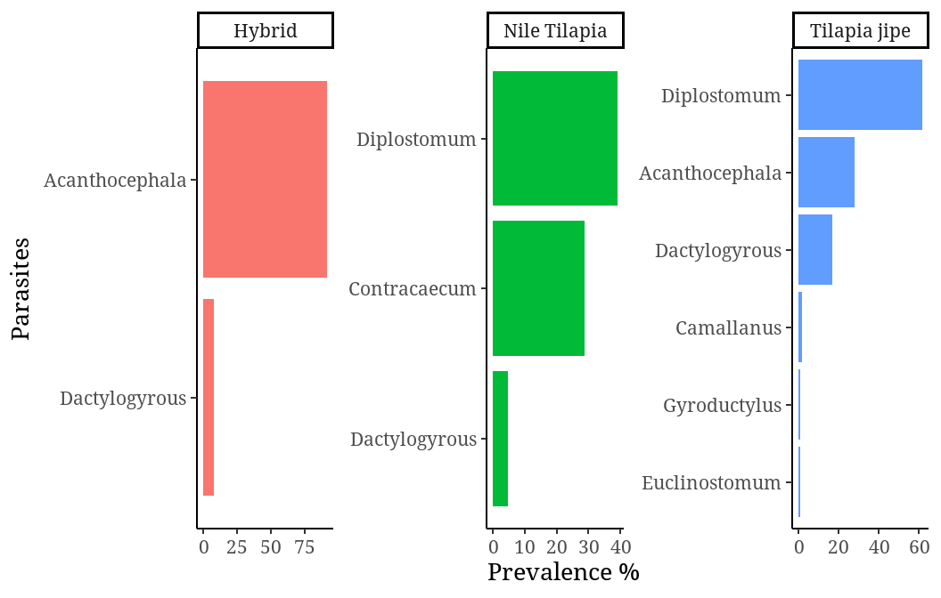

Figure 9 *Tilapia jipe* picture

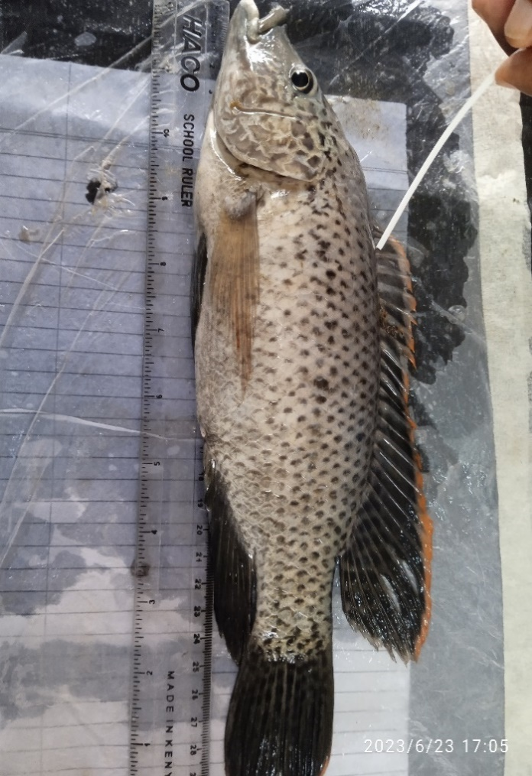

# **5.5 Fish parasites recovered**

## **5.5.1 Digenea trematode**

### 5.5.1.1 *Euclinostomum* spp

Metacercariae of *Euclinostomum* sp. were found in the kidney as round cysts infesting anterior and posterior parts of kidney.

Figure 10 Euclinostomum spp

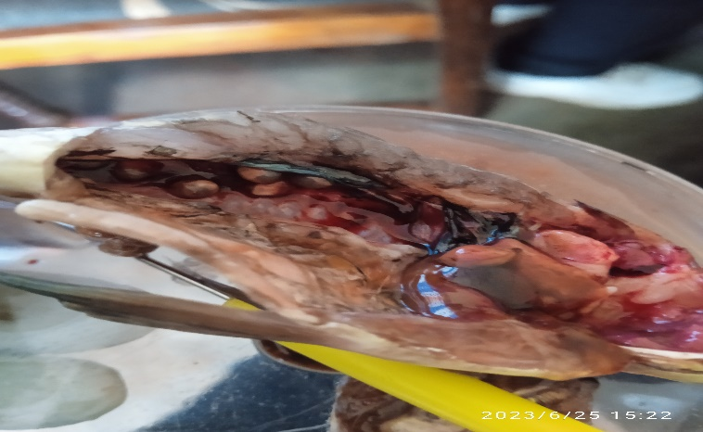

### 5.5.1.2 *Diplostomum* spp

Diagnosing was done by wet mount preparation of the crushed eye and *Diplostomum* spp was found swimming freely in the vitreous humour of the eyes of tilapia fish.

Figure 11 Diplostomum spp

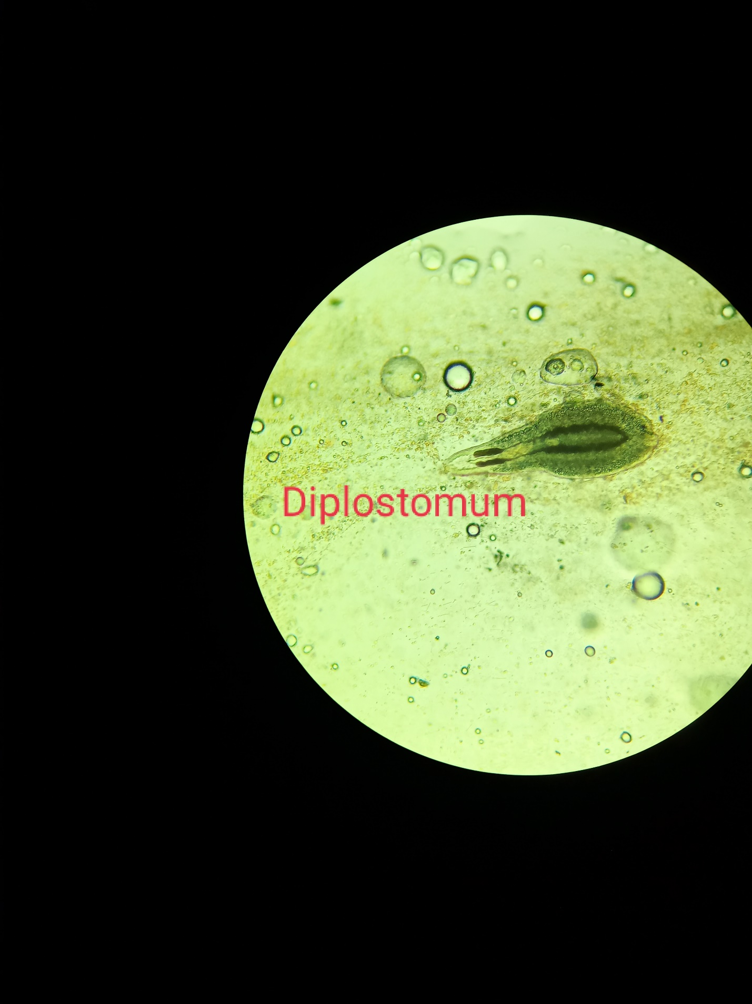

## **5.5.2 Nematodes**

*Contracaecum* spp, *Camallanus* and *Paracamallanu*s spp were in the intestine and mesentery tilapia fish. Larvae of *Contracaecum* spp were covered with a thick cuticle.

Figure 12 Photos of Contracaecum spp

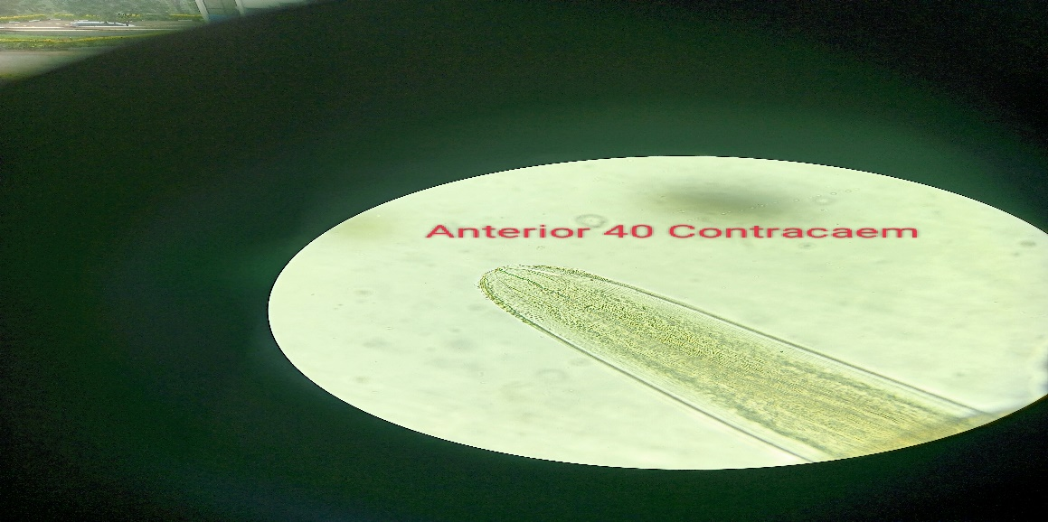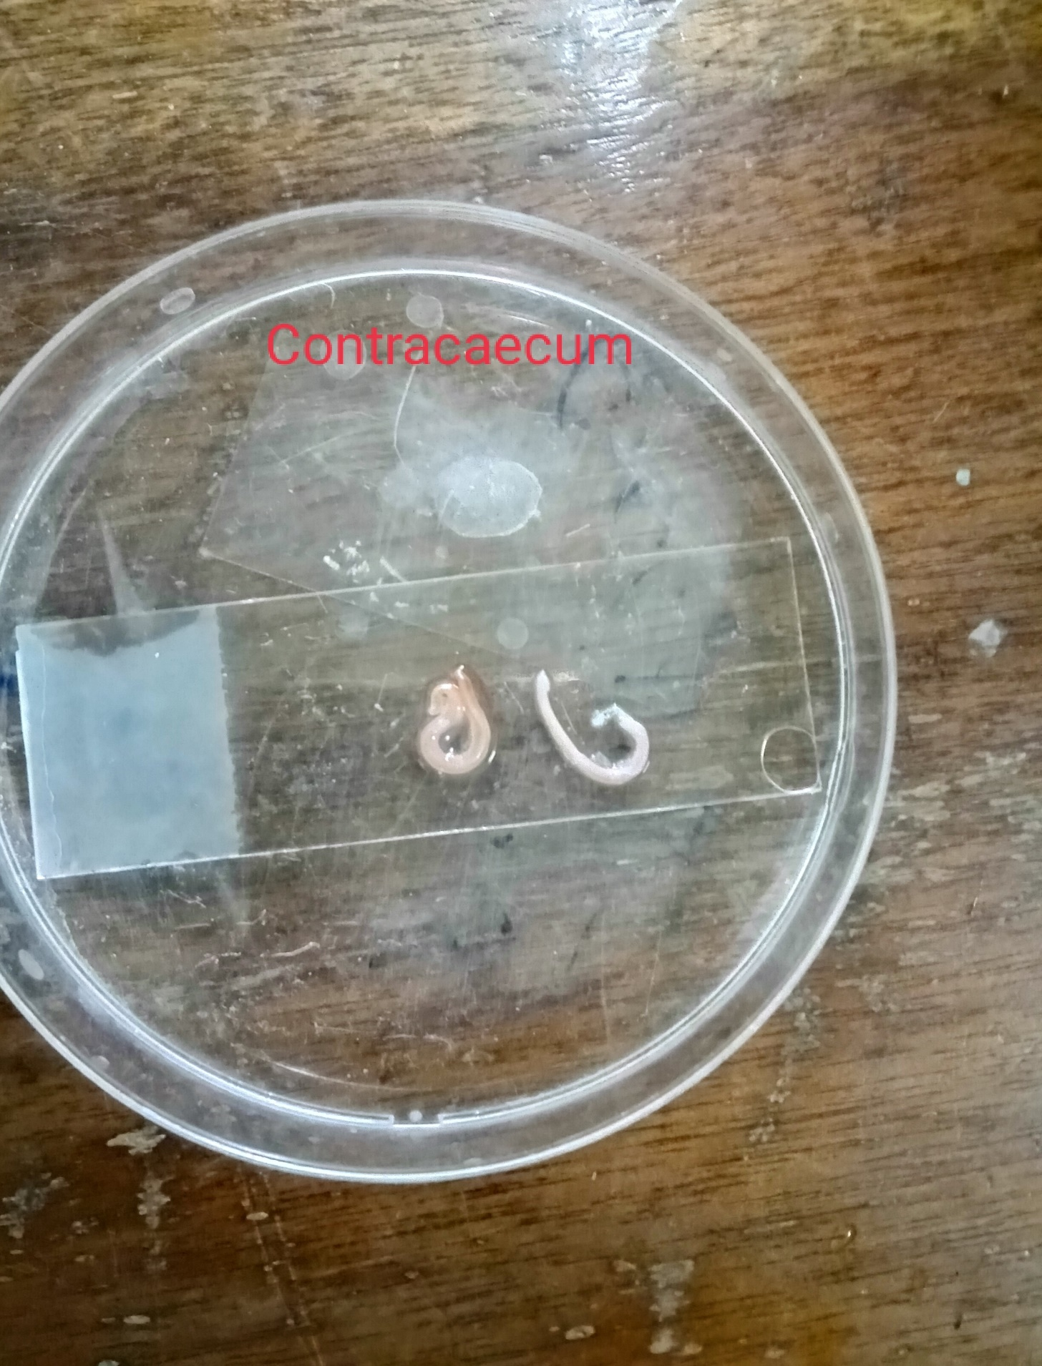 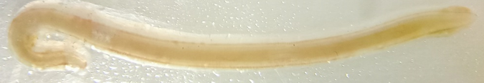

Figure 13 Camallanus spp

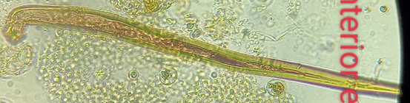 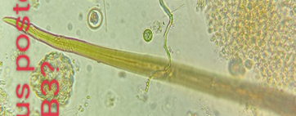

Figure 14 Paracamallanus spp

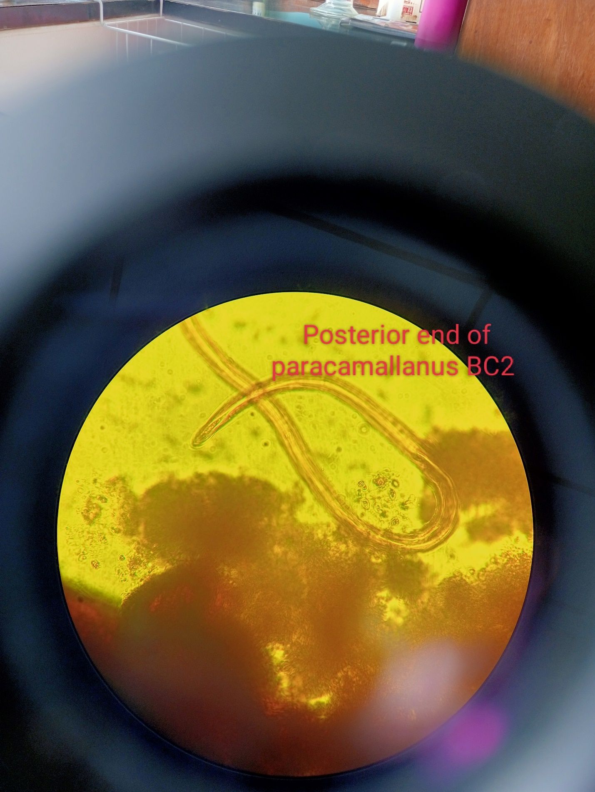 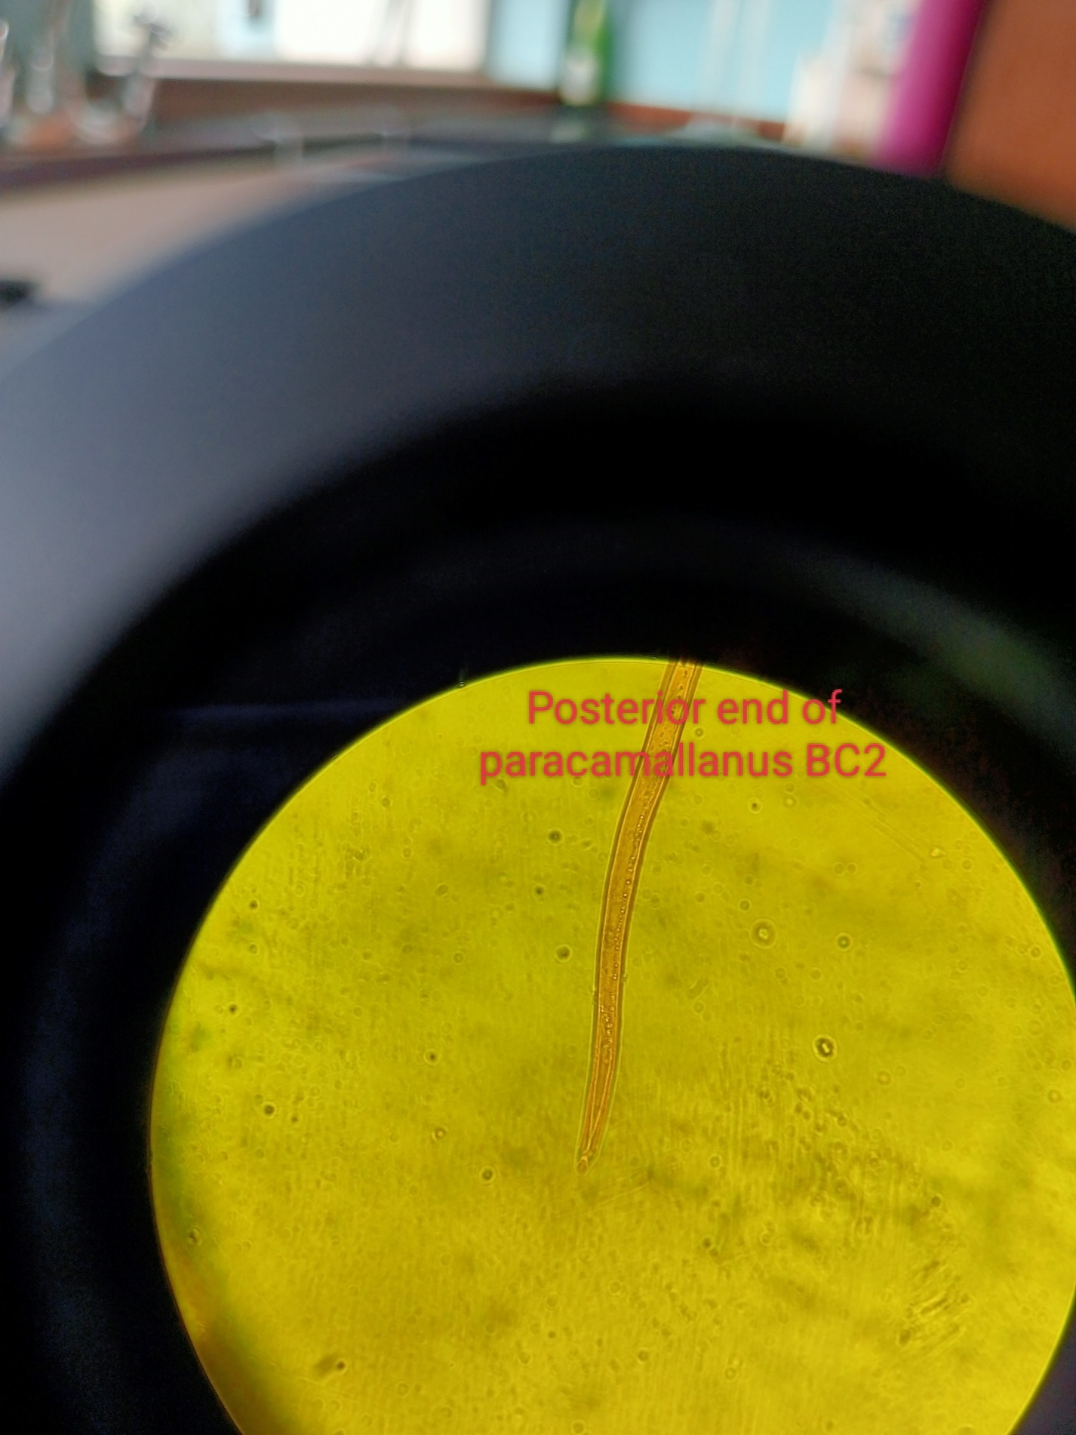

# **5.5.3 Monogea tremadote**

*Dactylogyrous* spp was found attached to the gills of fish and *Gyroductylus* was found on fish skin and fins.

Figure 15 Dactylogyrous spp

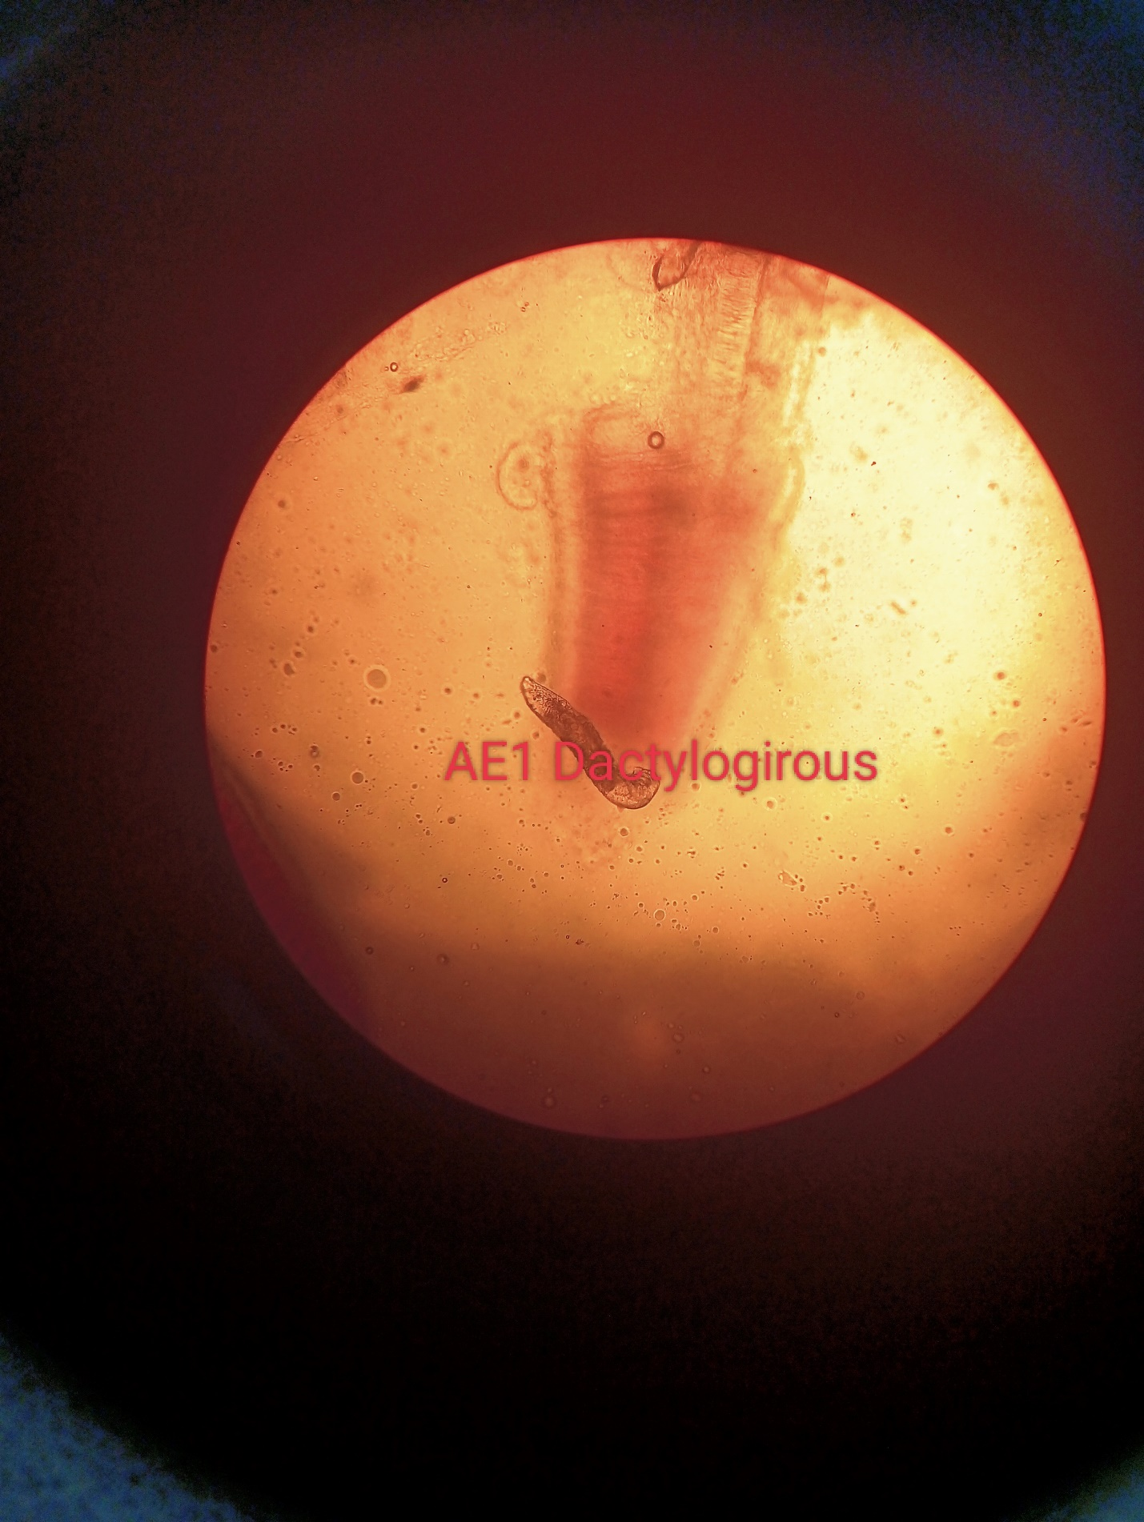

Figure 16 Gyroductylus spp

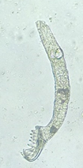

# **5.5.4 Protozoan parasites**

*Trichodina* spp was found on skin and fins of the examined fish. *Riboscyphidia* spp and *Epistylis* spp was found on fish skin while *Paramecium* spp was found in water, gills and skin.

Figure 17 Epistylis spp

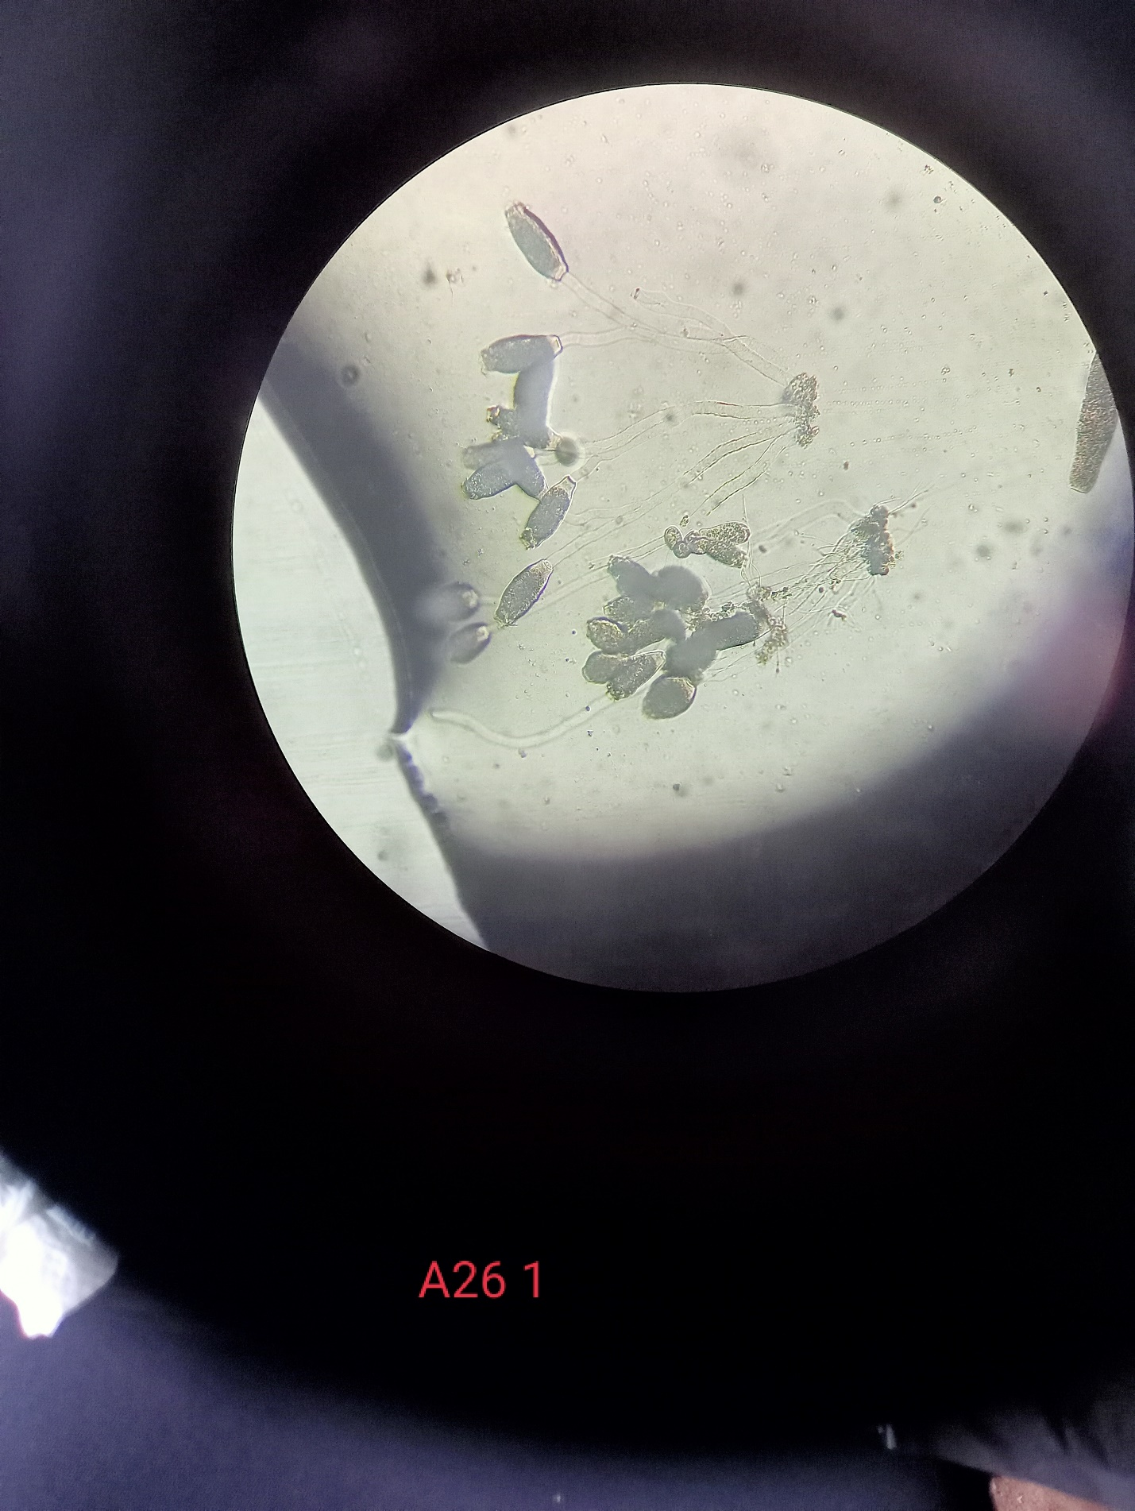

Figure 18 Paramecium spp

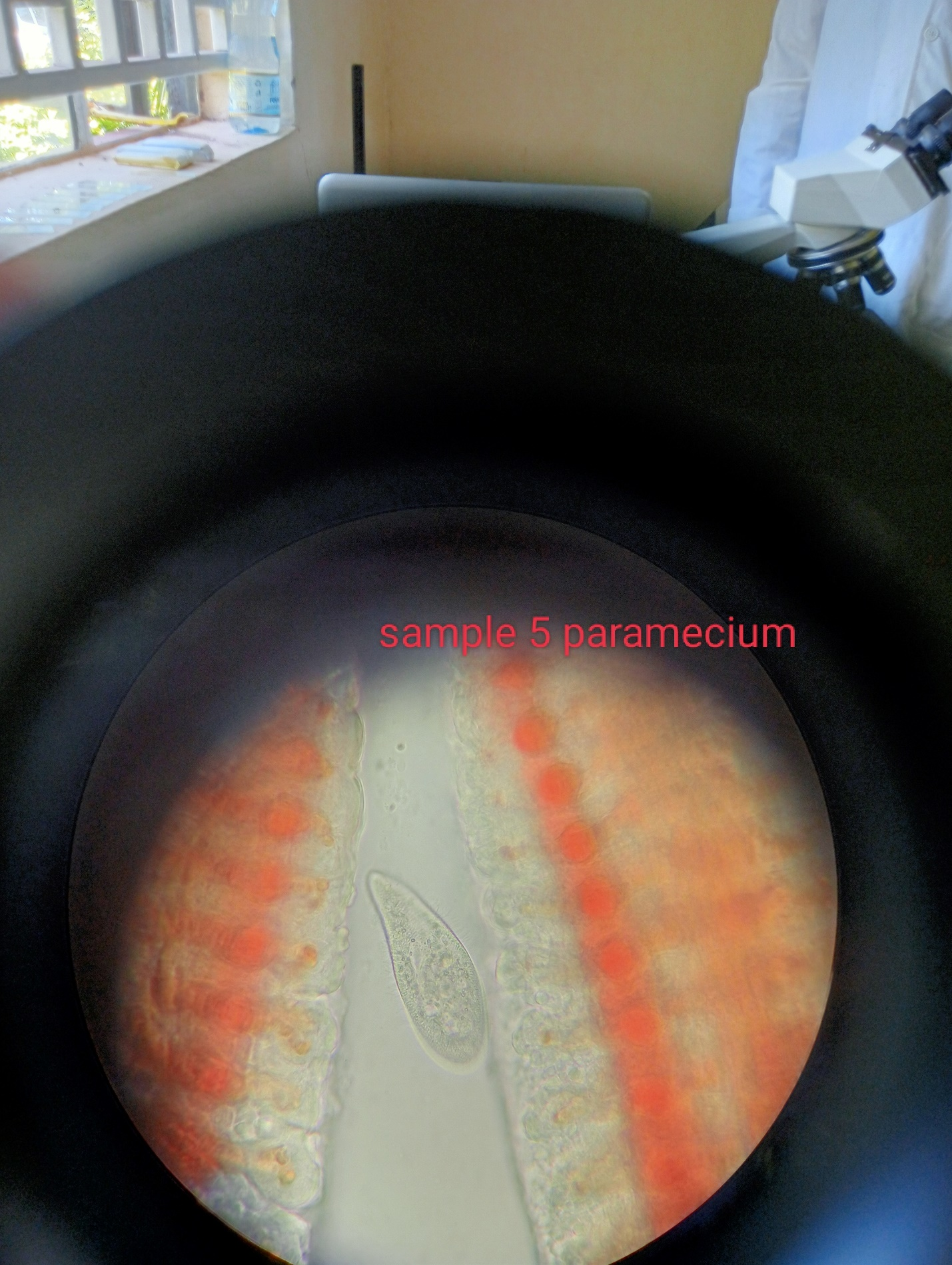

Figure 19 Trichodina spp

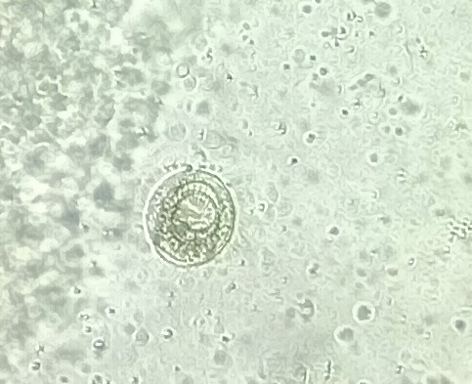

# **5.5.5 Acanthocephala**

In the study, *Acanthocephala* spp was found in the intestine of tilapia fish. This parasite is characterized by the presence of hooked proboscis at the anterior part.

Figure 20 Acanthocephala spp

## 

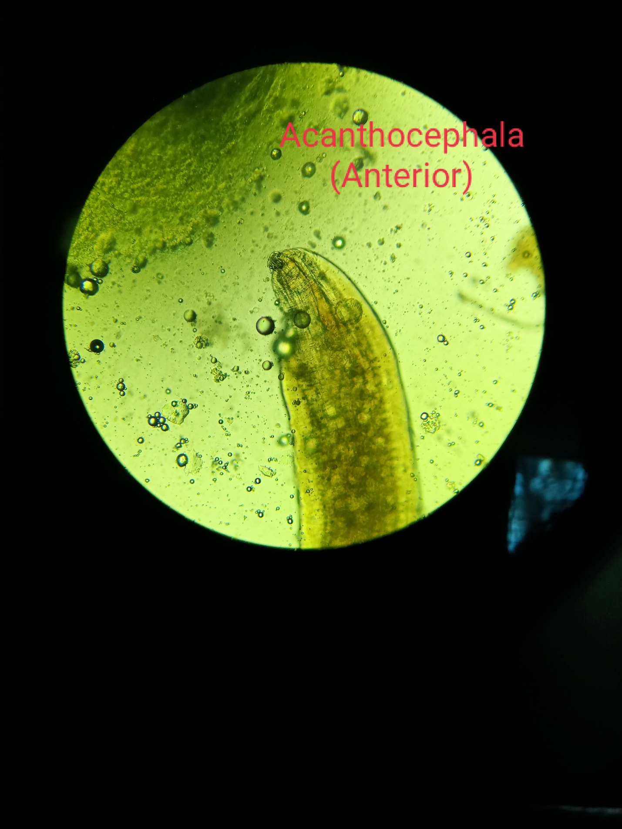

**5.6 Occurrence of parasites as per the fish body condition**

54.54% of the parasitized fish were in excellent body condtion. 32.38% of the infected fish were good body condition. However, 9.1% were in poor condition and 3.98% were in extreme poor body condition. *Gyroductylus spp*, *Camallanus spp*, copepods and *Contracaecum spp* were only found in fish with excellent body condition. *Epistylis spp, Riboscyphidia spp*, *Paramecium spp* and *Euclinostomum spp* were found in fish with both excellent and good body condition. Most of *Paracamallanus spp* was found in fish with excellent body condition, followed by good and fair. 62.5% of fish infected with *Trichodina spp* had excellent body condition, 25% good body condition and 6.5% had fair and poor body condition. 31% of fish infected with *Diplostomum spp* had excellent body condition, 38.59% good body condition,17.1% fair body condition and 14.6% had poor body condition. Fish infected with *Dactylogyrous spp* majority (62.5%) had excellent body condition, 31.25% were in good body condition while 6.25% in fair body condition. Slightly above the average (52.17%) of *Acanthocephalus* spp parasitized fish had good body condition, 30.43% were in excellent body condition while 17.39% were in poor condition.

# **This could fit in another chapter**

# **6.0 Water quality parameters in fish farms in selected Counties.**

## **6.1 Physiochemical parameters of the study sites**

Dissolve oxygen levels were varying averagely in the selected counties of study. Bomet had the highest dissolve oxygen of 16.9 ± 0.7, followed by Kericho 14.9 ± 0.3, Nakuru 12.5 ± 0.5 and Taita Taveta 7.3 ± 0.2. There were variable statical differences between the counties (p<0.001). Taita Taveta that had desirable dissolve oxygen for tilapia fish growth. The other counties were saturated (Bhatnagar & Devi, 2013). All counties had desirable temperature of 22 -28 o C for growth of fish (Bhatnagar & Devi, 2013).The average temperature for Bomet, Kericho, Nakuru and Taita taveta were; 22.22 ± 0.32, 25.22 ± 0.31, 23.60 ± 0.29 and 23.05 ± 0.14 o C, respectively and statically there was significance <0.001. The pH ranged from 7.22 ± 0.08, 7.79 ± 0.12, 9.40 ± 0.10, 9.18 ± 0.11 and 9.95 ± 0.13 in Bomet, Kericho, Nakuru, Taita Taveta and Lake Jipe, respectively and these differences were statically variable (p<0.001). Nakuru, Taita taveta counties and lake jipe had pH above the fish tolerant limit (Bhatnagar & Devi, 2013).

Phosphorous levels in milligram per litre were; 0.74 ± 0.22, 1.11 ± 0.13, 0.12 ± 0.01, 0.11 ± 0.01 and 0.06 ± 0.00 in Bomet, Kericho, Nakuru, Taita taveta and lake jipe respectively. All fell within the acceptable limit that is good for fish growth and statistically there was significance difference <0.001(Bhatnagar & Devi, 2013). Electrical conductivity (ec us cm) in Bomet, Kericho, Nakuru, Taita taveta and lake jipe were; 76 ± 5, 52 ± 4, 490 ± 44, 396 ± 20 and 663 ± 8 respectively with significance <0.001. Turbidity was; 67 ± 4, 36 ± 3, 53 ± 3, 18 ± 1 and 25 ± 1 in Bomet, Kericho, Nakuru, Taita taveta and Lake jipe respectively at a significance <0.001. Total suspended solid particles per milligram per litre was; 1,346 ± 23, 286 ± 13 and 356 ± 2 in Nakuru, Taita taveta and lake jipe respectively at p- value <0.001. Salinity level in Bomet and Kericho was; 329 ± 7 and 318 ± 4 respectively with a significance difference at <0.001.

## **6.2 Chemical parameters of the study sites**

The ammonia level in Nakuru, Taita taveta and lake jipe was; 3.2 ± 0.2, 6.0 ± 0.3 and 3.4 ± 0.3 respectively with a significance difference at <0.001. These were above the tolerant limits (Bhatnagar & Devi, 2013). The nitrite level in ponds in Bomet and Kericho were; 0.07 ± 0.01 and 0.06 ± 0.00 respectively, there was no significance between the two counties at p=0.8. All the nitrates were within the acceptable limit for fish farming (Bhatnagar & Devi, 2013).There was significance difference (<0.001) in all the counties in the level of nitrates. Bomet, Kericho, Nakuru and Taveta had; 13 ± 2, 29 ± 2, 1 ± 0 and 6 ± 0 levels of nitrates respectively. However, when the farms in the mentioned counties was compared with lake Jipe (5 ± 0), there was no significance difference (0.3). The level of nitrates in Bomet and Kericho we out of the acceptable limit for fish farming (Bhatnagar & Devi, 2013). The level of carbonate hardness (caco3) in Bomet was 60 ± 3 and Kericho 26 ± 2 and there was significance difference between the two counties (<0.001). Total alkalinity caco3 in Bomet was 79 ± 3 and Kericho 46 ± 1, and there was significance difference (<0.001). The levels were within desirable limits for fish growth (Bhatnagar & Devi, 2013). Sulphate (so4) levels in Bomet and Kericho were; 27 ± 2 and 41 ± 3 and there was significance difference (0.007).

## **6.4 Correlation of parasites with water Quality**

*Diplostomum* spp had perfect positive correlation with increase in ammonia (nh4) and sulphate (SO4). And perfect negative correlation of with nitrites, carbonates, alkalinity, salinity and total solid suspended. Dissolved oxygen and turbidity showed strong negative correlation with *Diplostomum* spp infection.

*Acanthocephalus* spp had perfect positive correlation with ammonia. And a perfect negative correlation with suspended solid particles in water. Fairly negative strong correlation was seen in *Acanthocephalus* spp infections with dissolved oxygen and turbidity.

*Dactylogyrus* spp had perfect positive correlation with ammonia and sulphate. And also, perfect negative correlation of with nitrites, carbonates hardness, alkalinity, salinity and total suspended solid particles. Nitrates, temperature, and phosphorus showed fairly strong positive correlation with *Dactylogyrus* spp.

*Gyroductylus* spp had perfect positive correlation with ammonia and perfect negative correlation with total suspended solid particles. Fairly strong negative correlation was seen *Gyroductylus* spp infections with dissolved oxygen and turbidity.

*Euclinostomum* spp had perfect positive correlation with electrical conductivity and fairly strong positive correlation with Ph. Nitrates, dissolved oxygen and phosphorous had fairly strong negative correlation with *Euclinostomum* spp infections.

*Paramecium* spp infections had perfect negative correlation with nitrites, alkalinity and salinity.Phosphorus showed fairly strong negative correlation while ph moderate negative correlation. Perfect positive correlation was seen sulphate and fairly strong positive correlation was seen Nitrates and electrical conductivity.

*Riboscyphidia* spp had perfect positive correlation with sulphate and fairly strong positive correlation with nitrates, temperature and phosphorus. Perfect negative correlation was seen in nitrites, alkalinity and salinity while moderate negative correlation was seen in electrical conductivity.

*Epistyis* spp had perfect positive correlation with sulphate and fairly strong positive correlation with nitrates, temperature and phosphorus. And perfect negative correlation with nitrites, alkalinity and salinity. *Epistylis* ssp also had moderate correlation with Electrical conductivity.

*Trichodina* spp showed perfect positive correlation with total suspended solid particles and sulphate. Electrical conductivity had moderate positive correlation with *Trichodina* spp. Ammonia, nitrites, alkalinity and salinity had perfect negative correlation with *Trichodina* spp.

*Contracaecum* spp showed perfect positive correlation with ammonia and sulphate. pH had moderate positive correlation with *Contracaecum* spp. Nitrites, alkalinity, salinity and suspended solid particles had perfect negative correlation with *Contracaecum* spp. Dissolved oxygen and turbidity showed fairly strong negative correlation.

*Camallanus* spp had perfect positive correlation with sulphate and suspended solid particles.And fairly strong positive correlation with nitrates, temperature and phosphorous. Ammonia, nitrites, alkalinity and salinity had perfect negative correlation with *Camallanus spp*.

*Paracamallanus* spp had perfect positive correlation with sulphate. And fairly strong positive correlation with nitrates, temperature and phosphorous. Nitrites, alkalinity and salinity had perfect negative correlation with *Paracamallanus* spp

Copepods showed perfect positive correlation with nitrites, alkalinity and salinity. Dissolved oxygen and turbidity had moderate positive correlation with copepods while temperature and ph had moderate negative correlation. Sulphate showed perfect negative correlation with Copepods.

# **7.0 DISCUSSION, CONCLUSIONS AND RECOMMENDATIONS**

**Objective 1**

In Kericho and Bomet counties, fish farming is done for subsistence by most of farmers (66%). The main economic activity is crop and livestock production done 85% (75/88) of farmers. The business has been left for fairly aged people above 56 years. Majority of fish farmers 81%, run their own farms and only 19% have employed farm managers this agrees (Maina et al., 2017). The business is skewed towards men as 81% (71/88) are men and 17/88(19%) are female. Nile tilapia is the preferred fish for culture with 95% (84/88) and the 5% practicing polyculture which is in agreement with (Maina et al., 2017; Murugami et al., 2018b). 53% of Nile tilapia farmed are sexually reversed male tilapia and the rest mixed sexed tilapia. Fish farming is mainly done on earthen ponds and the average pond size is 220m2 similar findings like (Maina et al., 2017; Wanja et al., 2020b) and contrary to the findings of (Murugami et al., 2017) that noticed most of ponds in Kirinyaga were liners. A good number of ponds 47% (41/88) are located in the valley, followed 35% (31/88) located within the residential areas (Mavuti et al., 2017). Primary fish ponds are used for rearing fish with only 1% used for hatchery production.92% (81/88) of fish ponds get water throughout the year with only 7% relying on rain water for fish production which is in agreement with (Maina et al., 2017; Murugami et al., 2018b; Mavuti et al., 2017). Farmers mainly source fish seeds from hatcheries and only 7% source from local farmers with the problem of prolific breeding their farms as recorded (Wanja et al., 2020). Slightly above half (52%) of farmers were drawing water for fish farming from rivers.19% of farms had water flowing through the pond throughout the year. 90% (79/88) were flowing through agricultural land before emptying in the ponds in agreement (Wanja et al., 2020; Mavuti et al., 2017). Almost all farmers were able drain their ponds with ease with 64% draining into the agricultural lands. On the aspect water, 57% believed water quality is influenced by the source and all believed water river water is the most suitable because of phytoplanktons and high volume of water. Water was not a problem as 75% of farmers had access to water for fish farming. Though some problems associated with floods were seen.14% of farmers are faced with problem of floods, incidence of fish escape, introduction of monitor lizards and disease outbreak associated with floods have been recorded which is in agreement with (Wanja et al., 2020b; Mavuti et al., 2017).80% of farmers were draining pond after harvesting and 38% were drying and cleaning ponds frequently before restocking. 27% were cleaning and drying ponds but not frequently before stocking. After harvesting fish, 34% of farmers were not removing pond bottoms only 32% were removing. Pond treatment have been observed also by (Wanja et al., 2020b) where 49% of farmers were removing pond bottom after harvesting. The fish were mainly fed on commercial feeds and fed twice a day. 82% were fertilizing their ponds to increase productivity and organic manure were applied mostly which is also in agreement with(Wanja et al., 2020b; Mavuti et al., 2017). The main economic problem noticed was feed shortage 65% (58/88) and this is agreement with (Maina et al., 2017; Wanja et al., 2020b; Mavuti al., 2017).

**Objective no.2**

During the study in the selected four counties in Kenya, twelve (12) parasite genera were recorded. Namely; *Dactylogyrous* spp, *Camallanus* spp,*Epistylis* spp, *Riboscyphidia* spp, Paramecium spp,*Trichodina* spp, *Paracamallanus* spp, *Diplostomum* spp, *Contracaecum* spp, *Gyroductylus* spp, *Euclinostomum* spp and *Acanthocephalus* spp and copepods. These parasites have been seen in Kenya and other parts of the world (Maina et al., 2017; Mathenge & Charles G, 2010; Mitiku & Konecny, 2017; Murugami et al., 2017; Ojwala et al., 2018).

Protozoa

*Trichodina* spp is a ciliate protozoon affecting both fresh water and marine fish. In small numbers they are ectocomensals and in higher numbers they are parasites. In the study, *Trichodina* spp in ponds were found in Nakuru, Kericho and Bomet counties at the prevalence of 49.39%,1.87% and 9.1%. High prevalence seen in Nakuru coincides with most of the findings that show farmed fish experience high prevalence. Florio *et* al., 2009 noted 34.6% prevalence in ponds in Uganda. The similar findings were also recorded by (Mitiku & Konecny, 2017) where pond infected with *Trichodina* spp had a prevalence 37.59% and hatchery pond was 53.25% prevalence. However, in the study low findings in Kericho and Bomet have been associated natural water bodies seen cages and wild Nile tilapia in the lakes at a prevalence 22.2% and 1.8% in Uganda. When *Trichodina* spp prevalence were was calculated according to holding systems, liner ponds prevalence was 16.13% and earthen 3.5%. Low prevalence in earthen imitates that of natural body where excess organic load that proliferate multiplication can be get rid of through seepage of water unlike in liner ponds and most of ponds where there is buildup of excess organic loads mainly from excess feeding and high density.

*Epistylis* spp a ciliate protozoon affecting fresh water fish. In the study, *Epistyli*s spp was only found in Kericho and Bomet county at a prevalence of 26.40% and 21.21% respectively. In the study done in Brasil by (Pala et al., 2018) showed 100% *Epistylis* spp which is in the contrary to this finding. When prevalence was calculated according to holding system, earthen pond prevalence was only 0.32% while liner had 26.56%. This can be attributed to the fact that there is high buildup of nutrients and organic load that favours proliferation of *Epistylis* spp in the pond.

*Paramecium* spp was only found in liner ponds at a prevalence of 0.95%. Distribution per county was only in Bomet and Kericho at a prevalence of 1.67% and 0.42%.

*Riboscyphidia* spp a sessile, solitary, ectocommensal ciliates that attach to the skin or gills with a holdfast.The parasite was only found in Kericho and Bomet county at a prevalence of 33.68% and 30.30%. in terms of holding, prevalence was lowest in liner ponds with a prevalence of 14.04% while earthen pond prevalence was 34.73%.

Digenean Trematode

*Diplostomum* spp was found swimming freely in the vitrous humour of eye of the infected fish. The prevalence were varying according to study sites, holding facilities and wild. In Kericho county the prevalence of *Diplostomum* spp was 2.91%, Nakuru and Taita taveta the prevalence was 7.93% and 23.70%. The low prevalence is Kericho can be attributed to the fact that farmers do not share harvesting nets. However, in Nakuru county, most of farms were adhering to biosecurity measures. There was footbath at the entrance of farms but still relied on harvesting nets from fisheries officers therefore making the prevalence to be slightly above Kericho county. Taita taveta had the highest prevalence of *Diplostomum* spp. Farmers and fisheries extension officers were not adhering to biosecurity measures. There was not footbath at the entrance of any farm and sharing of farm equipments like harvesting nets were very commom. In lake Jipe, prevalence of *Diplostomum* spp was 87%. This can be attributed to birds seen around the lake that are definite host of the parasite. Similar findings were also noted by (Migiro Kembenya et al., 2012)who recorded high prevalence of *Diplostomum* in dams where Kerita dam had 100% prevalence, Kasese dam 66% and Chepkoilel fish farm 85%. In lake jipe with the prevalence of 87% infestation by the parasite, Wild *Tilapia jipe* was more prone to infection and had the highest prevalence of 96% while Nile tilapia *(Oreochromis niloticus*) the prevalence was only 4%. They can be attributed to the fact that, the endemic *Tilapia jipe* in the lake is facing extinction and it is more vulnerable to infections. When the prevalence was calculated overall according to holding system, there was very slight difference at liner had a prevalence of 6.45% and earthen 7.07%. Taita taveta, the county with highest prevalence of 23.70%, Earthen Pond had the highest prevalence of 31.81% while liner 17.39%. This is because vegetations and pond bottom host molluscs which are intermediate of host *Diplostomum* spp.

*Euclinostomum* spps metacercaria were found embedded in the kidney of the *Oreochromis niloticus* examined. The parasites were found only in two counties; Nakuru and Taita taveta at a prevalence 34.13% and 0.74% respectively. All farms in Nakuru were liner ponds and high prevalence can be attributed to sharing harvested nets that might be have the parasites and also piscivourous birds seen around the ponds that are the final host.

Monogenea tremadote

Monogeneans are hermaphroditic ectoparasites with a direct life cycle and requiring only one host on which they attach to the skin and gills. During the study, lowest prevalence of *Dactylogyrus* spp was recorded in Lake jipe, 0.74%. This result agrees with the findings of Martins et al., (2015) which explains that external parasites are more prevalent in ponds and cages as they can spread easily to multiple hosts because of the overcrowding unlike in natural water bodies like lakes and oceans. In Taita taveta farms, *Dactylogyrus* spp prevalence was 14.81%, Bomet 15.15% and Kericho the prevalent was 20.17%. In the study, *Gyroductylus* spp prevalence was only 0.74%.

Acanthocephala

*Acanthocephalus* spp was found in Lake jipe, Nakuru county farms and Taita taveta farms at a prevalent of 3.90%, 1.22% and 60%. Low prevalence of *Acanthocephalus* spp in Lake jipe and Nakuru have also been recorded in different studies by Florio *et* al., (2009) a prevalence of 10.2% in wild in Uganda, 7.9% of farmed fish and in kenya 7.1%. However, in Taita taveta the prevalence of 60% is mainly attributed to aquaculture husbandry practices where farms equipments are shared by farmers. This is because, when the holding systems in Taita taveta prevalence was calculated, liner pond had the highest of 75.36% of *Acanthocephalus* spp contrary to the expected earthen pond which had prevalence 43.94%. Despite have vegetations and pond bottoms that habours snails which are first intermediate host of Acanthocephalus spp.

Nematodes

*Contracaecum* spp was only found in two counties, Kericho and Nakuru at very low prevalence of 0.62% and 1.22% respectively and with mean of 1.5 and 1 respectively. Low prevalence of 5.48% of *Contracaecum* spp was also recorded bySigei & Kiprono, (2017) in Lake Baringo. This however differs with findings of Mitiku & Konecny, (2017) where the prevalence of *Contracaecum* spp. in Koftu Lake was 53.92% with mean intensity of 5.27 and the prevalence in ponds was 17.19% with mean intensity of 5.91 worms per infested fish. Mathenge & Charles G, (2010) found the prevalence of *Contracaecum* spp with River Tana basin at 33.8%. High prevalence of *Contracaecum* spp is attributed to definitive piscivorous birds with the farm and water bodies. Low prevalence in the study which only tilapia fish were sampled can also be attributed to the herbivorous nature, where tilapias can only get infections from environment unlike catfish which is omnivorous where infections can come from feeding on first intermediate hosts like snails.

*Camallanus* spp was found in ponds Bomet, Kericho, Nakuru and Lake jipe at a prevalence of 3.03%, 1.04%,1.22% and 1.3% respectively. The arithmetic mean intensities were 2,2.5 and 2 respectively. Similar findings were recorded by (Sigei & Kiprono, 2017) in Lake Baringo were the prevalence of *Camallanus* spp was 1.36% with arithmetic mean intensity of 3. Low prevalence is attributed to lack of definite piscivorous birds within the farms. Secondly, all farms in Nakuru county were fenced and there was adherence to biosecurity measures apart from sharing harvesting nets. Kericho and Bomet counties there few aquaculture practices and pond areas were generally cleared hence removing the habitats of intermediate host of *Camallanus* spp.

*Paracamallanus* spp as first documented in Kenya by Mathenge & Charles G, (2010) in River Tana basin. And this was only in Catfish at a prevalence of 52.8%. Prevalence is catfish was because the fish is omnivorous thus eat even intermediate of parasite therefore increasing chances of infection unlike Tilapia fish which is herbivorous. In this study of only Tilapia fish in the selected counties, *Paracamallanus* spp was only found in Kericho and Bomet counties. The prevalence was 12.84% with a mean intensity of 12.4 and Bomet was prevalence was 16.77% with a mean intensity of 5.5. When the intensity of *Paracamllanus* spp was calculated according to holding systems, Liner ponds had the highest prevalence of 10.63% with mean intensity of 28. Earthen ponds had prevalence of 5.47% with mean of 3.4. High prevalence in liner ponds was because most of the farms sampled were liner ponds and the existence of sharing farm equipment like harvesting nets had increased the chance of *Paracamallanus* spp occurrence. Murugami al., (2017) recorded also most similar results of *Paracamallanu*s spp infection in Kirinyaga county to that of Mathenge & Charles G, (2010) in River tana basin where all *Paracamallanus* spp infection in Kirinyaga were found in catfish at a prevalence of 16.3% and 0.0% in Tilapia. Though in terms of Prevalence, Bomet county prevalence is the same with prevalence with what Murugami et al., (2017) got in Kirinyaga county.

Crustaceans

Copepods were only found in Bomet county at a prevalence of 3.03% with mean intensity of 2. There are high chances they were first intermediate host of *Paracamallanus* spp and *Camallanus* spp found Bomet county.

Condition factor

176 fish were infected with one or more parasites, making the overall prevalence of parasitic infections to be 53.3%. 54.55% (96 infected fish) had excellent body condition. 32.39% (57 infected fish) body condition was good. 16 infected fish (9.1%) had fair body condition while 4% (7 infected fish) had poor body condition.

*Diplostomum* spp infected 41 tilapias.31.71% had excellent body condition, 36.59% good body condition, 17.7% fair body condition and 14.63% poor body condition. The poor body condition is as a result of *Diplostomum* spp that cause diplostomosis in fish a condition associated with a severe ocular disease and lens opacity making infected fish blind (Migiro Kembenya et al., 2012; Rintamäki-Kinnunen et al., 2004).The blindness caused by *Diplostomum* spp metacercariae as a result of induced cataracts by mechanical damage of the fish eye lens and excreted metabolic products interferes with infected fish physiological activities. As the fish depend on vision for feeding, escaping predators and finding mates. Blind fish are prone to predation, poor feeding hence poor growth making fish farming not lucrative business(Fred D, 2018; Migiro Kembenya et al., 2012; Rintamäki-Kinnunen et al., 2004)

Fish infected with *Camallanus* spp, *Contracaecum* spp, Copepods and *Gyroductylus* spp had excellent body condition.

81.82% of fish infected with *Riboscyphidia* spp ha excellent body condition and 18.18% good body condition. Fish infected with *Epistylis* spp, 70% had excellent body condition while 30% had good body condition. *Paramecium* spp and *Euclinostomum* spp 50% of fish infected had excellent body condition while the other 50% had good body condition.

62.5% of *Dactylogyrus* spp infection had excellent body condition, 31.25% good body condition and only 6.25% had fair body condition.

*Acanthocephalus* spp infection on fish showed 30.43% had excellent body condition, 52.17% good body condition and 17.39% fair body condition. Study agrees with the by Aloo, (2002);A comparative study of helminth parasites from the fish *Tilapia zilli* and *Oreochromis leucostictus* In Lake Naivasha and Oloidien Bay, Kenya. That found despite of high prevalence and mean intensity of Acanthocephalus spp in infected, the was no effect on condition factor.

*Paracamallanus* spp, 66.67% of fish infected had excellent body condition, 22.22% good body condition and 11.11 fair body condition.

*Trichodina* spp infection was the only infection that 6.25% of fish infected had poor body condition. Though most of fish (62.5%) infected had excellent body condition,25% and 6.25% had good and fair body conditions.

**Objective 3 Effect of water quality**

Turbidity

The average turbidity in of farms in Bomet was 67 ± 4, Kericho 36 ± 3, Nakuru 53 ± 3 and Taita taveta 18 ± 1 and significance <0.001. In terms of culture systems, Concrete ponds had turbidity of 55 ± 4, earthen ponds 40 ± 3, Lake jipe 25 ± 1, liner ponds 39 ± 2 and Tank ponds 57 ± 0 at<0. 001.*Diplostomum* spp, *Acanthocephalus* spp, *Gyroductylus* spp and *Contracaecum* spp showed fairly strong negative relation with turbidity across the counties with only copepods showing fairly strong positive. When relationship is done along culture system, *Diplostomum* spp, *Euclinostomum* spp and *Contracaecum* spp still showed fairly strong negative correlation. The findings contradict Ojwala et al., (2018) that recorded *Acanthonsentis tilapiae* positively correlated with turbidity.

Electrical conductivity

In the study, Bomet had electrical conductivity of 76 ± 5, Kericho 52 ± 4, Nakuru the highest with 490 ± 44 and Taita Taveta 396 ± 20 at <0. 001.This was associated with perfect positive correlation with *Euclinostomum* spp. *Trichodina* spp had moderate positive correlation while Paramecium spp and *Riboscyphidia* spp had moderate negative correlation with electrical conductivity. This agrees with the similar study by Adamba et al., (2020) that found *Contracaecum* spp, *Euclinostomum* spp and *Trichodina* spp to be positively correlated with electrical conductivity.

Total suspended solid particles

In Nakuru county, total suspended solid particles were 1,346 ± 23 and 286 ± 13 in Taita taveta at <0. 001.There was perfect strong negative correlation with the following parasite species; *Diplostomum* spp, *Dactylogyrus* spp, *Gyroductylus* spp and *Contracaecum* spp. Perfect strong positive correlation was also seen in *Trichodina* spp and *Camallanus* spp.

Phosphorous mg/l

Bomet county had the highest level of phosphorous compared to other counties at 0.74 ± 0.22, In Kericho phosphorous level was 1.11 ± 0.13, Nakuru 0.12 ± 0.01 and Taita taveta 0.11 ± 0.01an and it was significance <0.001.The phosphorous level in ponds was associated with moderate correlation with *Dactylogyrus* spp and moderate negative correlation with *Euclinostomum* spp. *Paramecium* spp, *Epistylis* spp, *Paracamallanus* spp and *Camallanus* spp had fairly strong positive correlation with phosphorous levels in water. This finding agrees with (Adamba et al., 2020) that found *Euclinostomum* spp infections are positively correlated to phosphorus level in water, the study also found *Trichodina* spp positively correlate with phosphorus levels in water.

Salinity levels

The level of salinity in Bomet was 329 ± 7 and Kericho 318 ± 4. There was no significance difference. Only copepods showed perfectly positive correlation with salinity while infections of the fish with the following parasites showed perfectly negative correlation; *Diplostomum* spp, *Dactylogyrus* spp, *Paramecium* spp, *Riboscyphidia* spp, *Epistylis* spp, *Trichodina* spp, *Contracaecum* spp, *Paracamallanus* spp and *Camallanus* spp.

Temperature

There was significance difference in the temperatures recorded in different study counties. In Bomet, Kericho, Nakuru and Taita Taveta. Mean temperature was 22.22 ± 0.32,25.22 ± 0.31,23.60 ± 0.29 and 23.05 ± 0.14 respectively at <0. 001.*Dactylogyrus* spp, *Epistylis* spp, *Paracamallanus* spp and *Camallanus* spp had fairly strong positive correlation with temperature while copepods had moderate negative correlation. Correlation of temperature and parasitic infections by Adamba et al., (2020) found that *Contracaecum* spp, *Euclinostomum* spp and *Trichodina* spp are positively correlated.

Dissolved Oxygen

Dissolved oxygen in Bom*e*t, Kericho, Nakuru and Taita Taveta were 16.9 ± 0.7,14.9 ± 0.3,12.5 ± 0.5 and 7.3 ± 0.2 respectively at<0. 001.Moderate positive correlation of parasitic infection was observed *Paramecium* spp and copepods. Fairly strong negative correlation was seen in Diplostomum spp, Acanthocephalus spp, *Gyroductylus* spp, *Euclinostomum* spp and *Contracaecum* spp. Adamba et al., (2020) found *Diplostomum* spp and *Argulus* spp negatively correlate.

Sulphate (SO4)

Sulphate level in Bomet was 27 ± 2 and 41 ± 3 in Kericho. There was significance difference. Perfect positive parasitic infection correlation was seen in *Diplostomum* spp, *Dactylogyrus* spp, *Paramecium* spp, *Riboscyphidia* spp, *Contracaecum* spp, *Paracamallanus* spp and *Camallanus* spp. Perfect negative correlation was seen in copepods.

Ammonia

Ammonia level in Nakuru and Taita Taveta were 3.2 ± 0.2,6.0 ± 0.3 respectively <0.001. There was perfect strong positive correction of ammonia level with the following parasites; *Diplostomum* spp, *Acanthocephalus* spp, *Gyroductylus* spp and *Contracaecum* spp. *Trichodina* spp and *Camallanus* spp exhibited perfect strong negative correlation with Ammonia. The findings agree with (Adamba et al., 2020) that found *Contracaecum* spp, *Diplostomum* spp and *Argulus* spp positively correlate with Ammonia.

Total alkalinity CaCO3

Total alkalinity in Bomet was 79 ± 3 and Kericho 46 ± 1 and there was significance difference<0.001. In relation to parasitic infections, Perfect strong negative correlation was observed in the following parasites; *Diplostomum* spp, *Paramecium* spp, *Riboscyphidia* spp, *Epistylis* spp, *Trichodina* spp, *Contracaecum* spp, *Paracamallanus* spp and *Camallanus* spp. Only copepods had perfect strong positive correlation with alkalinity.

Nitrates (NO3)

Nitrates level in Bomet, Kericho, Naraku and Taita taveta farms were 13 ± 2,29 ± 2,1 ± 0 and 6 ± 0 at<0. 001.There was statistical difference. Nitrates levels in ponds showed fairly strong positive correlation in fish infection in the following parasites; *Dactylogyrus* spp, *Paramecium* spp, *Riboscyphidia* spp, *Epistylis* spp, *Paracamallanus* spp and *Camallanus* spp. *Euclinostomum* spp had fairly strong negative correlation with nitrates.

Nitrites (NO2)

Nitrites level in Bomet was 0.07 ± 0.01 and Kericho 0.06 ± 0.00. There was no statistical difference. In relation to parasitic infections, Perfect strong negative correlation was observed in the following parasites; *Diplostomum* spp, *Paramecium* spp, *Riboscyphidia* spp, *Epistylis* spp, *Trichodina* spp, *Contracaecum* spp, *Paracamallanus* spp and *Camallanus* spp. Only copepods had perfect strong positive correlation with nitrites. Similar positive correlation of nitrites to certain parasitic infections like; *Diplostomum* spp, *Contracaecum* spp and *Argulus* spp have been recorded by Adamba et al., (2020) .

Ph

The mean range of temperatures in selected counties were 7.22 ± 0.08,7.79 ± 0.12,9.40 ± 0.10 and 9.18 ± 0.11 in Bomet, Kericho, Nakuru and Taita taveta respectively. There was significance difference <0. 001.Temperatures were fairly, strongly and positively correlated with *Euclinostomum* spp and *Contracaecum* spp. Fair strong negative correlation was seen in Paramecium spp and moderate negative correlation was seen in Copepods. The findings agree with Adamba et al., (2020) that recorded positive correlation of *Contracaecum* spp and *Euclinostomum* spp with

Remarks

1. Do not replicate results – discuss them
2. Where are conclusions and recommendations – They are missing?

**REFERENCES**

**Abba Mustapha (2019).** IMPORTANCE OF pH CONTROL IN AQUACULTURE. https://www.researchgate.n*et*/publication/340870601

**Abera, T. A., Vuorinne, I., Munyao, M., Pellikka, P. K. E., & Heiskanen, J. (2022).** Land Cover Map for Multifunctional Landscapes of Taita Tav*et*a County, Kenya, Based on Sentinel-1 Radar, Sentinel-2 Optical, and Topoclimatic Data. Data, **7(3).** https://doi.org/10.3390/data7030036

**Abdel-Baki, A.-A., Al-Quraishy, S., & Abdel-Baki, A.-A. S. (2014).** First Record of Chilodonella spp. (Ciliophora: Chilodonellidae) in Cultured Nile Tilapia (Oreochromis niloticus) in the Central Region of Saudi Arabia. In Article in Pakistan Journal of Zoology (**Vol. 46**, Issue 3). [https://www.researchgate.n*et*/publication/287233485](https://www.researchgate.net/publication/287233485)

**Adamba S.W.K., Otachi E.O. and Ong’ondo G.O. (2020):** Parasite communities of *Oreochromis niloticus baringoensis* (Trewavas, 1983) in relation to selected water quality param*et*ers in the springs of Lorwai Swamp and Lake Baringo, Kenya. Acta Parasitologica, **65(2):** 441–451.

**Adams A.M., Murrell K.D., Cross J.H. (1997):** Parasites of fish and risks to public health. Revue Scientifique *et* Technique (International Office of Epizootics), **16(2):** 652-660. DOI: 10.20506/rst.16.2.1059. PMID: 9501379.

**Aibinu, I. E., Smooker, P. M., & Lopata, A. L. (2019).** Anisakis Nematodes in Fish and Shellfish- from infection to allergies. In International Journal for Parasitology: Parasites and Wildlife (**Vol. 9,** pp. 384–393). Australian Soci*et*y for Parasitology <https://doi.org/10.1016/j.ijppaw.2019.04.007>

**Akoll, P., Fioravanti, M. L., Konecny, R., & Schiemer, F. (2012).** Infection dynamics of Cichlidogyrus tilapiae and C. sclerosus (Monogenea, Ancyrocephalinae) in Nile tilapia (Oreochromis niloticus L.) from Uganda. Journal of Helminthology**, 86(3**), 302–310. https://doi.org/10.1017/S0022149X11000411

**Akoll P., Konecny R., Mwanja W.W., Nattabi J.K., Agoe C. and Schiemer F. (2012):** Parasite fauna of farmed Nile tilapia (*Oreochromis niloticus*) and African catfish (*Clarias gariepinus*) in Uganda. Parasitology Research, **110(1):** 315–323. <https://doi.org/10.1007/s00436-011-2491-4>

**Allalgua, A., Menasria, A., Mouaissia, W., Bensouilah, M., & Kaouachi, N**. (2021). Acta Aquatica Turcica Effect of Biotic and Abiotic Factors on the Epidemiological Index of Dactylogyrus h*et*eromorphus El Gharbi, 1994 (Monogenea) Parasitizing the Algerian Barbel Luciobarbus callensis (Cyprinidae) Inhabiting Foum-El-Khanga Dam (Souk-Ahras, Algeria). Acta Aquatica Turcica, **17(4),** 532–540. https://doi.org/10.22392/actaquatr.896109

**Alvin, R., Gay, P. V., Pablo, O., & Gay, V. (2019).** Sexual selection of parasites in Nile tilapia (Oreochromis niloticus L.). ~ 335 ~ International Journal of Fisheries and Aquatic Studies, **7(6).** <http://www.fisheriesjournal.com>

AN 10B01R20-01E http://www.yokogawa.com pH in fish farming. (2014). http://www.yokogawa.com

**Anonymous (2018a):** County Government of Kericho Integrated Development Plan 2018-2022.

**Anonymous (2018b):** County Government of Bom*et* Integrated Development Plan 2018-2022.

**Aronson, N. E., & Magill, A. J. (2020).** General Principles. In Hunter’s Tropical Medicine and Emerging Infectious Diseases (pp. 696–698). Elsevier. <https://doi.org/10.1016/B978-0-323-55512-8.00093-4>

**Asiru, R. A., Olurin, K., Okafor, J., Alade, A., Asiru, R., Ademiluwa, J., Owonifari, K., & Oronaye, O. (2012).** Olurin *et al*. (2012) 2 Helminth Parasites of Sarotherodon galilaeus and Tilapia zillii (Pisces: Cichlidae) from River Oshun, Southwest Nigeria. In International Journal of Aquatic Science (Vol. 3, Issue 2). [**https://www.researchgate.n*et*/publication/331719026**](https://www.researchgate.net/publication/331719026)

**Bao, M., Pierce, G. J., Strachan, N. J. C., Pascual, S., González-Muñoz, M., & Levsen, A. (2019**). Human health, legislative and socioeconomic issues caused by the fish-borne zoonotic parasite Anisakis: Challenges in risk assessment. In Trends in Food Science and Technology (**Vol. 86**, pp. 298–310). Elsevier Ltd. <https://doi.org/10.1016/j.tifs.2019.02.013>

**Barzegar, M., Rahmati-Holasoo, H., & Bozorgnia, A. (2017).** Gyrodactylus (Monogenea, Gyrodactylidae) parasite fauna of fishes in some rivers of the southern Caspian Sea basin in Mazandaran province PhD thesis View project A Survey on Ectoparasite of Fishes in Some Rivers in Southwest of Caspian Sea Basin, Mazandaran Province View project. <https://doi.org/10.22059/ijvm.2017.237792.1004824>

**Bertaglia, E. de A., Furtado, W. E., Silva e Souza, Â. T., Fernandes, M. C., Pereira, S. A., Brasil, E. M., Mouriño, J. L. P., Jerônimo, G. T., & Martins, M. L. (2023).** Influence of Seasonality and Culture Stage of Farmed Nile Tilapia (Oreochromis niloticus) with Monogenean Parasitic Infection. Animals, **13(9).** <https://doi.org/10.3390/ani13091525>

**Bhatnagar, A., & Devi, P. (2013).** IPA-Under Creative Commons license 3.0 Water quality guidelines for the management of pond fish culture. INTERNATIONAL JOURNAL OF ENVIRONMENTAL SCIENCES, **3(6).** https://doi.org/10.6088/ijes.2013030600019

**Biswas J. K. and Pramanik S. (2016):** Assessment of aquatic environmental quallty using *Gyrodactylus* sp . as a living probe : Parasitic Biomonitoring of Ecosystem Health, **4(4):**219-226.

**Bittencourt, L. S., Ferreira, R. L. da S., Videira, M. N., da Silva, M. F., da Silva, D. T., Hamoy, I., Carvalho, J. C. T., & Matos, E. (2021).** Sphaerospora festivus n. sp., a parasite of the flag cichlid, Mesonauta festivus (Teleostei: Cichlidae) from eastern Amazon, Brazil. Revista Brasileira de Parasitologia V*et*erinaria, **30(3).** <https://doi.org/10.1590/S1984-29612021056>

**Borzák, R., Borkhanuddin, M. H., Cech, G., Molnár, K., Hall*et*t, S. L., & Székely, C. (2021).** New data on Thelohanellus nikolskii Achmerov, 1955 (Myxosporea, Myxobolidae) a parasite of the common carp (*Cyprinus carpio, L*.): The actinospore stage, intrapiscine tissue preference and molecular sequence. International Journal for Parasitology: Parasites and Wildlife, 15, 112–119. <https://doi.org/10.1016/j.ijppaw.2021.04.004>

**Boyd, C. E. (2015).** pH, Carbon Dioxide, and Alkalinity. In Water Quality (pp. 153–178). Springer International Publishing. https://doi.org/10.1007/978-3-319-17446-4_8

**Boyd C.E., McNevin A.A. and Davis R.P. (2022):** The contribution of fisheries and aquaculture to the global protein supply. Food Security. <https://doi.org/10.1007/s12571-021-01246-9>

**Bush A.O., Lafferty K.D., Lotz J.M. and Shostak A.W. (1997):** Parasitology me*et*s ecology on its own terms: Margolis *et al*. revisited. Journal of Parasitology, **83:** 575–583.

COUNTY GOVERNMENT OF NAKURU NAKURU COUNTY INTEGRATED DEVELOPMENT PLAN. (2018). www.nakuru.go.ke.

COUNTY GOVERNMENT OF TAITA TAV*ET*A County Integrated Development Plan 2018-2022. (2018).

**Chai J.Y., Murrell, K.D. and Lymbery A.J. (2005):** Fish-borne parasitic zoonoses: Status and issues. International Journal for Parasitology, **35(11–12):** 1233–1254. https://doi.org/10.1016/j.ijpara.2005.07.013

**Chan C.Y., Tran N., Cheong K.C., Sulser T.B., Cohen P.J., Wiebe K. and Nasr-Allah A.M. (2021):** The future of fish in Africa: Employment and investment opportunities. PLoS ONE, 16(12 December). <https://doi.org/10.1371/journal.pone.0261615>

**Chang, E. D., Town, R. M., Owen, S. F., Hogstrand, C., & Bury, N. R. (2021**). Effect of Water pH on the Uptake of Acidic (Ibuprofen) and Basic (Propranolol) Drugs in a Fish Gill Cell Culture Model. Environmental Science and Technology, 55(10), 6848–6856. <https://doi.org/10.1021/acs.est.0c06803>

**Chaudhary, A., Chiary, H. R., & Singh, H. S. (2017).** First molecular confirmation of the Dactylogyrus anchoratus and D. Vastator (Monogenea, Dactylogyridae) from Carassius auratus in western India. BioInvasions Records**, 6(1),** 79–85. https://doi.org/10.3391/bir.2017.6.1.13

**Chia S.Y., Macharia J., Diiro G.M., Kassie M., Ekesi S., van Loon J.J.A., Dicke M. and Tanga C.M. (2020):** Smallholder farmers’ knowledge and willingness to pay for insect-based feeds in Kenya. PLoS ONE, **15(3).** <https://doi.org/10.1371/journal.pone.0230552>

**Clough S., Mamo, J., Hoevenaars K., Bardocz T., P*et*ersen P., Rosendorf P., Atiye T., Gukelberger E., Guya E. and Hoinkis J. (2020):** Innovative Technologies to Promote Sustainable Recirculating Aquaculture in Eastern Africa—A Case Study of a Nile Tilapia (*Oreochromis niloticus*) Hatchery in Kisumu, Kenya. Integrated Environmental Assessment and Management, **16(6):** 934–941. <https://doi.org/10.1002/ieam.4295>

**Deen, N. El, El-Hady, A., Lila, O. K., Mohamed, A., & Zaki, M. S. (2016).** Trials of Control of Some External Parasitic Nile tilapia Diseases with Emphasis on Preparation of vaccine against *Ichthyophthirius multifiliis*.

**Duarte, G. S. C., Lehun, A. L., Leite, L. A. R., Consolin-Filho, N., Bellay, S., & Takemoto, R. M. (2020).** Acanthocephalans parasites of two Characiformes fishes as bioindicators of cadmium contamination in two neotropical rivers in Brazil. Science of the Total Environment, 738. <https://doi.org/10.1016/j.scitotenv.2020.140339>

**FAO (2015):** [Fishery and Aquaculture Country Profiles, Kenya](https://www.fao.org/fishery/en/facp/114?lang=en)

**FAO Fisheries and Aquaculture Department. (2013).** FAO Fisheries &amp; Aquaculture - National Aquaculture Sector Overview - Kenya. <http://www.fao.org/fishery/countrysector/naso_kenya/en>

**Fayaz Ali, R. (2020).** Trematoda-Digenea Black Spot and Yellow Grub Parasites in Fish.

**Flores-crespo J., Flores R.C. 2003:** Monogeneos, parásitos de peces en México: Estudio recapitulaivo. Técnica Pecuaria México, **41:** 175–192.

**Florio D., Gustinelli A., Caffara M., Turci F., Quaglio F., Konecny R., Nikowitz T., Wathuta E.M., Magana A., Otachi E.O., Matolla G.K.,Warugu H.W., Liti D., Mbaluka R.,Thiga B., Munguti J., Akoll P., Mwanja W., Kassahun A., Zenebe T., Fioravanti M.L. (2009):** “V*et*erinary and Public Health Aspects in Tilapia (*Oreochromis niloticus niloticus*) aquaculture in Kenya, Uganda and Ethiopia.” Ittiopatologia, no. 6: 51–93.

**Francis-Floyd, R. (1992).** Fact She*et* FA-27 Dissolved Oxygen for Fish Production 1. http://edis.ifas.ufl.edu.

**Fred D, C. (2018).** African Diplostomum (sensu Dubois 1961): Minireview on taxonomy and biology. International Journal of Aquaculture and Fishery Sciences, 031–038. https://doi.org/10.17352/2455-8400.000041

from farmed rainbow trout and tilapia in Kenya is identical to European isolates. Journal

**Galli P., Crosa G., Mariniello L., Ortis M. and D’Amelio S. (2001):** Water quality as a d*et*erminant of the composition of fish parasite communities. Hydrobiologia, **452:** 173–179. <https://doi.org/10.1023/A:1011958422446>

**Githukia, C. M., Ogello, E. O., Kembenya, E. M., Achieng, A. O., Obiero, K. O., & Munguti, J. M. (2015).** Comparative growth performance of male monosex and mixed sex nile tilapia (Oreochromis niloticus l.) reared in earthen ponds. Ribarstvo, Croatian Journal of Fisheries, **73(1),** 20–25. <https://doi.org/10.14798/73.1.788>

**Hansen, H., Cojocaru, C. D., & Mo, T. A. (2016).** Infections with Gyrodactylus spp. (Monogenea) in Romanian fish farms: Gyrodactylus salaris Malmberg, 1957 extends its range. Parasites and Vectors, **9(1).** <https://doi.org/10.1186/s13071-016-1727-7>

**Hansen, H., Ieshko, E., Rusch, J. C., Samokhvalov, I., Melnik, V., Mugue, N., Sokolov, S., & Parshukov, A. (2022).** Gyrodactylus salaris Malmberg, 1957 (Monogenea, Gyrodactylidae) spreads further – a consequence of rainbow trout farming in Northern Russia. Aquatic Invasions, **17(2),** 224–237. https://doi.org/10.3391/AI.2022.17.2.06

**Hossain M.D., Hossain M.K. and Rahman M.H. (2007):** Water quality param*et*ers and incidence of fish diseases in some water bodies in Natore, Bangladesh, Journal of Life and Earth Science, 2(2): 27–30. <https://doi.org/10.3329/jles.v2i2.7493>

**Isibor, P. O., Akinsanya, B., Sogbamu, T., Olaleru, F., Excellence, A., Komolafe, B., & Kayode, S. J. (2020).** Nilonema gymnarchi (Nematoda: Philom*et*ridae) and trace m*et*als in Gymnarchus niloticus of Epe lagoon in Lagos State, Nigeria. Heliyon, **6(9).** https://doi.org/10.1016/j.heliyon.2020.e04959

**Iyaji, F. O., & Eyo. (2009).** Parasites and their Freshwater Fish Host (Vol. 6, Issue 1

**Karlsbakk E., Nystøyl C.F., Plarre H. and Nylund A. (2021):** A novel protist parasite, *Salmoxcellia vastator* n. gen., n. sp. (Xcelliidae, Perkinsozoa), infecting farmed salmonids in Norway. Parasites and Vectors, 14(1). <https://doi.org/10.1186/s13071-021-04886-0>

**Khallaf, E. A., Galal, M., & Authman, M. (2003).** The Biology of Oreochromis niloticus in a Polluted Canal*. In Ecotoxicology (Vol. 12).

**Klinger R. and Floyd R.F. (2013):** Introduction to Freshwater Fish Parasites. University of Florida, IFAS Extension. *1*. http://edis.ifas.ufl.edu

**KMFRI (2017):** Kenya’s Aquaculture Brief 2017: Status, Trends, Challenges and Future Outlook. Kenya Marine and Fisheries Research Institute, Mombasa, Kenya.

**Kumar Sarkar, U., Pathak, A. K., Mir, J. I., & Rebello, S. C. (2013).** Impact of climate change on Indian inland fisheries and adaptation strategies View project Impact assessment and risk communication of invasive fishes View project. In Article in Journal of Environmental Biology (Vol. 1). [https://www.researchgate.n*et*/publication/256443323](https://www.researchgate.net/publication/256443323)

**Kumar, S., Raman, R. P., Kumar, K., Pandey, P. K., Kumar, N., Mohanty, S., & Kumar, A. (2012).** In vitro and in vivo antiparasitic activity of Azadirachtin against Argulus spp. in Carassius auratus (Linn. 1758). Parasitology Research, **110(5),** 1795–1800. <https://doi.org/10.1007/s00436-011-2701-0>

**Kwong, R. W. M., Kumai, Y., & Perry, S. F. (2014).** The physiology of fish at low pH: The zebrafish as a model system. In Journal of Experimental Biology (Vol. 217, Issue 5, pp. 651–662). <https://doi.org/10.1242/jeb.091603>

**Laibu, P. K., Maingi, J., & Kebira, A. (2018).** B I O T E K N O L O G I D*et*ermination of bacterial composition, heavy m*et*al pollution and physicochemical param*et*ers of fish pond water in Abothuguchi Central, Meru County, Kenya. **15(2**). https://doi.org/10.13057/biofar/c150103

**Lom J. and Dyková I. (1992):** Protozoan parasites of fishes. Developments in Aquaculture and Fisheries Science, Vol. 26, Elsevier, 315 pp.

**MA, M. (2021).** The Effects of Fish Parasites in Freshwater Culture and Capture Fisheries and their Treatment Mechanisms. International Journal of Zoology and Animal Biology, 4(2). https://doi.org/10.23880/izab-16000289

**Maina K.W., Mbuthia P.G., Waruiru R.M., Nzalawahe J., Murugami J.W., Njagi L.W., Mdegela R.H. and Mavuti S.K. (2017):** Risk factors associated with parasites of farmed fish in Kiambu County, Kenya. International Journal of Fisheries and Aquatic Studies, **5(4):** 217-223.

**Maleki, L., & Ghaderi, E. (2018).** Occurrence and description of *Clinostomum complanatum* (Rudolphi, 1819) m*et*acercariae in freshwater fishes from Gheshlagh basin, West of Iran Article in. Iranian Journal of Animal Biosystematics. <https://doi.org/10.22067/ijab.v14i2.74577>

**Margolis L., Esch G.W., Holmes J.C., Kuris A.M. and Schad G.A. (1982):** The use of ecological terms in parasitology (report Bush *et al*. – Parasite Ecology and Terminology 583 of an adhoc committee of the American Soci*et*y of Parasitologists). Journal of Parasitology, **68:** 131–133.

**Martins, M. L., Cardoso, L., & de Pádua, S. B. (2015).** Infecções por protozoários em peixes cultivados no Brasil: Diagnóstico e patogênese. In Revista Brasileira de Parasitologia V*et*erinaria (**Vol. 24**, Issue 1, pp. 1–20). Brazilain Coll V*et*erinary Parasitology. https://doi.org/10.1590/S1984-29612015013

**Mathenge, & Charles G. (2010**). Prevalence, intensity and pathological lesions associated with helminth infections in farmed and wild fish in upper tana river basin, (BVM, UON).

**Mathews D.P., Mertins O., Mathews J.P.D. and Ismiño O.R. 2013:** Massive parasitism by *Gussevia tucunarense* (Platyhelminthes: Monogenea: Dactylogyridae) in fingerlings of bujurqui-tucunare cultured in the Peruvian Amazon. Acta Parasitologica, **58:** 223–225.

**Mavuti S.K., Waruiru R.M., Mbuthia P.G., Maina J.G., Mbaria J.M. and Otieno R.O. (2017):** Prevalence of ecto- and endo-parasitic infections of farmed tilapia and catfish in Nyeri County, Kenya. Livestock Research for Rural Development. Volume 29, Article #122. R*et*rieved July 4, 2017, from http://www.lrrd.org/lrrd29/6/stek29122.htm

**Meyers, T., Burton, T., Bentz, C., & Starkey, N. (2008).** Common Diseases of Wild and Cultured fishes in alaska.

**Mhaisen, F. T., & Abdul-Ameer, K. N. (2009).** Checklists of Dactylogyrus Species (Monogenea) from Fishes of Iraq.

**Migiro Kembenya, E., Oginga Odinga, J., Migiro, K. E., K, M. G., Ouko, O. V, & Victor, N. M. (2012).** Diplostomum Parasites Affecting *Oreochromis niloticus* in Chepkoilel Fish farm and Two Dams in Eldor*et*-Kenya. Article in International Journal of Scientific and Engineering Research, 3(7). http://www.ijser.org

**Mitiku, M. A., & Konecny, P. R. (2017).** A Study of Clinostomum (Trematode) and Contracaecum (Nematode) Parasites Affecting *Oreochromis niloticus* in Small Abaya Lake, Silite Zone, *Et*hiopia View project Marsh*et* Adugna Mitiku parasite species richness of fish from fish ponds and fingerling sources in central *Et*hiopia: it’s implication on “Master of Science.” https://www.researchgate.n*et*/publication/321717026

**Mjakakhamis, H., & Sagweorina, P. (2017).** Prevalence and Diversity of Internal Cestode Parasites Infected Nile Tilapia (*Oreochromis niloticus*) and African Catfish (*Clarias gariepinus*) in Farmers Fresh Water Ponds in Kenya. Technology, and Sciences (ASRJ*ET*S) American Scientific Research Journal for Engineering, **34(1),** 123–137. http://asrj*et*sjournal.org/

**Mohammed, R., Shehata, S., Ghanem, M., Abdelhadi, Y., & Radwan, M. (2018).** Prevalence of Cestode Parasites of Some freshwater Fishes Cultivated In EL-Abbasa Fish Farm, Egypt. Egyptian Academic Journal of Biological Sciences, B. Zoology, **10(1)**, 61–69. https://doi.org/10.21608/eajbsz.2018.13430

**Mukwabi D.M., Otieno S.O., Okemo P.O., Odour R.O. and Agwanda B. (2019):** Parasites infesting Nile tilapia grown in aquaculture systems in Kenya. Livestock Research for Rural Development. <http://www.lrrd.org/lrrd31/2/dmmak31020.html>

[**Mulei**](https://onlinelibrary.wiley.com/action/doSearch?ContribAuthorStored=Mulei%2C+I+R) **I.R.,** [**Nyaga**](https://onlinelibrary.wiley.com/action/doSearch?ContribAuthorStored=Nyaga%2C+P+N) **P.N.,** [**Mbuthia**](https://onlinelibrary.wiley.com/action/doSearch?ContribAuthorStored=Mbuthia%2C+P+G) **P.G.,** [**Waruiru**](https://onlinelibrary.wiley.com/action/doSearch?ContribAuthorStored=Waruiru%2C+R+M) **R.M.,** [**Njagi**](https://onlinelibrary.wiley.com/action/doSearch?ContribAuthorStored=Njagi%2C+L+W) **L.W.,** [**Mwihia**](https://onlinelibrary.wiley.com/action/doSearch?ContribAuthorStored=Mwihia%2C+E+W) **E.W.,** [**Gamil**](https://onlinelibrary.wiley.com/action/doSearch?ContribAuthorStored=Gamil%2C+AAA) **A.A.A., Evensen,** [**Ø**](https://onlinelibrary.wiley.com/action/doSearch?ContribAuthorStored=Evensen%2C+%C3%98) **&** [**Mutoloki**](https://onlinelibrary.wiley.com/action/doSearch?ContribAuthorStored=Mutoloki%2C+S) **S., 2018:** Infectious pancreatic necrosis virus isolated

[**Mulei**](https://onlinelibrary.wiley.com/action/doSearch?ContribAuthorStored=Mulei%2C+I+R) **I.R.,** [**Nyaga**](https://onlinelibrary.wiley.com/action/doSearch?ContribAuthorStored=Nyaga%2C+P+N) **P.N.,** [**Mbuthia**](https://onlinelibrary.wiley.com/action/doSearch?ContribAuthorStored=Mbuthia%2C+P+G) **P.G.,** [**Waruiru**](https://onlinelibrary.wiley.com/action/doSearch?ContribAuthorStored=Waruiru%2C+R+M) **R.M., Xu** [**C.,**](https://onlinelibrary.wiley.com/action/doSearch?ContribAuthorStored=Gamil%2C+AAA) **Evensen** [**Ø.**](https://onlinelibrary.wiley.com/action/doSearch?ContribAuthorStored=Evensen%2C+%C3%98) **& Mutoloki** **S. (2019):** First d*et*ection and isolation of infectious hematopoi*et*ic necrosis virus from farmed rainbow trout in Nyeri County, Kenya. Journal of Fish Diseases, 2019:00:1-8. https://doi.org/10.1111/jfd.12979

**Munguti J.M., Kim J.D. and Ogello E.O. (2014):** An overview of Kenyan aquaculture: Current status, challenges, and opportunities for future development. Fisheries and Aquatic Sciences, **17 (1):** 1–11). Korean Fisheries Soci*et*y. <https://doi.org/10.5657/FAS.2014.0001>

**Murugami J.W., Waruiru R.M, Maina K.W., Mbuthia P.G., Thaiyah A.G., Mavuti S.K., Otieno R.O., Ngowi H.A. and Mdegela R.H. (2018):** Helminth parasites of farmed fish and water birds in Kirinyaga County, Kenya. International Journal of Fisheries and Aquatic Studies, **6(3):** 06-12.

**Murugami K W Maina, J. W., Kenya, N., Mbuthia R M Waruiru, P. G., Thaiyah, A. G., & Ngowi R H Mdegela, H. A**. (2017). Predation And Its Associated Risk Factors In Fish Farms In Kirinyaga County, Kenya. [www.ijiras.com](http://www.ijiras.com)

**Mutea, F. G., Nelson, H. K., Van Au, H., Huynh, T. G., & Vu, U. N. (2021).** Assessment of water quality for aquaculture in hau river, mekong delta, Vi*et*nam using multivariate statistical analysis. Water (Switzerland), 13(22). <https://doi.org/10.3390/w13223307>

**Nachev M. and Sures B. (2009):** The endohelminth fauna of barbel (*Barbus barbus*) correlates with water quality of the Danube River in Bulgaria. Parasitology, **136:** 545–552.

**Naing L., Winn T. and Rusli B.N. (2006):** Practical Issues in Calculating the Sample Size for Prevalence Studies*. Archives of Orofacial Sciences* 1: 9–14.

**Neary, E. T., Develi, N., & Özgül, G. (2012).** Almus baraj gölü (Türkiye)n’deki sazangiller’de bulunan Dactylogyrus türleri (Platyhelminths, Monogenean). Turkish Journal of Fisheries and Aquatic Sciences, **12(1),** 15–21. <https://doi.org/10.4194/1303-2712-v12_1_03>

**Nehemia, A., & Maganira, J. (2012).** Length-Weight relationship and condition factor of tilapia species grown in marine and fresh water ponds. Agriculture and Biology Journal of North America, **3(3),** 117–124. <https://doi.org/10.5251/abjna.2012.3.3.117.124>

**Ndiwa, T. C., Mwangi, B. M., Kairu, E., Kaluli, J. W., & Nyingi, D. (2012).** Physicochemical characteristics in water. In Jomo Kenyatta University of Agriculture and Technology **(Vol. 14, Issue 2).**

**Noga E.J. (2010):** Fish disease Diagnosis and Treatment. Mosby-yearbook, Inc. watsworth publishing Co., USA. pp.366;00;1-10. <https://doi.org/10.1111/jfd.12807>

**Ojwala R.A., Otachi E.O. and Kitaka N.K. (2018):** Effect of water quality on the parasite assemblages infecting Nile tilapia in selected fish farms in Nakuru County, Kenya. Parasitology Research, **117(11):** 3459–3471. <https://doi.org/10.1007/s00436-018-6042-0>

**Opiyo M.A., Marijani E., Muendo P., Odede R., Leschen W. and Charo-Karisa H. (2018):** A review of aquaculture production and health management practices of farmed fish in Kenya. International Journal of V*et*erinary Science and Medicine, **6(2):** 141–148).

**OTACHI ONYANGO ELICK (2009).** Studies on occurrence of protozoan and helminth parasites in Nile tilapia (*Oreochromis niloticus*) from central and eastern provinces, Kenya

**Paredes-Trujillo A., Velázquez-Abunader I., Papiol V., del Rio-Rodríguez R.E. and Vidal-Martínez V.M. (2021):** Negative effect of ectoparasite burdens on the condition factor from farmed tilapia *Oreochromis niloticus* in the Yucatan, Mexico. V*et*erinary Parasitology, 292. https://doi.org/10.1016/j.v*et*par.2021.109393

**Pratoomyot J., Bron J. E. and Paladini G. (2015):** Economic impacts of aquatic parasites on global finfish production. https://www.researchgate.n*et*/publication/283506528

**Přikrylová, I., & Gelnar, M. (2008).** The first record of Macrogyrodactylus species (Monogenea, Gyrodactylidae) on freshwater fishes in Senegal with the description of Macrogyrodactylus simentiensis sp. nov., a parasite of Polypterus senegalus Cuvier. Acta Parasitologica, **53(1),** 1–8. https://doi.org/10.2478/s11686-008-0001-3

**Přikrylová, I., Blažek, R., & Gelnar, M. (2012).** Gyrodactylus malalai sp. nov. (Monogenea, Gyrodactylidae) from Nile tilapia, Oreochromis niloticus (L.) and Redbelly tilapia, Tilapia zillii (Gervais) (Teleostei, Cichlidae) in the Lake Turkana, Kenya. Acta Parasitologica, **57(2),** 122–130. https://doi.org/10.2478/s11686-012-0017-6

**Raghavan, R., Philip, S., Dahanukar, N., & Ali, A. (2013).** Freshwater biodiversity of India: A response to Sarkar *et al*. (2013). In Reviews in Fish Biology and Fisheries (**Vol. 23, Issue 4,** pp. 547–554). https://doi.org/10.1007/s11160-013-9315-9

**Raveendra, M., Suresh, G., Nehru, E., Pamanna, D., Venkatesh, D., Yugandhar Kumar, M., Sahul Hameed, A. S., Srilatha, Ch., Hari Babu, P., & Neeraja, T. (2018).** Effect of Microsporidian Parasite Enterocytozoon hepatopenaei (EHP) on Pond Profitability in Farmed Pacific White Leg Shrimp Litopenaeus vannamei. International Journal of Current Microbiology and Applied Sciences, **7(05),** 1625–1638. <https://doi.org/10.20546/ijcmas.2018.705.192>

**Richards, E. L., van Oosterhout, C., & Cable, J. (2010).** Sex-specific differences in shoaling affect parasite transmission in guppies. PLoS ONE, 5(10).https://doi.org/10.1371/journal.pone.0013285

**Rintamäki-Kinnunen, P., Karvonen, A., Anttila, P., & Valtonen, E. T. (2004**). Diplostomum spathaceum m*et*acercarial infection and colour change in salmonid fish. Parasitology Research, **93(1),** 51–55. https://doi.org/10.1007/s00436-004-1092-x

**Robert J R 2012:** Fish Pathology. Fourth Edition. Edited by J R Robert. Wiley-Blackbell, West Sussex UK.

**Roohi, D. J. (2020).** Morphom*et*ric and molecular characterization of Dactylogyrus lamellatus isolated from farmed Grass carp, Ctenopharyngodon idella (Valenciennes, 1844), in Guilan Province, Iran. In Iranian Journal of Fisheries Sciences.

**Salem, M. A., Abdel-Maogood, S. Z., Abdelsalam, M., & Mahdy, O. A. (2021**). Comparative morpho-molecular identification of Clinostomum phalacrocoracis and Clinostomum complanatum m*et*acercaria coinfecting Nile tilapia in Egypt (**Vol. 25**, Issue 1). [www.ejabf.journals.ekb.eg](http://www.ejabf.journals.ekb.eg)

**Sampantamit T., Ho L., Lachat C., Hanley-Cook G. and Go*et*hals P. (2021):** The contribution of thai fisheries to sustainable seafood consumption: National trends and future projections. Foods, **10(4).** <https://doi.org/10.3390/foods10040880>

**Sanil, N. K., Asokan, P. K., John, L., & Vijayan, K. K. (2011).** Pathological manifestations of the acanthocephalan parasite, Tenuiproboscis sp. In the mangrove red snapper (Lutjanus argentimaculatus) (Forsskål, 1775), a candidate species for aquaculture from Southern India. Aquaculture, **310**(3–4), 259–266. https://doi.org/10.1016/j.aquaculture.2010.10.027

**Santoro, M., Iaccarino, D., & Bellisario, B. (2020**). Host biological factors and geographic locality influence predictors of parasite communities in sympatric sparid fishes off the southern Italian coast. Scientific Reports, **10(1**). https://doi.org/10.1038/s41598-020-69628-1

**Scholz, T., & Kuchta, R. (2016).** Fish-borne, zoonotic cestodes (Diphyllobothrium and relatives) in cold climates: A never-ending story of neglected and (re)-emergent parasites. In Food and Waterborne Parasitology (**Vol. 4,** pp. 23–38). Elsevier Inc. https://doi.org/10.1016/j.fawpar.2016.07.002

**Sharma, P., Agarwal, N., & Kumar, S. (2011).** Ribosomal DNA and morphological analysis of Dactylogyrus species from freshwater fishes of India. Journal of Parasitic Diseases, **35(2),** 210–214. <https://doi.org/10.1007/s12639-011-0060-5>

**Smith, S. A. (2019).** Dealing with Trichodina and Trichodina-like species What are Trichodina and Trichodina-like species? Commercial Fish & Shellfish Technology Fact She*et* How does Trichodina spp. affect the fish? www.ext.vt.edu

**Steckler, N., & Yanong, R. P. E. (2011).** Argulus (Fish Louse) Infections in Fish 1. <http://edis.ifas>.

**Stefanakis, A. I. (2020).** Constructed w*et*lands for sustainable wastewater treatment in hot and arid climates: Opportunities, challenges and case studies in the Middle East. In Water (Switzerland) (**Vol. 12, Issue 6**). MDPI AG. https://doi.org/10.3390/W12061665

**Summerfelt, R. C., & Goodwin, A. E. (2010).** A. Name of Disease or *Et*iological Agent.

**Székely, C., Borkhanuddin, M. H., Cech, G., Kelemen, O., & Molnár, K. (2014).** Life cycles of three Myxobolus spp. from cyprinid fishes of Lake Balaton, Hungary involve triactinomyxon-type actinospores. Parasitology Research, **113(8),** 2817–2825. https://doi.org/10.1007/s00436-014-3942-5

**Székely, C., Ghosh, S., Borzák, R., Goswami, U., Molnár, K., & Cech, G. (2021).** The occurrence of known Myxobolus and Thelohanellus species (Myxozoa, Myxosporea) from Indian major carps with the description of Myxobolus bandyopadhyayi n. sp. in West Bengal. International Journal for Parasitology: Parasites and Wildlife, **16,** 18–25. https://doi.org/10.1016/j.ijppaw.2021.07.008

**Walsh, H. L., Blazer, V. S., & Mazik, P. M. (2022).** Development of a Multiplex Fluorescence in Situ Hybridization Assay to Identify Coinfections in Young-of-the-Year Smallmouth Bass. Journal of Aquatic Animal Health, 34(1), 12–19. https://doi.org/10.1002/aah.10144

**Wanja D.W., Mbuthia P.G., Waruiru R.M., Bebora L.C. and Ngowi H.A. (2020a):** Natural concurrent infections with black spot disease and multiple bacteriosis in farmed Nile tilapia in central Kenya. V*et*erinary Medicine International, https://doi.org/10.1155/2020/8821324

**Wanja D.W., Mbuthia P.G., Waruiru R.M., Mwadime J.M., Bebora L.C., Nyaga P.N. and Ngowi H. A. (2020b):** Fish husbandry practices and water quality in central Kenya: potential risk factors for fish mortality and infectious diseases. *Veterinary Medicine International*, <https://doi.org/10.1155/2020/6839354>

**Waruiru R.M., Mbuthia P.G., Wanja D.W. and Mwadime J.M. (2020):**Prevalence, intensity and influence of water quality on parasites of farmed fish in Kirinyaga County, Kenya. Livestock Research for Rural Development. Volume 32, Article #164. *Retrieved January 26,* 2023, from <http://www.lrrd.org/lrrd32/10/rmwar32164.html>

**Woo P T K 2006:** Fish diseases and disorders volume 1 protozoan and m*et*azoan infections. 2nd edition. Edited by W P T K. University of Guelph, Canada.

**Yusuf, A. A., Saini, G., Idris, S., & Abdulfatah Abdu, Y. (2016).** Assessment of Surface Water Quality Using Qual2k Software: A Case Study of River Yamuna, India. In European Journal of Advances in Engineering and Technology (**Vol. 3, Issue 7**).

**Zargar, U. R., Yousuf, a. R., Chishti, M. Z., Ahmed, F., Bashir, H., & Ahmed, F. (2012**). Effects of water quality and trophic status on helminth infections in the cyprinid fish, Schizothorax niger Heckel, 1838 from three lakes in the Kashmir Himalayas. Journal of Helminthology, **86(**01), 70–76. <https://doi.org/10.1017/S0022149X11000071>

**7.0 APPENDICES**

## **7.1: Study questionnaire**

**A questionnaire to assess potential risk factors of water quality in fish farms in Kericho and Bomet counties, Kenya**

**Serial NO: ……...**

Sub-county/Ward__________________ Name of the farmer (Optional): ____________________ Name of respondent_________________ Education and role of respondent_________/________

Age and gender of the respondent: ________M  F 

Date of interview: ____/____/23 / Time of interview____: ____ a.m. /p.m.

**GENERAL INFORMATION**

1. How many pond(s) do you have? ____________
2. What type of fish holding system do you use?

1= Earthen ponds 2= Concr*et*e ponds 3= High density poly*et*hylene- lined earthen ponds 4 = Others (Specify): ____

1. What is the average size of pond(s) (m2)? _______
2. Where are your ponds located?

1 = Residential areas, 2 = Rice fields, 3 = At the valley, 4 = Others (Specify).

1. How do you use the ponds? 1 = Rearing fish, 2 = Hatchery/Nursery, 3= Breeding 4= Production 5 = Others (Specify): ____)
2. Where do you source seeds from?

1=Own 2=Bought from mark*et* through agents 3=Bought from hatchery 4=Others/local farmers

1. How many grow-out have you stoked/M2? _____________
2. How many fish seed have you stocked/M2? _____________
3. For how long have you been farming fish? _____________

**WATER USE & MONITORING**

1. Do you normally use the ponds throughout the year or mainly during rainy seasons?

1 = Throughout the year 2 = Rainy season 3 = Others (Specify) ___________________

What is the source of water used in ponds?

1. = Well 2 = Rain water, 4 = Borehole 5=Tap water 6= River 7= Others (Specify) _______
2. Do you have water flowing through the ponds? Yes  No  If yes which months? _____________________
3. Does the water flow through rice paddy or other ponds or other agricultural land before emptying into your ponds

1 = Rice paddy 2 = Ponds 3 = water does not flow into the ponds 4 = Others (Specify): _____________________

1. Where do you normally drain used water from ponds?

1 = Rice paddy 2 = Other ponds, 3 = River 4 = Agricultural lands 5 = Others (Specify) ___________________

1. Do you think water quality is influenced by water source? Yes  No  . If yes, which water sources do you think is suitable for fish rearing? Why?

_________________________________________________________________________________________________

1. Do you usually monitor water quality? Yes: _______ No: ________ If yes, which particular param*et*ers do you monitor?

1= Temperature 2=Dissolved Oxygen 3= Salinity 4=Ammonia 5=pH 6= Others (Specify) _________________

1. Have you at any time been faced by acute water shortage? Yes  No  If yes, which months? __________________
2. Have you ever experienced floods before? Yes  No  If yes, what happened?

Outbreak of diseases  Escape of fish from ponds  Introduced predators 

Others__________________

1. Are you able to drain water from ponds? Yes  No  If yes, does draining ponds depends on other agricultural activities? Yes  No 
2. Do you normally clean and dry the ponds before restocking?

1 = Yes, Often, 2 = Yes, sometimes 3 = Rarely/Never, 4 = Others_____________

1. Do you usually remove the bottom mud after harvesting?

1 = Yes, Each time, 2 = Yes, Som*et*imes, 3=Never, 4=Others__________________

**FEEDS AND POND FERTILIZATION**

1. What type of fish feed do you use?

1=Rice/wheat bran and husk 2= Weeds, duckweed 3= No feed 4= Commercial fish feeds 5= Others (Specify) ________________

1. How many times do you feed your fish in a day?

1 = Once, 2 = Twice, 3 = Less frequently, 4 = Never

1. Are you, at any point faced by feed shortage? Yes  No  If yes, which period do you experience such shortage?

__________________________

1. Do you think, all the fish in the ponds are having enough feeds? Yes  No 
2. Do you use manure in your ponds? Yes  No 

If yes, which particular pond (s)? A: _____ B: ____ C: ____

1. Which source of manure do you frequently use?

1= Cattle/Goat/Sheep, 2 = Pig, 3 = Poultry, 4 = Others (Specify)______________

1. What is the amount of manure used per pond and how often?

A: ____/____ B: ____/____ C: ____/____ (E.g. 3kgs twice per week)

1. In what form do you usually use manure?

1 =Mixed with water 2 = Dry 3= Others___________

1. Have you integrated fish farming with other animals like poultry, pigs?

Yes  No  If yes, which particular ponds___________________________________

# **7.2 Ethical clearance letter**

